Tuesday 12th  January Home Learning  Year 6 | Maths:  1. Warm-up  Answer the maths ‘Warm-up’ questions below. A large copy of the questions is attached on Google Classroom.  2. Long Division  CLICK ON THE LINK BELOW TO VIEW THE VIDEOS ABOUT HOW TO USE THE LONG DIVISION METHOD:  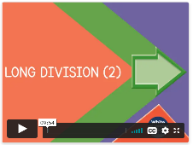  https://whiterosemaths.com/homelearning/year-6/week-6-number-addition-subtraction-multiplication-division/  THERE ARE 3 VIDEOS YOU CAN WATCH.  Record the answers to the division questions on a Google doc. The question sheet is attached on Google Classroom.  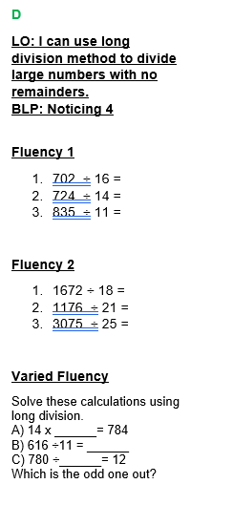  The question sheet looks like this!  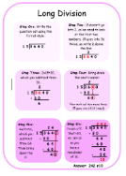  Use the Steps to Success to help you. A large version is on Google Classroom | Reading:  Look at the Reading Inference Worksheet. Read the text extracts and then answer the questions. Remember to use evidence from the text.  There are TWO inference questions to answer:  The worksheet looks like this!  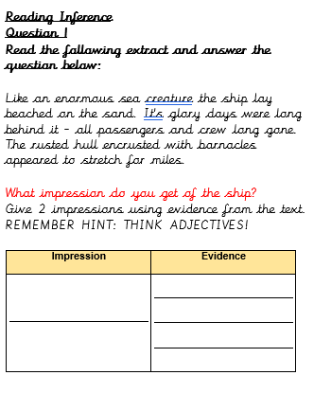  Remember the worksheet has 2 pages!  English  Grammar:  VIEW THE POWERPOINT IN GOOGLE CLASSROOM TO HELP YOU:  Complete the TWO worksheets:  1. Apostrophe for Possession  2. Apostrophe for Contraction | PPA SESSION  SEE THE WORK POSTED BY MRS WHITE AND MRS WALKER.

