Tuesday 19th  January Home Learning  Year 6 | Maths:  1. TTRS/Mathletics 9:00am – 9.30am  Before the start of each lesson get yourself onto times tables rockstars or matheletics and practise some timestables or maths skills.  We have new battles starting this term and to keep things simple the new battle is 6.1 v 6.2 v 6.3.  Let us see who are the year group champions!  2. Warm-up 9:30am - 9:45am  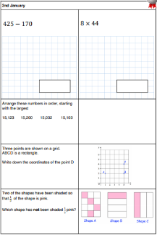  Answer the maths ‘Maths Warm-up’ questions below. A large copy of the questions is attached on Google Classroom.  3. Main Task- Simplifying 9.45am – 10:30am  Once you have finished the warm up open the sheet which says ‘Simplifying Fractions Maths task’ and have a go at Task 1, 2 and 3. The Tasks get harder but do progress so give each a go and see how far you get.  Click on the link below and watch the following videos:  - Equivalent Fractions  - Simplify Fractions  These should help you understand and answer some of the questions.  https://whiterosemaths.com/homelearning/year-6/week-8-number-fractions/  Give yourself a 15 min break now until 10:45am | Reading: 10:45am – 11.15am  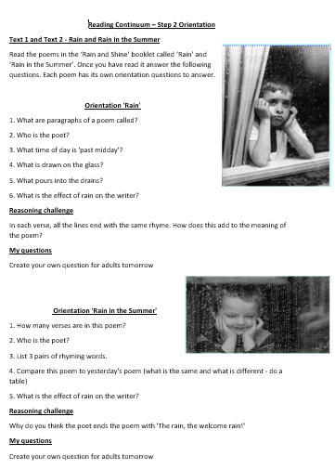  Read the poems ‘Rain’ and ‘Rain in the summer’ from the Rain and Shine booklet. Once you have read them answer the orientation questions. Remember each poem has its own set of questions which you need to answer. See the ‘large version’ in Google Classroom – it is called Reading Step 2 Orientation.  The question sheet looks like this!  Formal and Informal: 11:15am - 12:15pm  Open the PowerPoints 1 and 2 on Formal and Informal in Google Classroom. Read through them and understand what the difference between them.  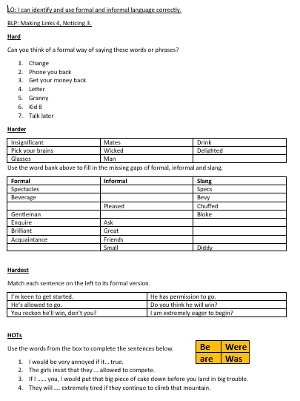  Then open the worksheet and complete the Formal and Informal Task. Once you have finished the task open the Extension ppt and work through it.  The worksheet looks like this!  Give yourself a hour lunch break now until 1:15pm | PPA Session: 1:15pm – 3.15pm  See the work posted by Mrs White, Mrs Walker and Mrs Clayton.

