Wednesday 20th January Home Learning  Year 6 | Maths:  1. TTRS/Mathletics 9:00am – 9.30am  Before the start of each lesson get yourself onto times tables rockstars or matheletics and practise some timestables or maths skills.  We have new battles starting this term and to keep things simple the new battle is 6.1 v 6.2 v 6.3.  Let us see who are the year group champions!  2. Warm-up 9:30am - 9:45am  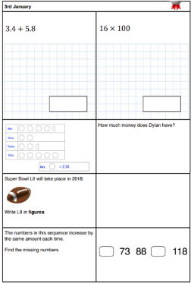  Answer the maths ‘Maths Warm-up’ questions below. A large copy of the questions is attached on Google Classroom.  3. Main Task – Simplifying (2) 9.45am – 10:30am  Once you have finished the warm up open the sheet which says ‘Simplifying Fractions 2 Maths task’ and have a go at Task 1, 2 and 3. The Tasks get harder but do progress so give each a go and see how far you get.  Click on the link below and watch the following videos:  - Equivalent Fractions  - Simplify Fractions  These should help you understand and answer some of the questions.  https://whiterosemaths.com/homelearning/year-6/week-8-number-fractions/  Give yourself a 15 min break now until 10:45am | Reading: 10:45am – 11.15am  Read the poems ‘Rain’ and ‘Rain in the summer’ from the Rain and Shine booklet. Once you have read them look at the vocabulary words. Remember each poem has its own set of words which you need to look at. See the ‘large version’ in Google Classroom – it is called Reading Step 3 Vocabulary.  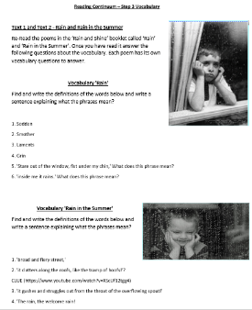  The question sheet looks like this!  Diary Planning: 11:15am - 12:15pm  Open the WAGOLL from Google Classroom and read it again make sure you are clear what each paragraph is about.  Next open the planning sheet and you will start to plan your own version of the Diary. Use the success criteria to help you and ensure you have included everything.  Think about the writing features you need to include.  - Punctuation  - Relative Clause  - Subjunctive  - Formal and Informal Language  - Modal verbs  - Subordinate and coordinate Clause  - Expanded noun phrases  - Parenthesis  - Question and exclamation mark  - Apostrophes for possessions and contractions  Give yourself a hour lunch break now until 1:15pm | History: 1:15pm – 2.15pm  In this week’s History lesson, we will be looking at how the country of Greece is or was split into states.  Open the map document and have a careful look at all 3 maps in particular at the different states.  Then complete the filling in the gap activity.  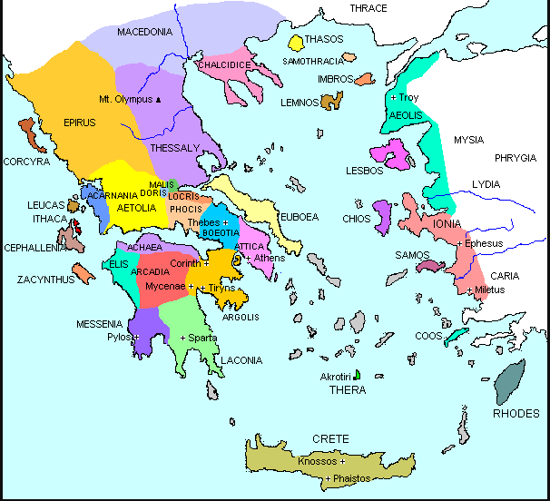  Finally read the information sheet on some of the Greek States, research them further and create a brochure selling the states enticing people to come pay a visit. Think about the ancient culture of each state. | DT:  2:15pm – 3.15pm  Greek Cuisine  Over the next few weeks you will learn about, taste, make and write your own Greek style cuisine and recipes.  For today’s lesson research the different types of Greek dishes and create a fact file about them.  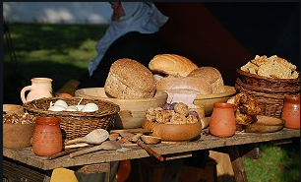  If and when parents go to the supermarket tell them to keep a lookout for any particular Greek ingredients and make a note or a list of some of them.

