Wednesday 6th January Home Learning  Year 6 | Maths:  Complete this Year 6 Arithmetic paper. Record your answers on a Goggle Doc and submit your work to your class teacher. You can check your work using the answers on the last page of the test.  The test is saved in Google Classroom. | Reading:  Read the story The Hottest day pages 3-7, which is saved on Google Classroom.  Answer the orientation questions (see below) on a Google doc.  Orientation Questions  Why did Garnet’s dad look at the sky each night?  What do you already know about harvest?  Garnet’s father would sit in silence and complete sums on paper. What do you think he was working out? (Page 5)  Reasoning Challenge  Who do you think Donald is and how old do you think he is? Give evidence to support your answer from the text. (Page 5 and 6)  Mother told Garnet not to hand the mail over to her father when he came in. Why did her mother make that decision? (Page 6)  Think of two difficult questions about the text to challenge your teachers!  English  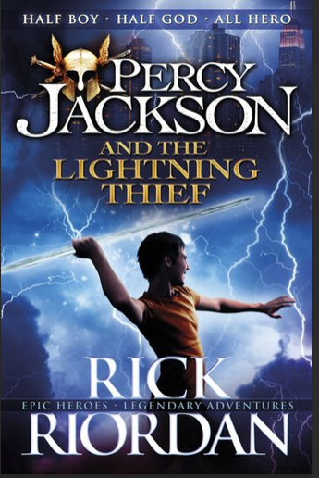  Look at the picture below and answer the questions on a Google doc.  What can you see?  What can you infer?  What questions would you like to  ask?  What do you predict will happen? | BLP:  For each of the BLP muscles look at the document on Google Classroom and think about how each muscle supports your learning in the classroom and answer the following questions.  You can use the BLP Powerpoint to help you too.  1.What is this BLP muscle?  2.How will this BLP muscle help me with my learning?  3.What targets will I set myself for this half term? | Computing:  In this lesson, you will briefly explore a brief history of moving images from still images in art to computer-generated imagery (CGI) and recorded video, learning that the purpose of video is to communicate a message to an audience, or to record an event.  Plan your own video and record your ideas on a Google doc.  https://classroom.thenational.academy/lessons/what-is-video-c4v68d  Complete the quiz.

