F
Reasoning and Problem solving using the Long division method.
BLP: Reasoning 4

Varied Fluency 1
- A group of 6 boys win 186 lollies at the school fair. They want to share them. How many lollies does each boy receive?
- There are 798 passengers in an airport. There are 14 flights each day. Using long division, work out how many passengers are on each plane?
- There are 945 chocolate coins to divide between 35 children. How many chocolate coins does each child receive?

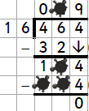
Varied Fluency 2 – Work out the missing numbers.
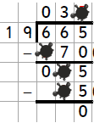
Reasoning – find and explain the mistakes.
