C
Reasoning and Problem solving – short division
BLP: Making links 4, Reasoning 4

Varied Fluency
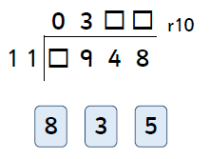
Use the digit cards to complete the calculation.
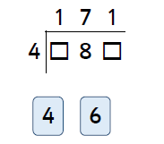

Reasoning
Identify the odd one out and explain why it is.
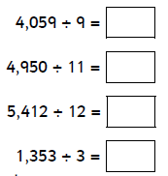
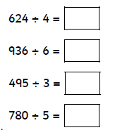

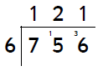
Asha knows she has made a mistake in the calculation. Explain what she has done wrong and what her answer should be.

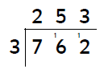
Mason knows he has made a mistake. Find the error and explain what he did wrong and what the answer should be.

