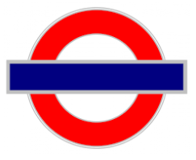
EDITING STATION 1: PUNCTUATION PARTY!
HAVE A LOOK FOR –
- CAPITAL LETTERS (START OF SENTENCES AND PROPER NOUNS)
- FULL STOPS TO FINISH SENTENCES
- QUESTION MARKS OR EXCLAMATION MARKS IF NEEDED
- COMMAS – IN A LIST OR TO SEPARATE CLAUSES
- BRACKETS TO ADD EXTRA INFORMATION
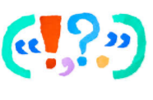
CHALLENGE – SEMI-COLON IF YOU KNOW HOW IT WORKS!
EDITING STATION 2: ADVERBIAL PHRASES
HAVE A LOOK FOR –
- ADVERBS IN YOUR SENTENCES (HINT: LY WORDS)
- PHRASES THAT TELL THE READER – WHEN/WHERE/HOW/WHY
- PREPOSITIONAL PHRASES – UNDER/ABOVE/BETWEEN

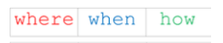
CHALLENGE – CAN YOU SWITCH YOUR SENTENCE STRUCTURE AROUND TO HAVE A FRONTED ADVERBIAL?

EDITING STATION 3: DETERMINERS
HAVE A LOOK FOR –
- LOTS OF SENTENCES STARTING WITH ARTICLES: THE, A OR AN
- SWITCHING YOUR SENTENCE STRUCTURE SO THAT YOUR OPENERS ARE VARIED

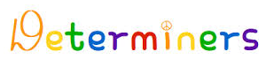
CHALLENGE – CAN YOU USE A POSSESSIVE, QUANTIFIER OR DEMONSTRATIVE DETERMINER?

EDITING STATION 4: SPELLING
HAVE A LOOK FOR –
- SPELLINGS THAT DON’T LOOK RIGHT
- DICTIONARIES
- THE YEAR 5/6 SPELLING WORDS LIST

CHALLENGE – CAN YOU FIND ALL YOUR MISPELLED WORDS?

EDITING STATION 5: IMAGERY
HAVE A LOOK FOR –
- SIMILIES – AS/LIKE
- METAPHOR – IT IS A…
- PERSONIFICATION – BRING INANIMATE OBJECTS TO LIFE
- ALLITERATION – FOUR FLUFFY FEATHERS
- ASSONANCE – IGNITE LIGHTS IN THE NIGHT

CHALLENGE – CAN YOU ADD AN APPROPRIATE EXAMPLE OF ONOMATOPOEIA?
EDITING STATION 6: THESAURUS PARTY!
HAVE A LOOK FOR –
- DULL ADJECTIVES
- BORING VERBS
- ALTERNATIVES IN THE THESAURUS

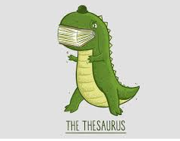
CHALLENGE – CAN YOU UPLEVEL YOUR CONJUNCTIONS?

