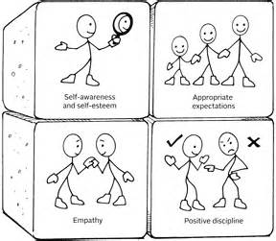
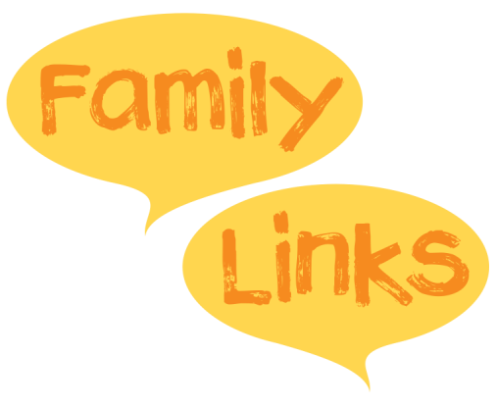
All included in a 10 week programme!

What is the Nurturing Programme?
Children are rewarding, stimulating and fun but looking after them can be challenging.
The Nurturing Programme helps deal with those challenges so that you can have a calmer, happier family life.
Coming to…
South  Bierley Life Centre – Thursday 12th September 9.30-11.30am  Sutton Community Centre – Wednesday 25th September 9.30-11.30am  Holme Wood Children’s Centre – Thursday 12th September 6.00-8.00pm  Farnham Children’s Centre – Thursday 20th September 9.30-11.30am  Contact: 01274 432639 familyhubsouth@bradford.gov.uk | West  Midland Road – Tuesday 17th September 1.00-3.00pm  Margaret McMillan Tower – Wednesday 9.15-11.15am  Contact:01274 436700 familyhubwest@bradford.gov.uk
Keighley & Shipley  Windhill Community Centre – Tuesday 29th September 12.30pm-2.30pm  Rainbow – Wednesday 25th September 9.30am-11.30am  Highfield – Wednesday 9th October 1.00pm-3.00pm  Contact:01535 618005 familyhubkeighleyshipley@bradford.gov.uk | East  Gateway – Wednesday 18th September 9.30-11.30am  Barkerend – Wednesday 18th September 1.00-3.00pm  Contact: 01274 437523 familyhubeast@bradford.gov.uk

Not sure which group to attend? Please use our postcode checker to ensure you are contacting the correct Family Hub – Link: https://www.bradford.gov.uk/children-young-people-and-families/family-hubs/postcode-checker-for-family-hubs/

