The Freedom Programme for Women
The aims of the Freedom Programme are to:
What is the Freedom Programme and who is
it for?
The Bradford Early Help Freedom Programme is for any woman with children, who has experienced or is affected by domestic abuse, including same sex relationships.
The course is also for women with children who just want to learn more about abusive and controlling relationships as well as healthy relationships, whether personal or professional.
The Freedom Programme runs for 2 hours each week for 12 weeks.
The Freedom Programme provides a safe and supportive environment. You do not have to speak about your experiences if you don’t want to and you can do the course at your own pace.
- Help women to identify abusive behaviours and beliefs held by abusive and controlling partners.
- Help women to gain confidence and improve the quality of their lives.
- Explore how domestic abuse affects children.
- Make new friends and meet other people in the same situation.
- Help women to recognise both abusive and healthy behaviours in future relationships.

Where is the Freedom Programme Held?
The Bradford Early Help Freedom Programme is for women with children and is available in several locations across the Bradford district – see overleaf.
Prior to attending, women should contact the person named on this leaflet to find out the exact location of the programme.
How Do I Book?
Choose the best location and then contact the named person overleaf to request a place and find out the exact location of the group.

Barkerend Starting: 1st October 2019
Times: Tuesday 9.30am-11.30am
Contact: East 01274 437523
Email: familyhubeast@bradford.gov.uk
Farcliffe Starting: 26th September 2019
Times: Thursday 10am-12pm
Contact: West Family Hub 01274 436700
Email: familyhubwest@bradford.gov.uk
St Edmunds
Starting: October 2019
Times: Thursday 9.30am-11.30am
Contact: West Family Hub 01274 436700
Email: familyhubwest@bradford.gov.uk
The Freedom Programme
Bradford District
The Freedom Programme
Bradford Early Help
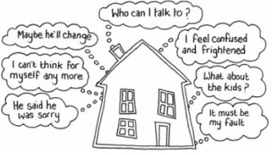
Holmewood Children’s Centre
Starting: Rolling Programme
Times: Friday 9:30am – 11:30am
Contact South Family Hub 01274 432639
Email: familyhubsouth@bradford.gov.uk

An awareness raising programme about domestic abuse and healthy relationships for women
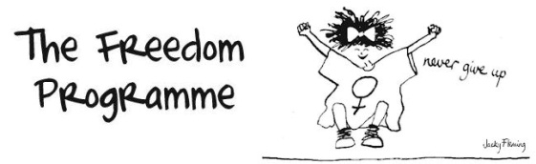

www.freedomprogramme.co.uk
Reevy Hill
Starting: Rolling Programme
Times: Tuesday 6.00-8.00pm
Contact: Family Hub 01274 432639
Email: familyhubsouth@bradford.gov.uk

Woodroyd
Starting: 5th July 2019 Times: Tuesday 10.00-11.30
Contact:: East 01274 437523
Email: familyhubeast@bradford.gov.uk
Owlet, Shipley Starting: Rolling Programme
Times: Thursday 1.00pm-3.00pm
Contact: Keighley/Shipley Hub: 01535 618005 Email: familyhubkeighleyshipley@bradford.gov.uk
Shipley Library Starting: 17th September 2019
Times: Tuesday 1.00pm-3.00pm
Contact: Keighley/Shipley Hub: 01535 618005 Email: familyhubkeighleyshipley@bradford.gov.uk
Rainbow, Keighley Starting: TBC
Times: Tuesday 9.30am - 11.30am
Contact: Keighley DVS 01535 210999 Email: referrals@domesticviolenceservices.org.uk
Rainbow, Keighley Starting: TBC
Times: Thursday 9.30am - 11.30am
Contact: Keighley DVS 01535 210999 Email: referrals@domesticviolenceservices.org.uk

www.freedomprogramme.co.uk

