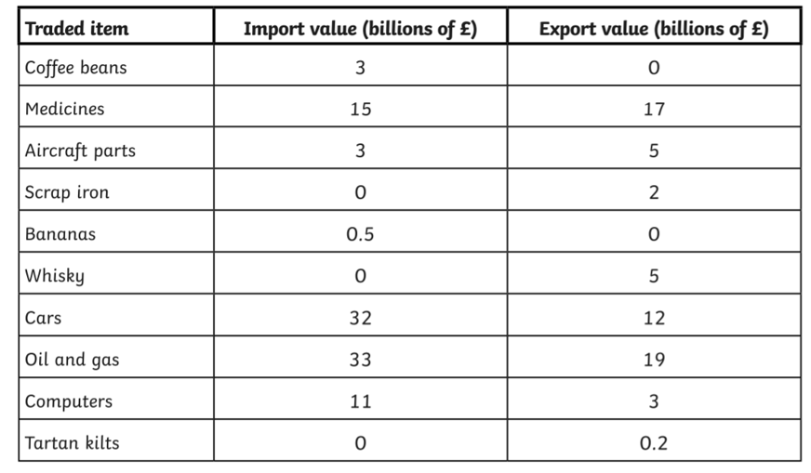
Use the data in the table above to create 2 bar charts to show how much the UK earns from exporting and importing goods. You will need one on UK Imports and one on UK Exports. Below is an example of what your axes will look like.
