Important things to do each day

Get yourself dressed. Only ask an adult for help if you really get stuck and can’t put something on by yourself. Can you get quicker each day?
Brush your teeth twice a day; after your breakfast and before you go to bed.
Count the number of steps in your house; when you come downstairs for breakfast each morning and when you go back upstairs to bed at night.
Read a bedtime story with an adult or older brother/sister.
Practise drawing lines and circles, or writing your name (You could use pens, pencils, chalk or water & a paintbrush on the doorstep).

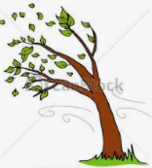

Click on the link below to watch Lynne’s new video on YouTube:

Wild Winter Weather! Rain, snow and wind songs for pre-schoolers

https://youtu.be/hUtcPqllNas

www.explorify.wellcome.ac.uk

Find out about how birds feed their babies.

- Click on the bar at the top of the page where it says
‘Explorify during school closure’

- Scroll down and click on ‘Birds’.

- Click on the video for 5-7 year olds.

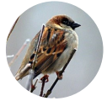 Feed the Birds 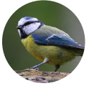

Birds love to eat insects and berries but can get very hungry during the Winter if they can’t find enough food to eat. They are always pleased if people leave out food for them to eat.

Why not make a bird feeder to hang in your garden. There are a few ideas below.

