Important things to do each day

Get yourself dressed. Only ask an adult for help if you really get stuck and can’t put something on by yourself. Can you get quicker each day?
Brush your teeth twice a day; after your breakfast and before you go to bed.
Count the number of steps in your house; when you come downstairs for breakfast each morning and when you go back upstairs to bed at night.
Read a bedtime story with an adult or older brother/sister.
Practise drawing lines and circles, or writing your name (You could use pens, pencils, chalk or water & a paintbrush on the doorstep).

Meet Fred Frog in today’s video

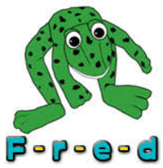

The Big Wibsey Bird Watch 2021

- Put on your coat so that you’re nice and warm.
- Find a pencil and the bird watching sheet (make your own if you can’t print it out). Now you’re ready to get started.
- Go outside to your garden or the park and stand very still so that the birds don’t know you’re there.
- Each time you see a bird, draw a line next to it on your sheet.
- When you’ve finished, count how many of each bird you saw.
- Which bird did you see most of?
- Which bird did you see fewest of?

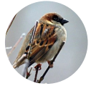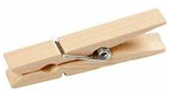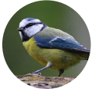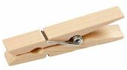
Play ‘Feed the Birds’

- Put some pompoms or pasta on a plate. Pretend its bird food.
- Find a clothes peg. Use your finger and thumb to squeeze the peg open.
- Pretend your peg is a bird’s beak and use it to pick up and eat the pompoms or pasta.
- Why not have a competition with the other members of your family to see who can pick up the most food.

