Important things to do each day

Get yourself dressed. Only ask an adult for help if you really get stuck and can’t put something on by yourself. Can you get quicker each day?
Brush your teeth twice a day; after your breakfast and before you go to bed.
Count the number of steps in your house; when you come downstairs for breakfast each morning and when you go back upstairs to bed at night.
Read a bedtime story with an adult or older brother/sister.
Practise drawing lines and circles, or writing your name (You could use pens, pencils, chalk or water & a paintbrush on the doorstep).

Today we are practising the letter sound

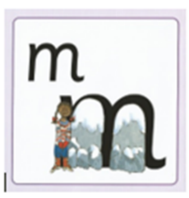

Have a go at writing ‘m’ in different ways
- Use different coloured pens or pencils
- Write ‘m’ in different sizes (huge for a giant, big for Daddy Bear, medium for Mummy Bear and small for Baby Bear)
- Chalk ‘m’ outside on the path
- Use paints to write ‘m’

‘m’ is for monkey

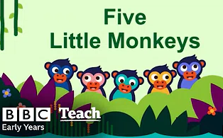

Click on the link below to listen to ‘Five Little Monkeys’

https://youtu.be/T8Hid9dBnOA

This week we’re going to be thinking about how lots of people celebrate the Chinese New Year. Watch the cBeebies film to find out how Abbie and her brother prepare for it.

Search cBeebies - Let’s Celebrate – Preparing for Chinese and Lunar New Year

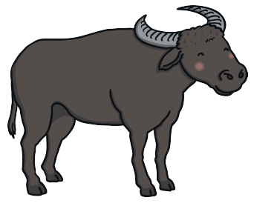

Read the Chinese New Year flipbook to find out about why each year has an animal named after it.
(Adults: I usually use my own words to simplify the story. We also tell the story practically by using small animals to act out the race. A towel would make a good river. This is also a good way for the children to understand ordinal number (ie, 1st, 2nd, 3rd…).

#4 – Make Your Mark

This week there will be lots of ideas for you to ‘make your mark’ at home whilst learning about the Chinese New Year and practising the letter sounds that we’ve learnt so far. You could also try any of the previous ideas on the home learning that you’ve not had time to do yet.

Remember to ask an adult to send a photo or video of you ‘making your mark’ and your name will go into the prize draw.

HAPPY MARK MAKING

