Important things to do each day

Get yourself dressed. Only ask an adult for help if you really get stuck and can’t put something on by yourself. Can you get quicker each day?
Brush your teeth twice a day; after your breakfast and before you go to bed.
Count the number of steps in your house; when you come downstairs for breakfast each morning and when you go back upstairs to bed at night.
Read a bedtime story with an adult or older brother/sister.
Practise drawing lines and circles, or writing your name (You could use pens, pencils, chalk or water & a paintbrush on the doorstep).

Today we are practising the letter sound

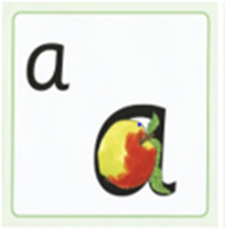

Have a go at writing ‘a’. Try something different to yesterday.
- Use different coloured pens or pencils
- Write ‘a’ in different sizes (huge for a giant, big for Daddy Bear, medium for Mummy Bear and small for Baby Bear)
- Chalk ‘a’ outside on the path
- Use paints to write ‘a’

‘a’ is for apple

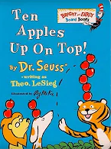

Click on the link below to listen to ‘Ten Apples Up On Top’

https://youtu.be/OB-5s02AsUU

Watch today’s cBeebies film to find out about all the fun things that Abbie and her brother do to celebrate the Chinese New Year.

Search cBeebies - Let’s Celebrate – Celebrating Chinese and Lunar New Year

Make some animal stick puppets (in Chinese New Year craft file) or use your own toy animals to tell the story of the Chinese New Year animal race across the river.

