Important things to do each day

Get yourself dressed. Only ask an adult for help if you really get stuck and can’t put something on by yourself. Can you get quicker each day?
Brush your teeth twice a day; after your breakfast and before you go to bed.
Count the number of steps in your house; when you come downstairs for breakfast each morning and when you go back upstairs to bed at night.
Read a bedtime story with an adult or older brother/sister.
Practise drawing lines and circles, or writing your name (You could use pens, pencils, chalk or water & a paintbrush on the doorstep).

Today we are practising the letter sound

Have a go at writing ‘s’. Try something different to yesterday.
- Use different coloured pens or pencils
- Write ‘s’ in different sizes (huge for a giant, big for Daddy Bear, medium for Mummy Bear and small for Baby Bear)
- Chalk ‘s’ outside on the path
- Use paints to write ‘s’

‘s’ is for snake

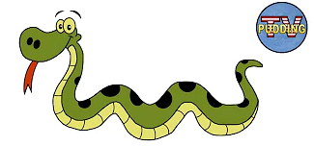
Click on the link below to listen to ‘Crawling Like a Snake’

https://youtu.be/2LcMyu5vrM8

Can you slither like a snake?

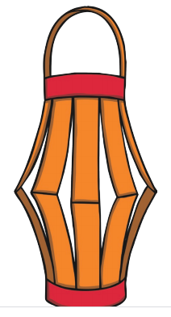
Use your s-s-s-s-scissor skills to make a paper lantern for Chinese New Year. See instructions in the Chinese New Year craft file.

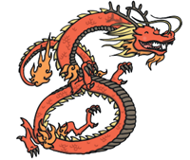

Click on the link below to watch Lynne’s new video on YouTube:

Chinese New Year with Lynne O’Malley

https://youtu.be/oBGW5DAD6kk

