Important things to do each day

Get yourself dressed. Only ask an adult for help if you really get stuck and can’t put something on by yourself. Can you get quicker each day?
Brush your teeth twice a day; after your breakfast and before you go to bed.
Count the number of steps in your house; when you come downstairs for breakfast each morning and when you go back upstairs to bed at night.
Read a bedtime story with an adult or older brother/sister.
Practise drawing lines and circles, or writing your name (You could use pens, pencils, chalk or water & a paintbrush on the doorstep).

Today we are practising the letter sound

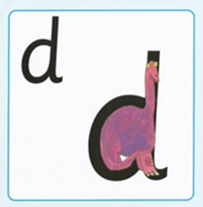

Have a go at writing ‘d’. Try something different to yesterday.
- Use different coloured pens or pencils
- Write ‘d’ in different sizes (huge for a giant, big for Daddy Bear, medium for Mummy Bear and small for Baby Bear)
- Chalk ‘d’ outside on the path
- Use paints to write ‘d’

‘d’ is for dinosaur

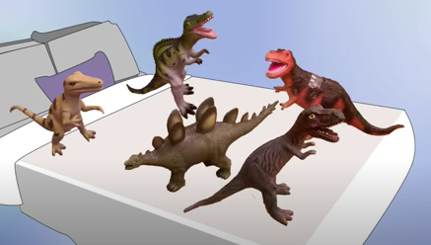

Click on the link below to listen to ‘5 Little Monkeys Jumping on the Bed (Dinosaur Version)

https://youtu.be/jpEE5Can4sA

How many dinosaur jumps can you do before you get tired?

‘d’ is for dragon

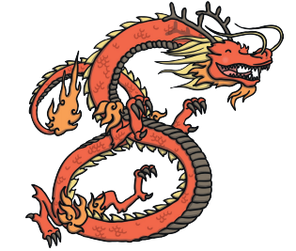
Make a paper plate dragon using the instructions in the Chinese New Year craft file.

Building Learning Power

Watch Copy Cat using his IMITATION superpower to find out about patterns.

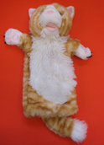

Can you use your imitation superpower to make some patterns too?

