LO: I can find and draw rectilinear shapes that have the same area.
BLP: Noticing 1, Reasoning 3.
Fluency
Task 1:
- Sort the shapes into the Carroll diagram.
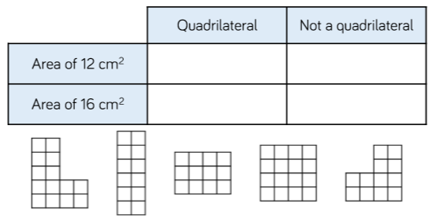
- Draw another shape for each section of the diagram.
Task 2:
- How many rectangles can you draw with an area of 24 cm squared where the side lengths are integers?
- What do you notice about the side lengths?
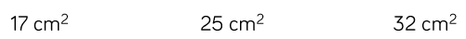
- Using integer side lengths, draw as many rectangles as possible that give the following areas:
Reasoning
- Who is correct?
Rosie and Dexter are drawing shapes with an area of 30cm squared.
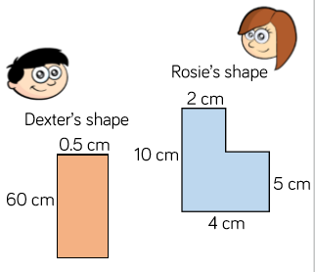

Who is correct? Explain your reasoning.

- Always, Sometimes or Never?
If the area of a rectangle is odd then all of the lengths are odd.
Problem Solving
Three children are giving the same rectilinear shape to draw.
Amir says, “The smallest length is 2cm.”
Alex says, “The area is less than 30cm squared.”
Annie says, “The perimeter is 22cm.”
What could the shape be?
How many possibilities can you find?

