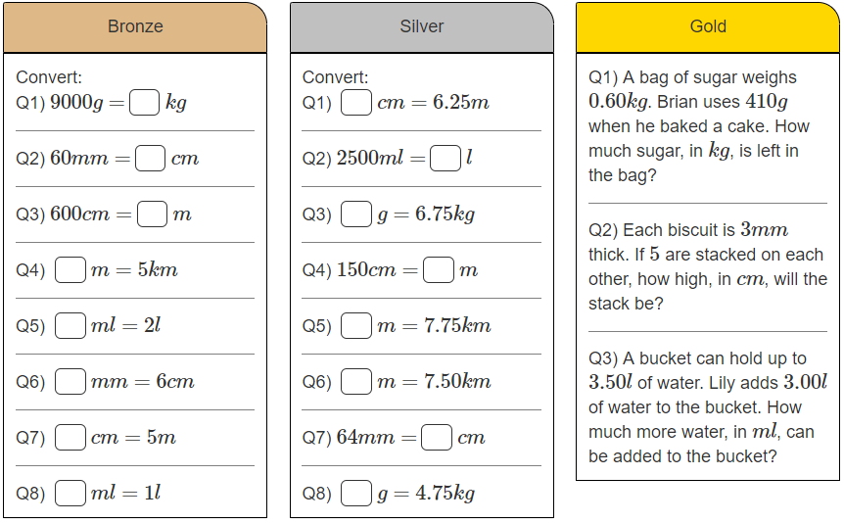 **Maths Warm** **up – Friday**