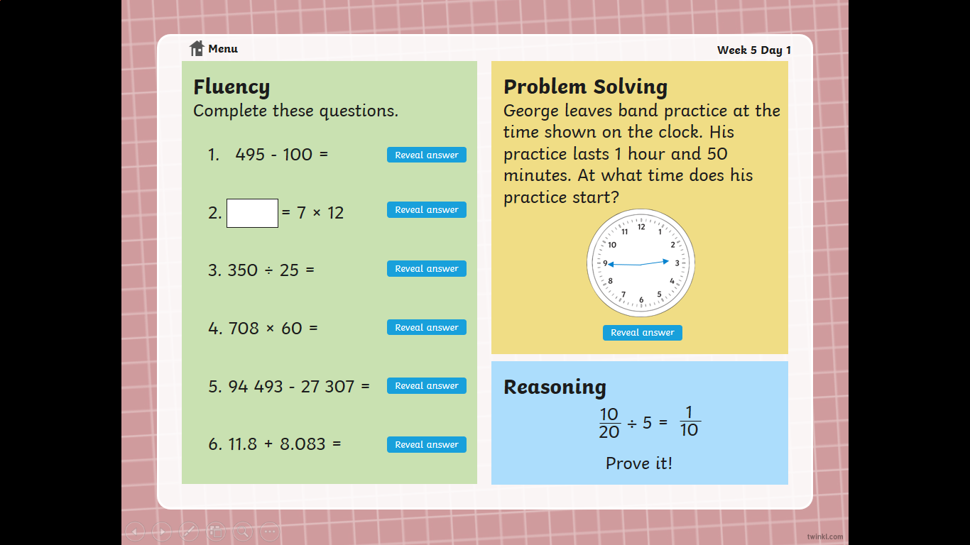 **Maths Warm** **up – Monday**