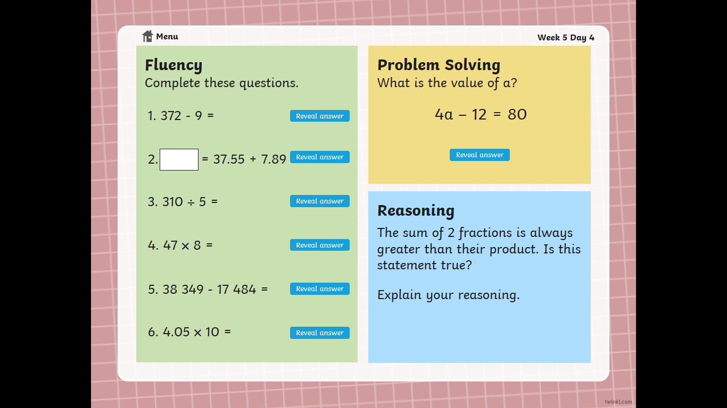 **Maths Warm** **up – Thursday**