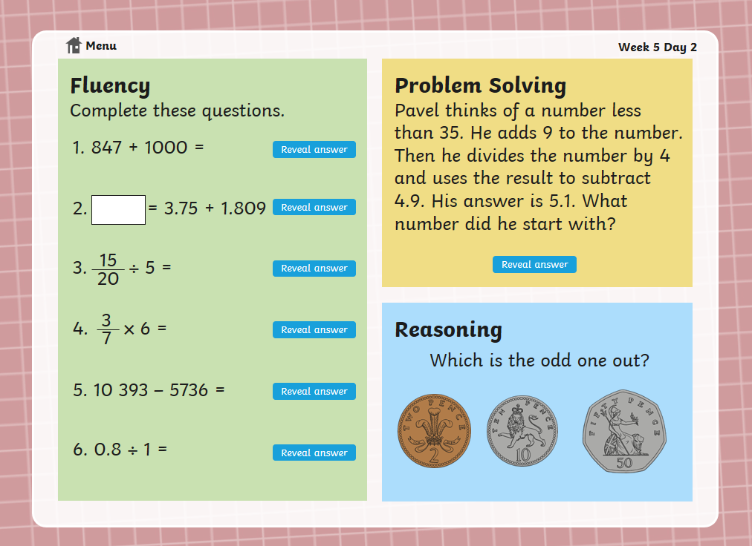
Maths Warm up – Tuesday

