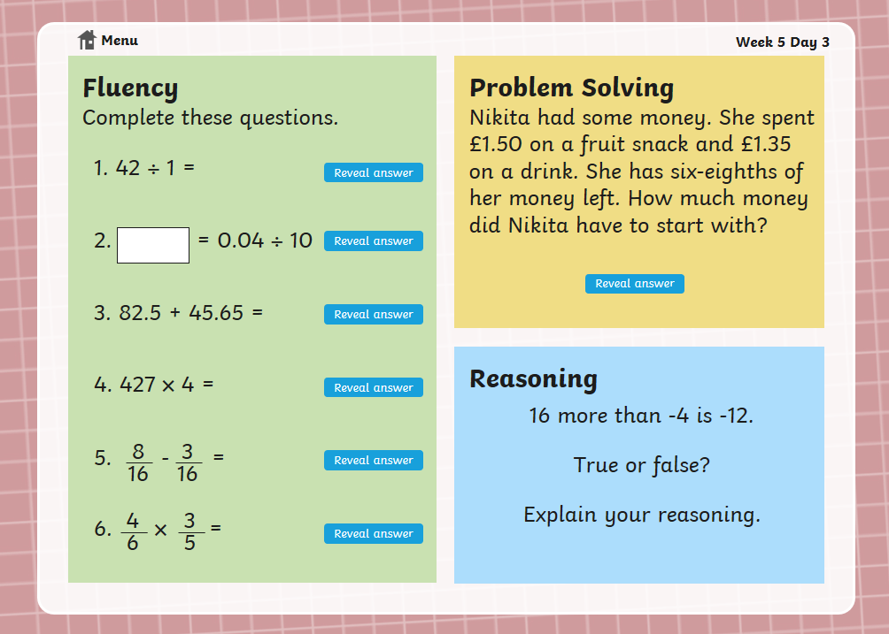
Maths Warm up – Wednesday

