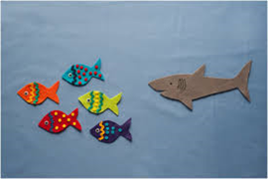
Click on the link below to watch Lynne’s YouTube video

Something Fishy! Songs of the sea for preschoolers

https://youtu.be/8uUDDiUXxuI

