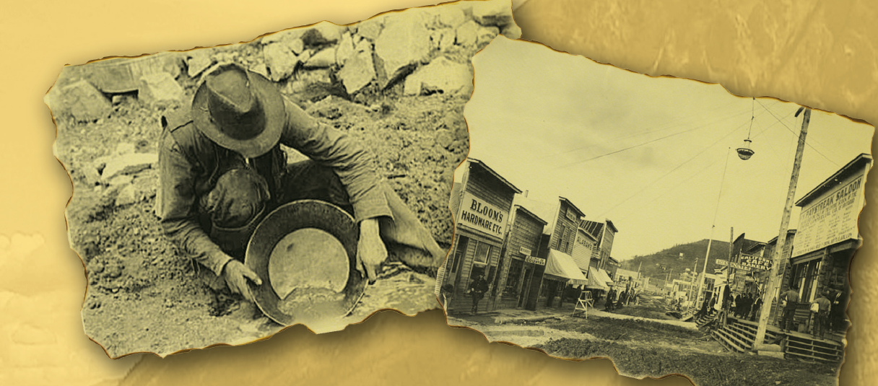
Look at the illustrations below. Answer the following questions, giving reasons for your answers.
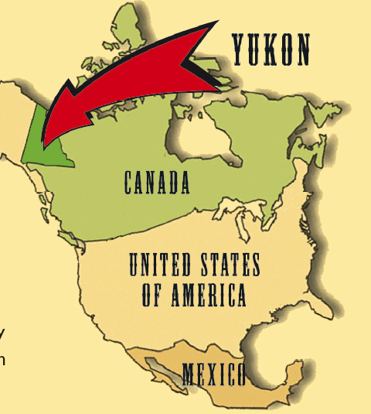
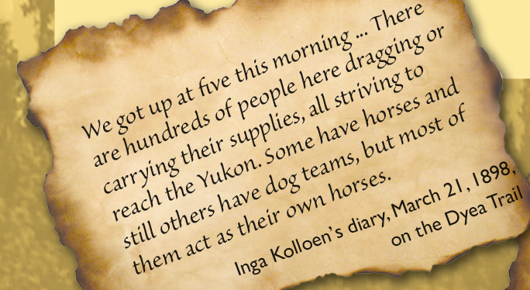
1. What could the text be about? Explain why and give evidence from the illustrations.

2. What type of text could it be? Explain why and give evidence from the illustrations.

