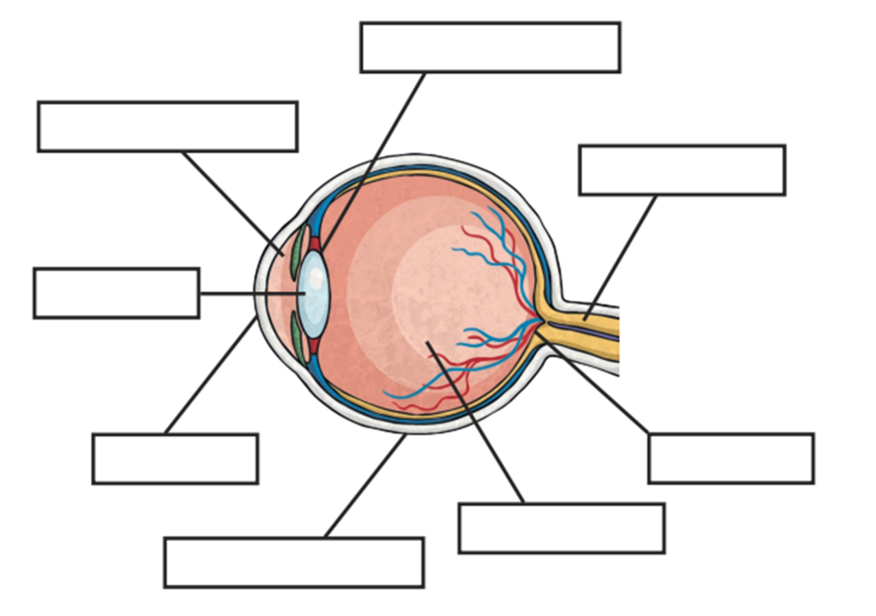

Insert the words below into the correct space on the diagram above:

Retina Vitreous Jelly Conjunctiva Cornea Lens

Optic Nerve Ciliary Muscle Anterior Chamber

