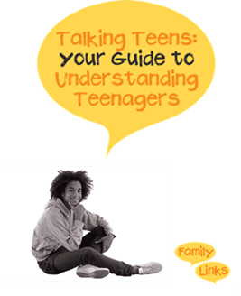

Talking Teens is a 6-week programme designed to enhance the transition from childhood to adolescence, by encouraging positive parenting and relationship building.
Suitable for Parents of teenagers, 11-18 years of age
The sessions cover:
- Effective communication
- Relationship building
- Managing conflict
- Building self esteem
- Managing problem behaviour

Coming to…
South  Bierley Life Centre – Tuesday 11th September 5.45pm-8.15pm  Hill Top Primary School – Thursday 19th September 9.30am-12.00pm  Contact: 01274 432639 familyhubsouth@bradford.gov.uk | West  Farcliffe – Wednesday 25th September 1.00pm-3.30pm  Contact:01274 436700 familyhubwest@bradford.gov.uk
Keighley & Shipley  Rainbow – Tuesday 23rd September 9.30am-11.30am  Shipley – Friday’s Time TBC October 2019  Contact:01535 618005 familyhubkeighleyshipley@bradford.gov.uk | East  Barkerend – Thursday 1st August 5.30pm-7.30pm  Contact: 01274 437523 familyhubeast@bradford.gov.uk

Not sure which group to attend? Please use our postcode checker to ensure you are contacting the correct Family Hub – Link: https://www.bradford.gov.uk/children-young-people-and-families/family-hubs/postcode-checker-for-family-hubs/

