Using 2Connect to create a Plan for Your Blog
1. First click on 2Connect. This is found in Purple Mash under the Computing Section.
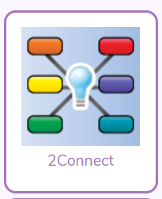
2. Click on the Blank document.

3. Click on the video image in the top right hand corner, which will show you how you can add text, images and sounds.
4. Now create your plan for your blog. Remember to include the features that you learnt about last week.
You can save your work in your Purple Mash folder so your teacher can view it.

