Day One:
Maths
TTRS: Soundcheck
My Mini Maths: Complete the following questions
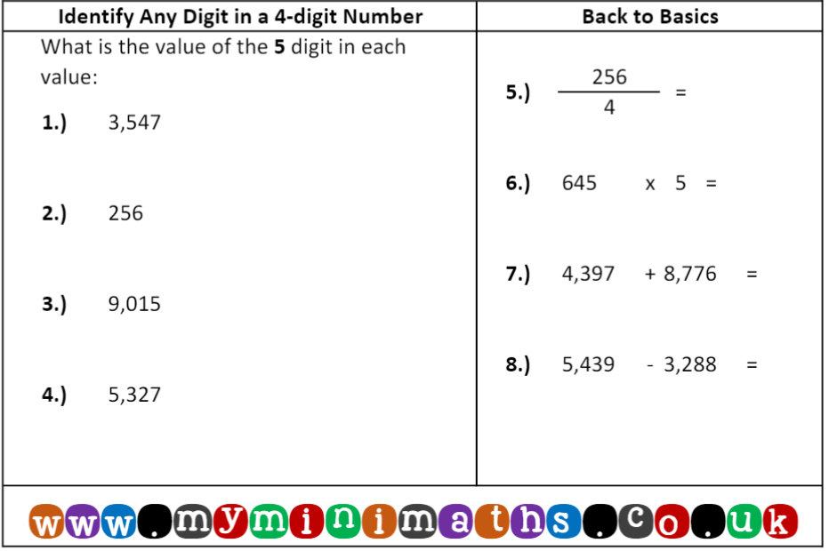
I can identify multiples.
Fluency
Play the game and identify the multiples.
https://www.topmarks.co.uk/times-tables/coconut-multiples
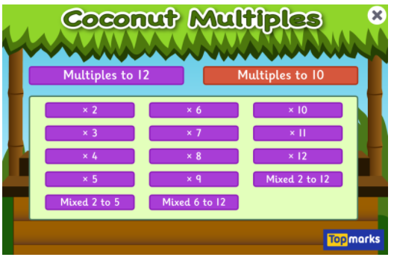

Circle the shirts which are multiples of 4.
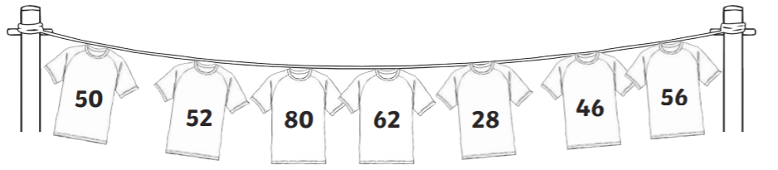
Circle the shirts which are multiples of 8.
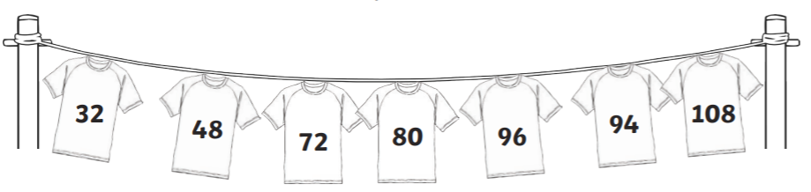
Circle the shirts which are multiples of 50.
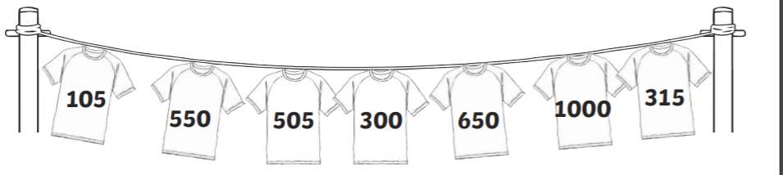

Problem Solving: True or False?
Mrs Bilevych said, “7 is an odd number which means that all the multiples of will 7 must be odd.”
Use reasoning to explain your ideas.

English
I can write my story setting.

Read your plan from the last lesson. Use your notes to help write your paragraphs.
Paragraph about making the den.
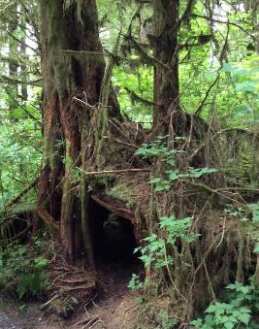
Paragraph about searching for food.
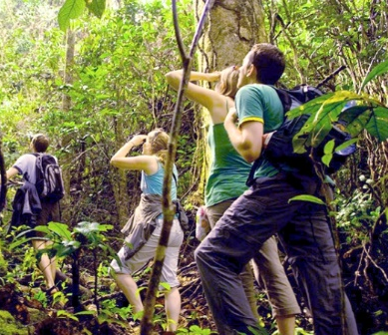
Paragraph about finding the water.
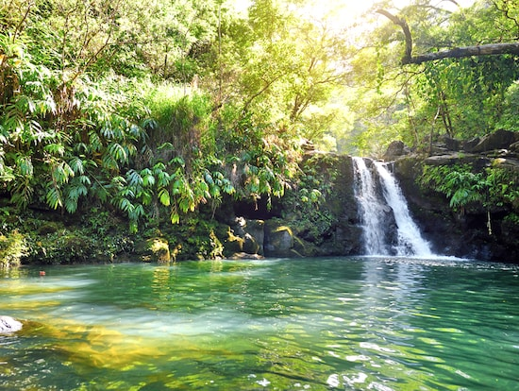
When you have finished your writing – use the marking ladder provided as a stuck prompt to help check it.
Did I include:
Fronted adverbials?
Expanded noun phrases?
A variety of pronouns?

he, his, she, her, they, their, the adventurers, the explorers, the grumpy girl, the exhausted children, the curious boy

A variety of conjunctions:

if, since, as, when, after, while, although, because, until, before, and, but, yet, so, or

Reading
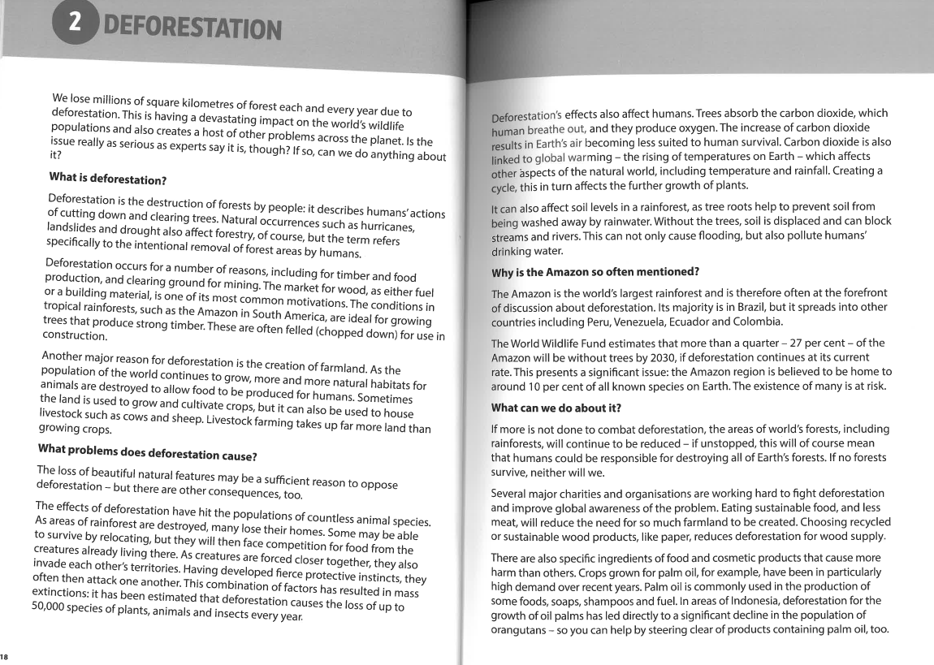
Orientation
- Name 3 natural occurrences that affect forestry.
- How many species of plants, animals and insects are lost each year due to deforestation?
- Why is the Amazon rainforest mentioned so often?
- Which countries does the Amazon rainforest spread into?
- What do the World Wildlife Fund think will happen by 2030?
Reasoning Challenge!
- Do you think it is worth trying to save the rainforests? Explain why.

- What do you think YOU could do to help combat deforestation? Read the last section of the text carefully for some ideas.

Art
Instead of listening to and appraising a piece of music this week, we are looking at and appraising a local artist!
Have a look at the art work and answer the questions below. The year 4 teachers will send some of your questions to Emily Dove on Thursday and will feedback her replies during live registration on Friday morning.
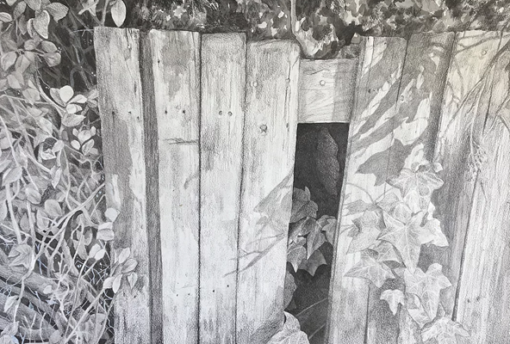
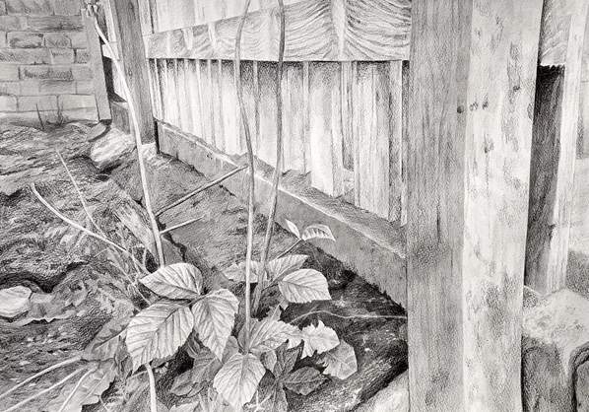

- What do you like about the art work?
I like her art work because …

- What do you notice about the techniques that Emily Dove has used?
I notice that she has used …

- Any questions about this piece of art?
My questions for Emily Dove:

- How has she inspired you?
Emily Dove has inspired me to…

Day Two:
Maths
TTRS: Soundcheck
My Mini Maths: Complete the following questions
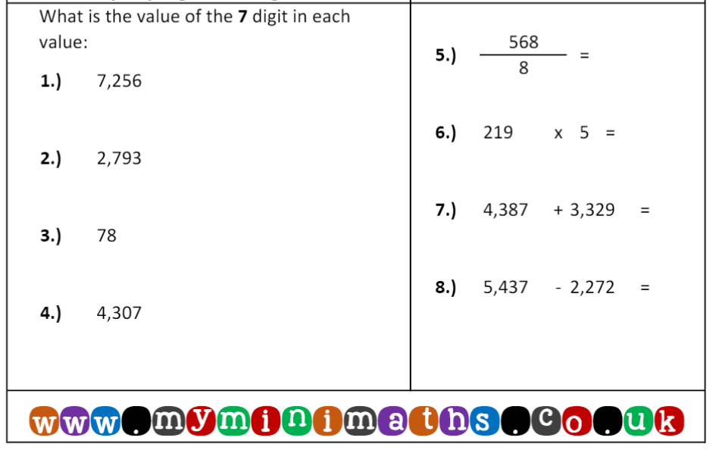

I can identify lowest common multiples.
Fluency:
List the multiples of each number and use your lists to identify the lowest common multiple.
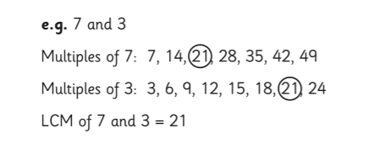
A)
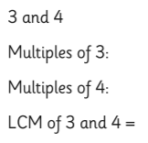

B)
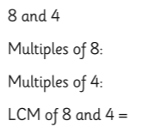
C)
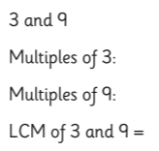

D)

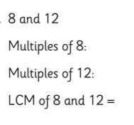
Problem solving.
- Miss Knowles is trying to find the LCM of 12 and 10. Maria says the LCM of 12 and 10 is 120 because 12 X 10 = 120. Is she correct? Show your working out and use reasoning to explain your answer.

- Mr Hudson is finding the LCM of 5 and 12. He says that the answer is 120 because both 5 and 12 go into 120. Is he correct? Show your working out and use reasoning to explain your answer.
English
I can edit and publish my story setting.

Read your story setting and check it. Check for:
- sense
- correct punctuation
- correct spelling

Use the marking ladder provided as a check list to help make sure that you have used expanded noun phrases, fronted adverbials and a variety of other writing skills across the piece of writing.

Did I include:
Fronted adverbials?
Expanded noun phrases?
A variety of pronouns?

he, his, she, her, they, their, the adventurers, the explorers, the grumpy girl, the exhausted children, the curious boy

A variety of conjunctions:

if, since, as, when, after, while, although, because, until, before, and, but, yet, so, or

Look at your marking ladder to help you decide how you can improve your story. Make 3 improvements. Here are some questions to help with this:
- Can something be added?
For example:
- A ‘with’ or ‘that’ to add detail to an expanded noun phrase.
- A comma to demarcate a fronted adverbial.

- Can something be removed?
For example:
- Find a simple sentence. Remove the full stop and find a conjunction that can be used to add a second clause to the simple sentence. Check that it makes sense. This will now be a compound sentence.
- Can something be moved?
For example:
- An adverb within a sentence – if you move it to the front of the sentence – can this now create a fronted adverbial? You might need to re-arrange some of your words in the sentence and will need to check that it makes sense.

- Can something be swapped?
For example:
- A repeated pronoun for a more interesting, alternative pronoun.

When you have edited your story, use your best cursive handwriting to publish and write the story on lined paper. Take a photo of your hand-written work when you and email it to year4@wibsey.bradford.sch.uk

Cursive handwriting:
abcdefghijklmnopqrstuvwxyz
Reading
Look at the vocabulary listed below.
Include any words you identified yesterday that you weren’t familiar with.
For each word, write the meaning and put it into a sentence. Either complete on Google docs or on paper. Please submit any photo evidence to: Year4@wibsey.bradford.sch.uk

To find the meaning use the website: www.wordhippo.com

Words to focus on:

devastating | relocating
intentional | extinction
mining | carbon dioxide
cultivate | displaced
livestock | pollute
sufficient | sustainable food
consequences | cosmetic
instincts | decline

Geography
Geography: I can reflect on how humans have impacted on the survivability of animals.
Please watch this video clip: https://www.bbc.co.uk/bitesize/topics/zp22pv4/articles/z2md82p
Please read the information below to find more about how humans are impacting on our environment.
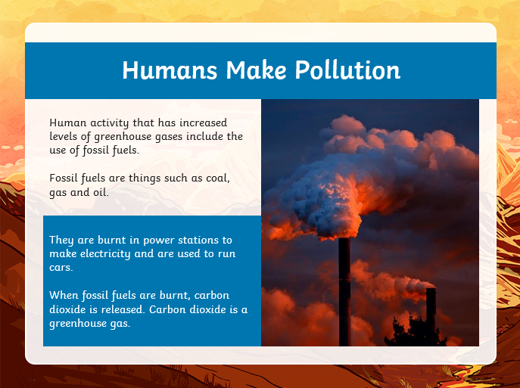

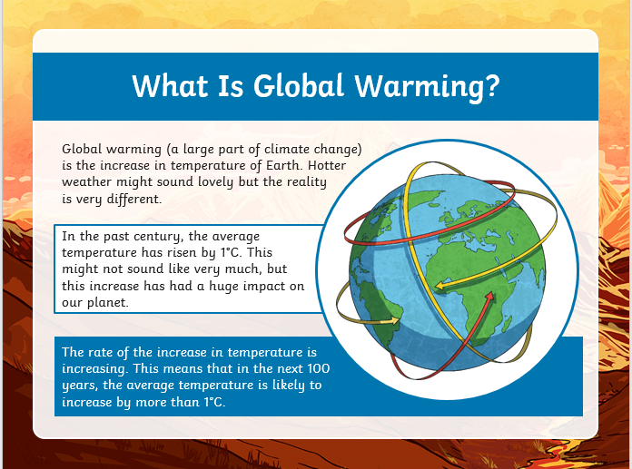

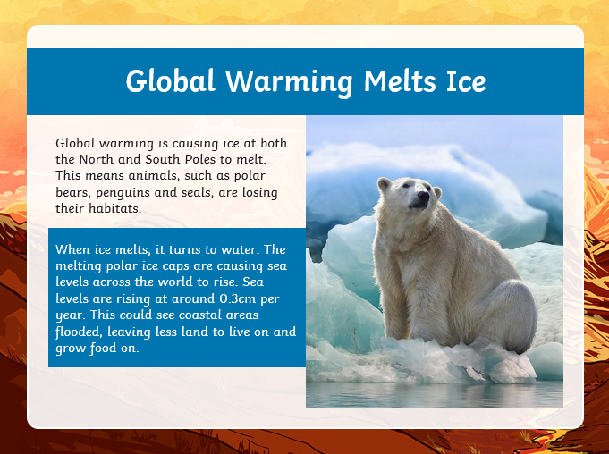

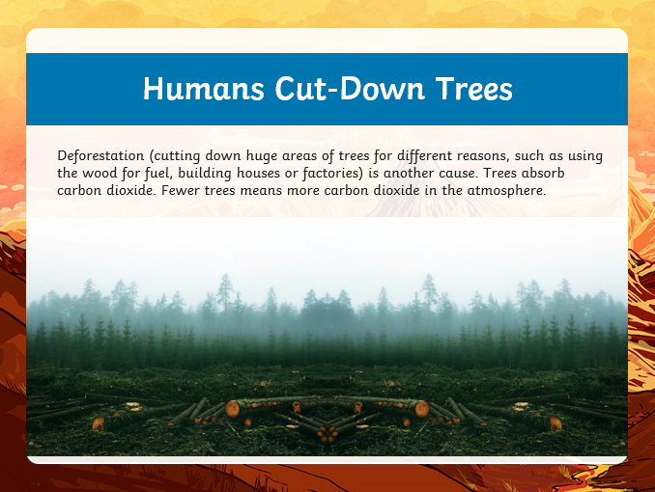

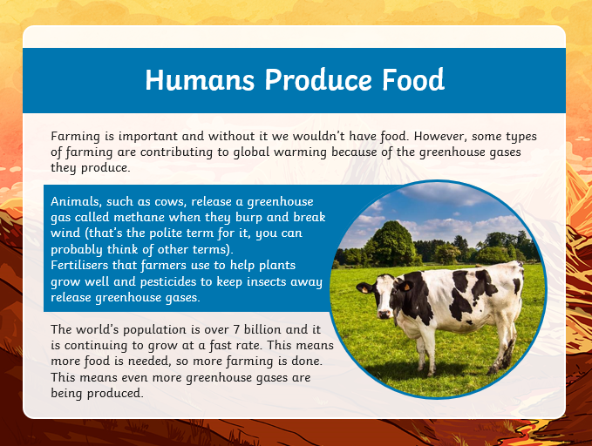
Hard: Think about the information you have read about how humans are impacting on our environment.
Can you list three ways that humans are having an impact on our environment?
1.
2.
3.
Harder: Using the three answers you have chosen for your hard task, can you explain why they are having an impact on the environment?

Hardest: Earlier in the year, you looked at Greta Thunberg and her campaign about the ice caps melting and what we must do to stop the rate at how fast they are melting. Today, you are going to be creating a poster about deforestation and what we must to do stop how quickly we are losing the rainforests around the world.
Below are some key questions to include as well as some key vocabulary and sentences starters to get you started. If you are at home, you can take a picture of your poster and email it to the Year 4 email year4@wibsey.bradford.sch.uk.

Key Questions:
- What is deforestation?
- Possible effects of deforestation.
- How would you reduce the effect of deforestation?

Key Vocabulary
- Deforestation
- Global Warming
- Carbon Dioxide

Persuasive Openers
- It is clear that…….
- The fact is…….
- There is no doubt that……..
- Clearly………

Day Three:
Maths
TTRS: Soundcheck
My Mini Maths: Complete the following questions
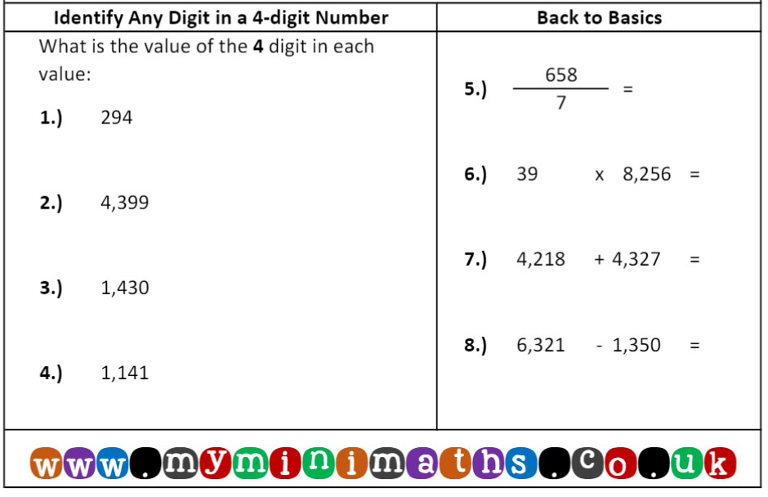
I can identify factor pairs.
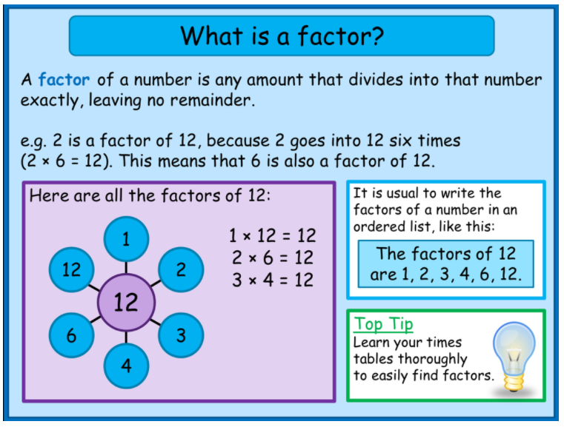
Fluency: Find all the factors of each number. The number of factors is shown in the brackets.
13 (2)

28 (6)

32 (6)

48 (10)

72 (12)

144 (15)
Problem Solving:
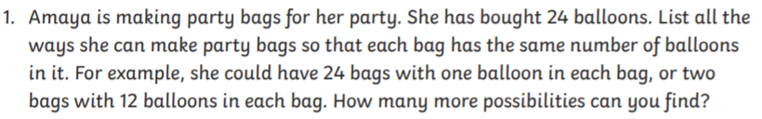

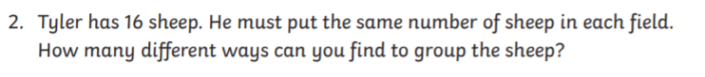
English
Spelling task:
Log on to Purple Mash and complete the spelling task that has been set as a 2do for you.
Y4 SPR 1 WK 6

I can retrieve information from a text.
We are currently reading a story called ‘Around the world in 80 minutes’ on purple mash.
Read Chapter five – this has been set as a 2do for you.
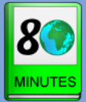
When you read the story, you can click on the underlined words and the definitions of the words will be explained to you.

When you have finished reading the chapter, answer the questions in the purple mash quiz. This has also been set as a 2do for you.
Day Four:
Maths
TTRS: Soundcheck
My Mini Maths: Complete the following questions
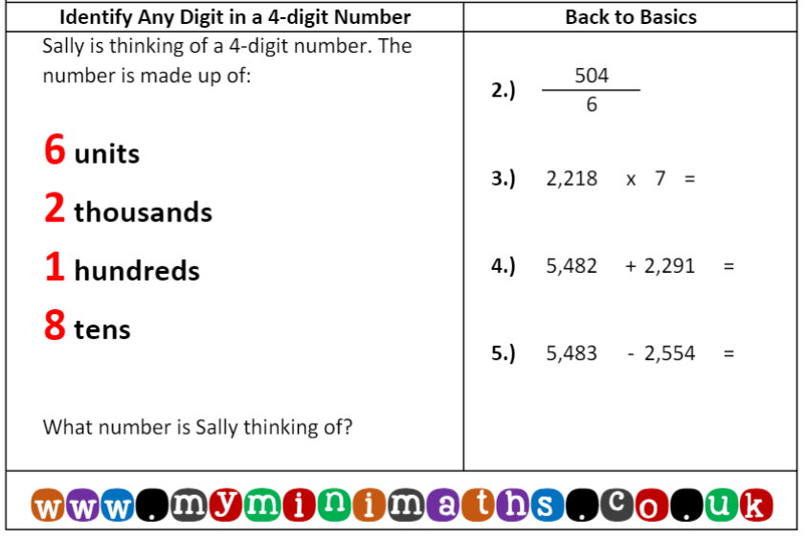
ones
I can identify factors.
Fluency: Find the highest factor shared by:

- 15 and 40

- 18 and 24

- 30 and 50

- 22 and 55

Problem Solving:
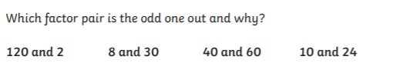
English
I can use conjunctions to write sentences
- Read the WAGOLL explanation text.
- Find the conjunctions.
Co-ordinating conjunctions | Subordinating conjunctions
for, and, nor, but, or, yet, so | if, since, as, when, after, while, although, because, until, before
- Make a list of the conjunctions that you find from each section. The first has been done for you.
Deforestation
We lose millions of square kilometres of forest each and every year due to deforestation. This is having a devastating impact on the world’s wildlife populations and also creates a host of other problems across the planet. Is the issue really as serious as experts say it is, though? If so, can we do anything about it?
What is deforestation?
Deforestation is the destruction of forests by people: it describes humans’ actions of cutting down and clearing trees. Natural occurrences such as hurricanes, landslides and drought also affect forestry, of course, but the term refers specifically to the intentional removal of forest areas by humans.
Deforestation occurs for a number of reasons, including for timber and food production, and clearing ground for mining. The market for wood, as either fuel or a building material, is one of its most common motivations. The conditions in tropical rainforests, such as the Amazon in South America, are ideal for growing trees that produce strong timber. These are often felled (chopped down) for use in construction.
Another major reason for deforestation is the creation of farmland. As the population of the world continues to grow, more and more natural habitats for animals are destroyed to allow food to be produced for humans. Sometimes the land is used to grow and cultivate crops but it can also be used to house livestock such as cows and sheep. Livestock farming takes up far more land than growing crops.

Conjunctions
- and
- if
- but
- as

What problems does deforestation cause?
The loss of beautiful, natural features may be a sufficient reason to oppose deforestation but there are other consequences too.
The effects of deforestation have hit the populations of countless animal species. As areas of rainforest are destroyed, many lose their homes. Some may be able to survive by relocating but they will then face competition for food from the creatures already living there. As creatures are forced closer together, they also invade each other’s territories. Having developed fierce protective instincts, they often then attack one another. This combination of factors has resulted in mass extinctions. It has been estimated that deforestation causes the loss of up to 50,000 species of plants, animals and insects every year.
Deforestation’s effects also affect humans. Trees absorb the carbon dioxide, which humans breathe out, and they produce oxygen. The increase of carbon dioxide results in Earth’s air becoming less suited to human survival. Carbon dioxide is also linked to global warming – the rising temperatures on Earth – which affects other aspects of the natural world, including temperature and rainfall. Creating a cycle, this in turn affects the further growth of plants.
It can also affect soil levels in a rainforest as tree roots help to prevent soil from being washed away by rainwater. Without the trees, soil is displaced and can block streams and rivers. This can not only cause flooding, but also pollute humans’ drinking water.
Why is the Amazon so often mentioned?
The Amazon is the world’s largest rainforest and is therefore often at the forefront of discussion about deforestation. Its majority is in Brazil, but it spreads into other countries including Peru, Venezuela, Ecuador and Colombia.
The World Wildlife Fund estimates that more than a quarter (27%) of the Amazon will be without trees by 2030 if deforestation continues at its current rate. This presents a significant issue: the Amazon region is believed to be home to around 10% of all known species on Earth. The existence of many is at risk.
Conjunctions
-
-
-
-
What can we do about it?
If more is not done to combat deforestation, the areas of the world’s forests, including rainforests, will continue to be reduced – if unstopped, this will of course mean that humans could be responsible for destroying all of Earth’s forests. If no forests survive, neither will we.
Several major charities and organisations are working hard to fight deforestation and improve global awareness of the problem. Eating sustainable food, and less meat, will reduce the need for so much farmland to be created. Choosing recycled wood or sustainable wood products, like paper, reduces deforestation for wood supply.
There are also specific ingredients of food and cosmetic products that causes more harm than others. Crops grown for palm oil, for example, have been in particularly high demand over recent years. Palm oil is commonly used in the production of some foods, soaps, shampoos and fuel. In areas of Indonesia, deforestation for the growth of oil palms gas led directly to a significant decline in the population of orang-utans – so you can help by steering clear of products containing palm oil, too.

Conjunctions
-
-
-

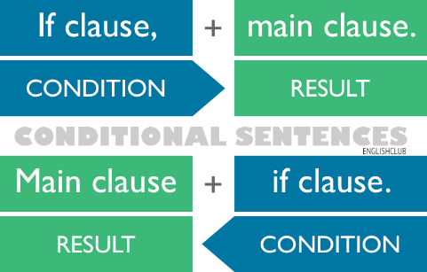
Using the conjunction ‘if’
We can use the conjunction ‘if’ in two different ways. We can either have the ‘if clause’ at the start of the sentence or the end of the sentence. Look at these examples to help you to understand.

If we carry on with deforestation, there will be no rainforests.
There will be no rainforests if we carry on with deforestation.

If people ate less meat, the need for farming would be reduced.
The need for farming would be reduced if people ate less meat.

Using the conjunction ‘as’
We can use the conjunction ‘as’ in two different ways. We can either have the ‘as clause’ at the start of the sentence or the end of the sentence. Look at these examples to help you to understand.
As clause + main clause.
Reason + fact

Main clause + as clause.
Fact + reason

As this process is destroying the homes of animals, we cannot continue to use palm oil.
We cannot continue to use palm oil as this process is destroying the homes of animals.

As it is the world’s largest rainforest, the Amazon is very well-known.
The Amazon is very well-known as it is the world’s largest rainforest.

TASK: Use the conjunctions from today’s work to create 8 sentences. Try to create:
- 2 sentences using ‘and’
- 2 sentences using ‘but’
- 2 sentences using ‘if’
- 2 sentences using ‘as’

Extra challenge! Can you create some more sentences using any of the conjunctions below?
Co-ordinating conjunctions | Subordinating conjunctions
for, and, nor, but, or, yet, so | if, since, as, when, after, while, although, because, until, before

Reading

Thursday 11th February – Retrieval
1.Look at the following questions.
- What are major charities and organisations working hard to do?
- Name two reasons why deforestation occurs.
- Which animal’s population has seen a significant decline as a result of deforestation for the growth of oil palms?
- What are the conditions in tropical rainforests ideal for?
- What problem might animals face if they have to relocate due to deforestation?
- What causes the air to become less suited to human survival?
- Which two aspects of the natural world does global warming affect?
- How can we reduce the need for farmland to be created?
- How can we reduce deforestation for wood supply?
- Who causes deforestation?
- Without the trees, soil is displaced and can block streams and rivers. What happens as a result of this? (Name two examples.)
- Which rainforest is the biggest in the world?
- What percentage of all known species in the world is the Amazon believed to be home to?
What is deforestation? | What problems does deforestation cause? | Why is the Amazon so often mentioned? | What can we do about it?
 |  |  | - What are major charities and organisations working hard to do?
2.Think about which section of the text you would have to look at to answer these questions. Sort the questions into the table below. The first one has been done for you. You do not need to answer the questions today.

11.02.21 Science
I can describe environmental dangers to endangered species.
Please read the following information about environmental dangers and some endangered species:
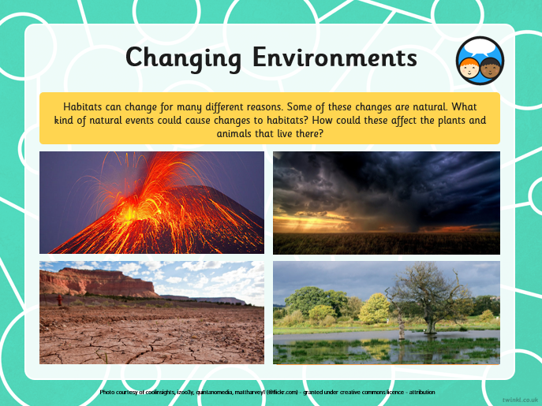

Discuss the following questions with an adult:
What kind of natural events could cause changes to habitats?

How could these affect the plants and animals that live there?

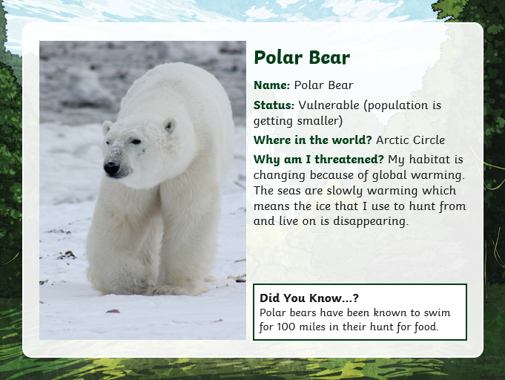

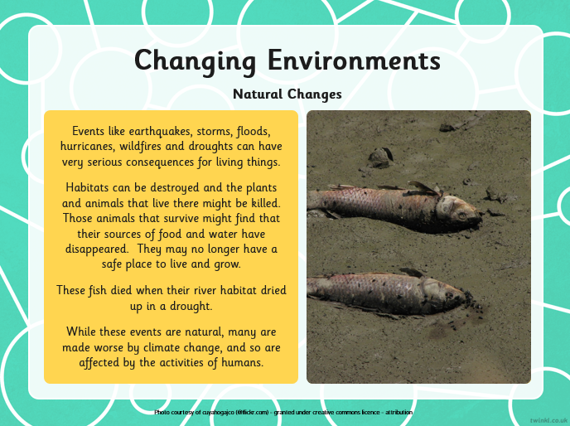

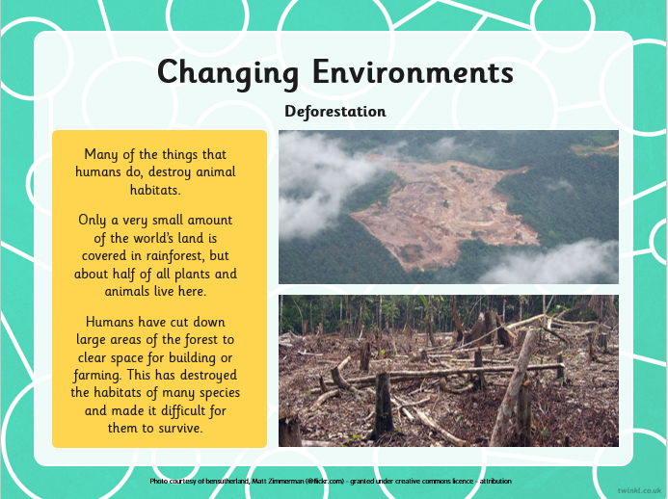
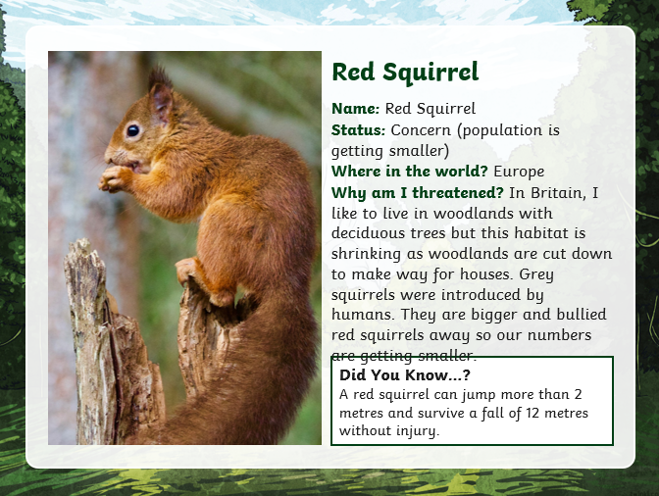
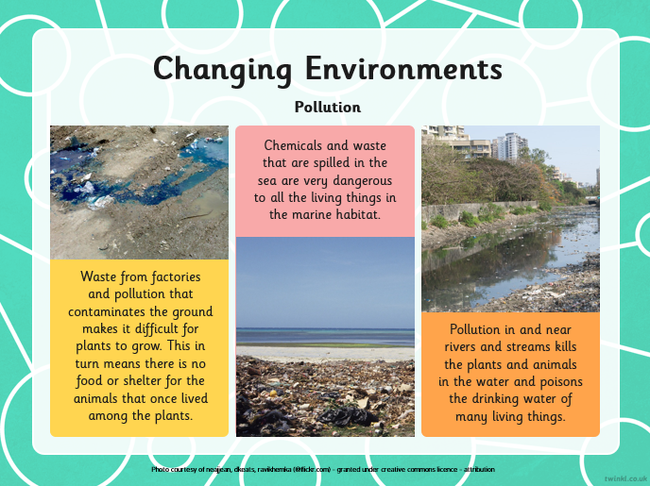
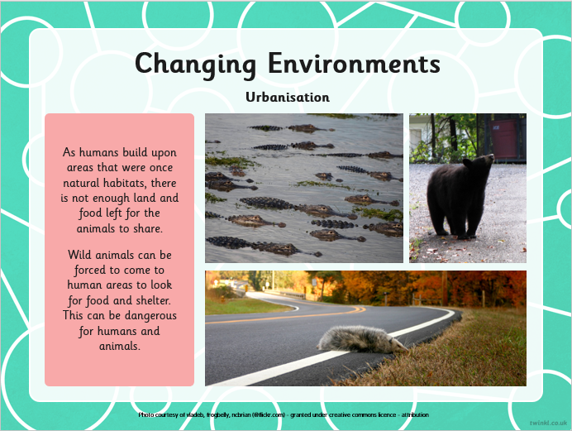
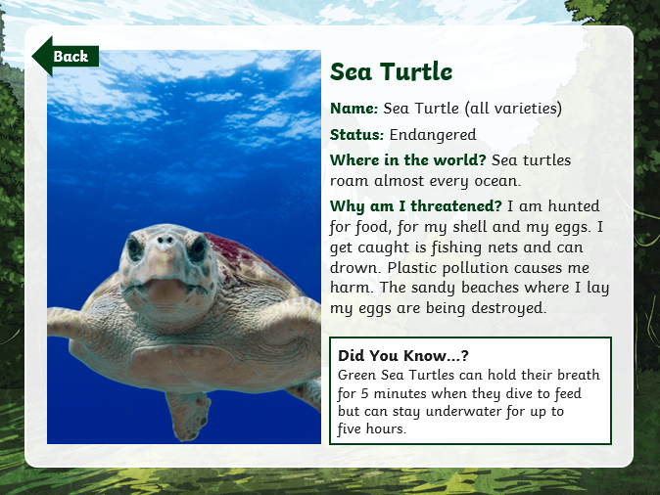
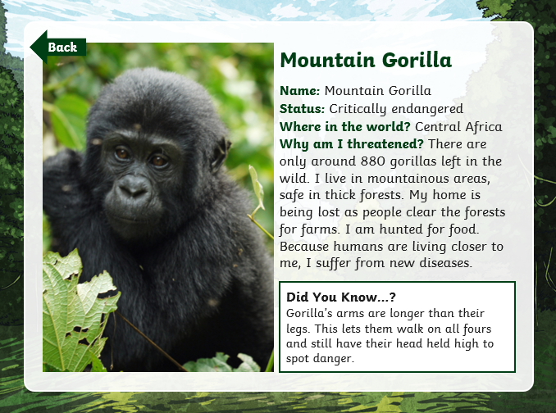

Hard: Know the environment danger to the animals and its habitat.

Harder: Use this knowledge to explain what can be done to stop it from becoming endangered.
Animal | Habitat | Environmental Danger | What can be done to stop it becoming endangered?

What changes could you make to reduce environmental dangers around the local area? Write your ideas down below. There are also some helpful websites to help you.
1.
2.
3.

Helpful websites (please copy and paste the links into your browser):
https://www.theclimatecoalition.org/resource

https://www.chesterzoo.org/news/preventing-extinction-of-endangered-animals/

Day Five:
Maths
Maths
TTRS: Soundcheck
My Mini Maths: Complete the following questions
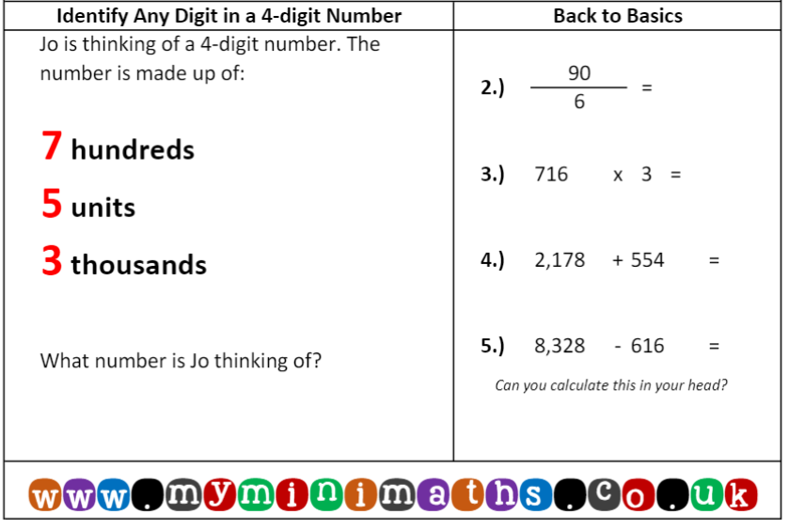
ones
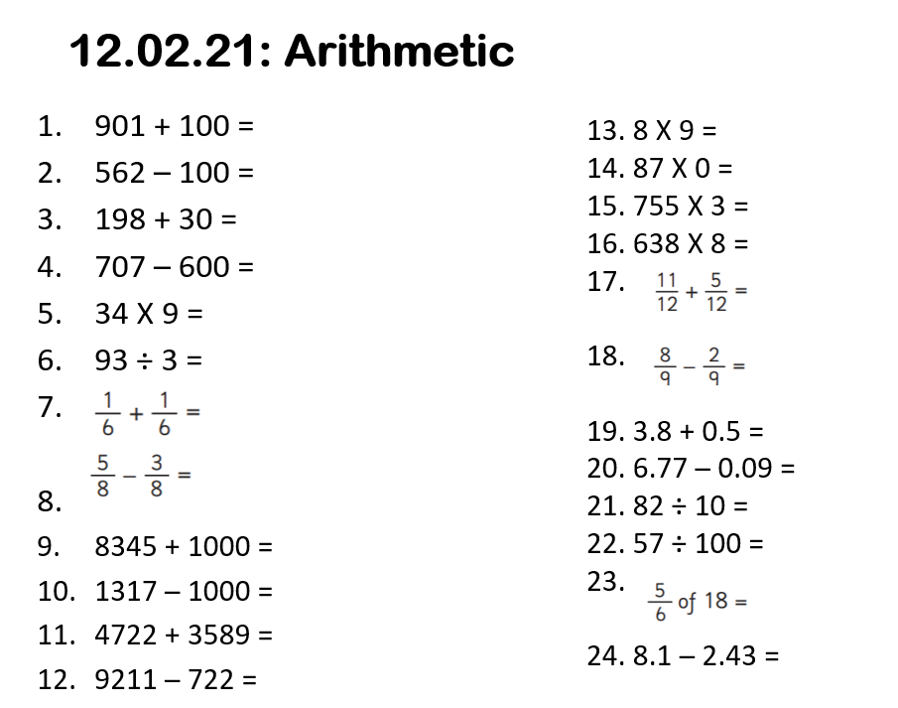
English
I can use formal language to write sentences.
In our writing and speaking, we use either formal or informal language.
Informal language – our ‘everyday’ language. We use this most of the time and use it when we are chatting to our friends and family. We also use this when writing text messages as well as in a letter to a friend.
Formal language – think of it as our ‘special language’. We use this when meeting someone important or when we are writing something important. We use this when writing important emails, letters or even job applications. Formal language is used for explanation texts.
Have a look at some examples below.
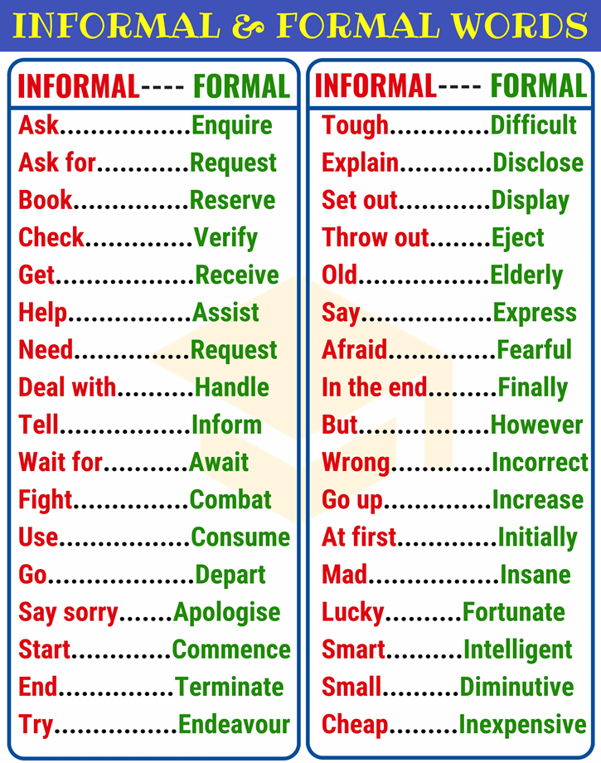

- Read the WAGOLL explanation text.
- Look at the bold words/phrases – you are given the choice of an informal word/phrase or a formal word/phrase. Both options have the same meaning. Choose the one that you think is more formal and underline/highlight/circle it.
Deforestation
We lose millions of square kilometres of forest each and every year due to trees being cut down/deforestation. This is having a devastating impact on the world’s wildlife populations and also creates lots/a host of other problems across the planet. Is the issue/problem really as serious as experts say it is, though? If so, can we do anything about it?
What is deforestation?
Deforestation is the destruction of forests by people: it describes humans’ actions of cutting down and clearing trees. Natural occurrences/things that happen such as hurricanes, landslides and drought also affect forestry, of course, but the term refers specifically to the on purpose/intentional removal of forest areas by humans.
Deforestation occurs for a number of reasons, including for timber and food production, and clearing ground for mining. The market for wood, as either fuel or a building material, is one of its most common motivations. The conditions in tropical rainforests, such as the Amazon in South America, are ideal for growing trees that produce strong timber. These are often felled (chopped down) for use in building/construction.
Another major reason for deforestation is the creation of farmland. As the population of the world continues to grow, more and more natural habitats for animals are destroyed to allow food to be produced for humans. Sometimes the land is used to grow and prepare/cultivate crops but it can also be used to house livestock/farm animals such as cows and sheep. Livestock farming takes up far more land than growing crops.

What problems does deforestation cause?
The loss of beautiful, natural features may be a sufficient reason to oppose deforestation but there are other consequences/bad things that happen too.
The effects of deforestation have hit the numbers/populations of countless animal species. As areas of rainforest are destroyed, many lose their homes. Some may be able to survive by moving/relocating but they will then face competition for food from the creatures already living there. As creatures are forced closer together, they also invade/go into each other’s territories. Having developed fierce protective instincts, they often then attack one another. This combination of factors has resulted in mass extinctions. It has been estimated that deforestation causes the loss of up to 50,000 species of plants, animals and insects every year.
Deforestation’s effects also affect humans. Trees absorb the carbon dioxide, which humans breathe out, and they produce/make oxygen. The increase of carbon dioxide results in Earth’s air becoming less suited to human survival. Carbon dioxide is also linked to global warming – the rising temperatures on Earth – which affects other aspects of the natural world, including temperature and rainfall. Creating a cycle, this in turn affects the further growth of plants.
It can also affect soil levels in a rainforest as tree roots help to prevent/stop soil from being washed away by rainwater. Without the trees, soil is displaced and can block streams and rivers. This can not only cause flooding, but also pollute humans’ drinking water.
Why is the Amazon so often mentioned?
The Amazon is the world’s largest rainforest and is therefore often at the forefront of discussion about deforestation. Its main bit/majority is in Brazil, but it spreads into other countries including Peru, Venezuela, Ecuador and Colombia.
The World Wildlife Fund estimates that more than a quarter (27%) of the Amazon will be without trees by 2030 if deforestation keeps going/continues at its current rate. This presents a significant issue: the Amazon region is believed to be home to around 10% of all known species on Earth. The existence of many is at risk.

What can we do about it?
If more is not done to combat deforestation, the areas of the world’s forests, including rainforests, will continue to be reduced – if unstopped, this will of course mean that humans could be to blame/responsible for destroying all of Earth’s forests. If no forests survive, neither will we.
Several major charities and organisations/groups are working hard to fight deforestation and improve global awareness of the problem. Eating sustainable food, and less meat, will reduce the need for so much farmland to be created. Choosing recycled wood or sustainable wood products, like paper, reduces deforestation for wood supply.
There are also specific ingredients of food and cosmetic products that causes more harm than others. Crops grown for palm oil, for example, have been in particularly high demand over recent years. Palm oil is commonly used in the making/production of some foods, soaps, shampoos and fuel. In areas of Indonesia, deforestation for the growth of oil palms gas led directly to a significant decline/drop in the population of orang-utans – so you can help by steering clear of products containing palm oil, too.

TASK: Choose 5 of the formal words that you found and create sentences using them

Reading
Hard: I can scan a text for specific information
- Who causes deforestation?
- What are the conditions in the rainforest ideal for?
- What problem might animals face if they have to relocate due to deforestation?
- Without the trees, soil is displaced and can block streams and rivers. What happens as a result of this? Name two examples.
- Which rainforest is the biggest in the world?
- What percentage of all known species in the world is the Amazon believed to be home to?
- What are major charities and organisations working hard to do?
- How can we reduce the need for farmland to be created?
Harder: I can identify the meaning of words within the context of the text
- Find and write the word that means the same as ‘farm animals’.
- What is meant by the phrase ‘sustainable food’?
- Find and write another word that means the same as ‘enough’.
- In the final paragraph, it says ‘… has led directly to a significant decline in the population of orang-utans…’. What is meant by ‘significant decline’?
- Find and write the word that means the same as ‘an animal species no longer existing’.
Hardest: I can evaluate the effectiveness of a text

The main purpose of an explanation text is to give the reader a clear understanding of the topic by the time they have finished reading the text.

- How would you rate your understanding of the text on a scale from 1 to 10? (1 = didn’t understand at all, 10 = fully understand). Give a reason for your answer.
- How would you rate how easy the text was to read on a scale from 1 to 10? (1 = extremely hard to read, 10 = extremely easy to read). Give a reason for your answer.
- What was the most useful feature of the text? (eg. subheadings, paragraphs, vocabulary). Give a reason for your answer.
- How do you think the text could be improved? Try to think about what would make it easier for you to understand. Give a reason for your answer.

Computing
I understand how to keep myself safe online.
Watch the following videos:
https://www.youtube.com/watch?v=-nMUbHuffO8
https://www.youtube.com/watch?v=X9Htg8V3eik
Hard:
After watching the videos, make a list of what you have learnt about keeping safe online.
Harder:
What information should you NOT share with anyone else?
Put a X in the correct boxes. The first one has been done for you.
What is your name? | X | Your computer password.
What you had for lunch. |  | What your favourite colour is?
Your address |  | What school you go to?
How old are you? |  | What tv programmes you like to watch.

Hardest:
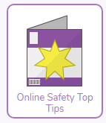
Create a poster on purple mash to explain to other children how to keep safe online.
The 2do is set for you.

Celebration task:
CONGRATULATIONS – you have completed this half term! Your task is to celebrate your hard work and effort by creating your very own certificate. This has been set as a 2do for you.

