 | Handwriting | Maths | Topic/ English | 50 Things Challenge!
Monday | Practice writing your name.  Practice writing  I, l, t  Remembering to start each letter on the line with a “whoosh”.  Challenge: Can you write a word with the sounds in? | Please watch one of the maths warm up videos for the lesson starter.  Introduce the number of the week which is 15.  Go through the power point with your child  (they will be familiar with this) discuss 15. Can they find 15 objects in your house?  Challenge: Can you find different ways to make 15? Can you write down the number sentences? | Can your child tell you what they celebrate? Can they think of a celebration that someone else might celebrate – Eid, Christmas, Diwali, baptism/christening etc.  Explain that Friday 12th February is Chinese New Year when the Chinese start their year. Read the power point of the Chinese New Year together. At the moment we are in the Year of the rat so can they work out what year it will be next year? | Download the app ‘50 things to do before you’re five’ (in Bradford)  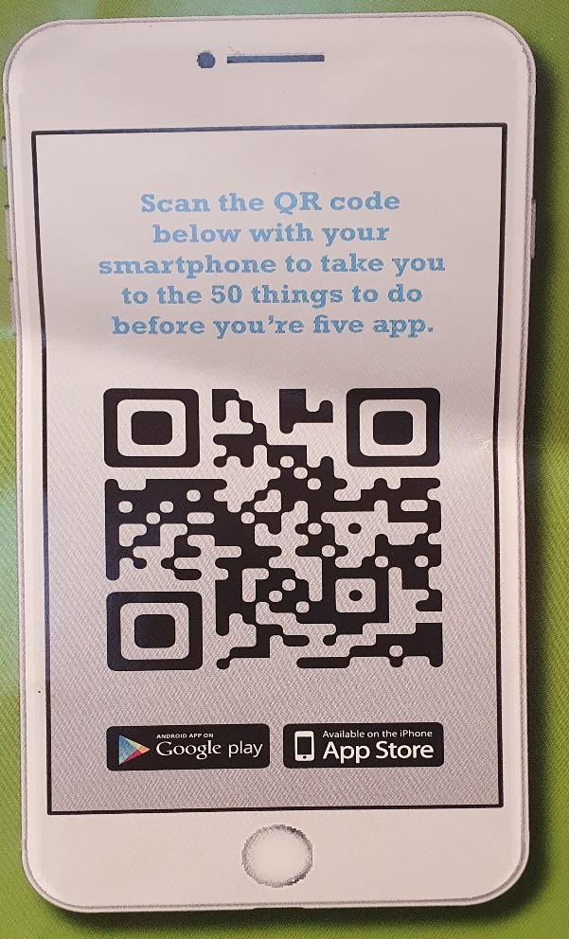  The Reception and Nursery children are going to be participating in ‘50 things to do before you’re five’.  When your child completes a challenge send us a photo to our class email.  reception1@wibsey.bradford.sch.uk  reception2@wibsey.bradford.sch.uk  reception3@wibsey.bradford.sch.uk  Once we have received a photo, your child’s name will go into a prize draw to win some fantastic prizes!  The more tasks your child completes the more chances they have at winning a prize!  This week’s Challenge is:  Challenge #4 Make your mark.  Drawing, painting, patterns or collage are a perfect way to make marks.  Why don’t you try to create a dragon for Chinese New Year?  Be creative- Can you talk about your dragon?  Please remember to send us a photograph.
Tuesday | Practice writing your name.  Practice writing  r, n, m  Remembering to start each letter on the line with a “whoosh”.  Challenge: Can you write a word with the sounds in? | Please watch one of the maths warm up videos for the lesson starter.  Today we are thinking about repeated patterns. Click on the link to play the game  https://www.topmarks.co.uk/ordering-and-sequencing/shape-patterns  Challenge: Can your child draw their own repeated pattern? Can they use more than 2 shapes/colours in the repeat, eg rybryb, rrybrryb? | Using the power point pictures can your child help you to retell the story.  Support your child to construct a simple sentence about the story, e.g. The dog had a bath in the river.  Please remember the sentence doesn’t have to be long but it is really important that your child has a go at sounding the words out. Please refer to the “Parents Guide to Independent Writing” on Google classroom to support your child’s writing.  Challenge: Can you write a sentence with “and” or “because” in?
Wednesday | Practice writing your name.  Practice writing  h, b, f  Remembering to start each letter on the line with a “whoosh”.  Challenge: Can you write a word with the sounds in? | Please watch one of the maths warm up videos for the lesson starter.  Today we are thinking about the length of things. Ask your child to complete the work sheet. Can your child order the caterpillars from the shortest to the longest?  If you do not have a printer just ask your child to draw their own caterpillars.  Challenge: Find a spoon. Can you find 3 objects in your house that are longer than the spoon and 3 objects that are shorter? | Look at the power point about how the Chinese New Year is celebrated. Can your child identify any similarities or differences between special times they celebrate?  Challenge: Can you write a sentence about how the Chinese celebrate the New Year?
Thursday | Practice writing your name.  Practice writing  c, a, d  Remembering to start each letter on the line with a “whoosh”.  Challenge: Can you write a word with the sounds in? | Please watch one of the maths warm up videos for the lesson starter.  Today we are thinking about height.  Height is very different to length as height stands up tall to reach up to the sky, where as length lays on the floor.  Stand up tall and raise your arms in the air. Is your adult shorter or taller than you?  Please ask your adult to make a tower (you can use anything to make the tower as long as the tower stands tall)  Can you make a tower that is taller than their tower?  Can you make a tower that is shorter than their tower?  Challenge: Can your child place the towers in order from the tallest tower to the shortest tower? | Watch the clips on CBeebies about how Chinese New Year is celebrated.  https://www.bbc.co.uk/cbeebies/watch/chinese-new-year  Discuss how the children prepared for the celebrations.  Choose 1 of the activities  1. Using paint or pens can you have a go at some Chinese writing?  2. Can you make a Chinese lantern?  3. Can you pick up things with chopsticks? You can use pencils, or the end of two forks.
Friday | Practice writing your name.  Practice writing  c, o, g  Remembering to start each letter on the line with a “whoosh”.  Challenge: Can you write a word with the sounds in? | Please watch one of the maths warm up videos for the lesson starter.  Please watch the online lesson on positional language.  Focus on the language, on, under, behind, next to, in between and in front.  Challenge: Using a chair and a toy can your child place their toy in the correct place following your instructions. | Watch the YouTube clip of a dragon dance, explaining to the children that this is another way the new year is celebrated. What colours can they see? What are the dragons doing?  https://www.youtube.com/watch?v=25tomfyG7qU  Can you make a dragon with things around the house, make a puppet on sticks or draw a dragon? Don’t forget to show us what you have created by sending us a photo or video.

