Friday 12th February Home Learning  Year 6 | Maths:  1. TTRS/Mathletics 9:00am – 9.30am  Before the start of each lesson get yourself onto times tables rockstars or matheletics and practise some timestables or maths skills.  We have new battles starting this term and to keep things simple the new battle is 6.1 v 6.2 v 6.3.  Let us see who are the year group champions!  2. Warm-up 9:30am - 9:45am  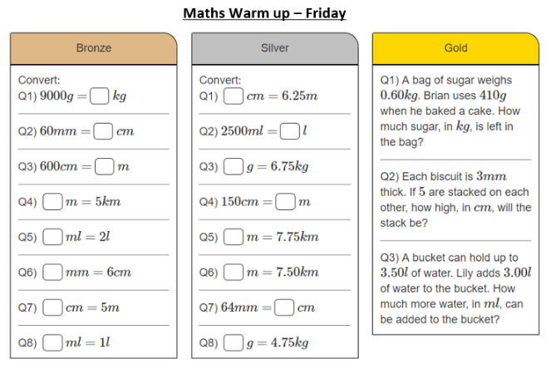  Answer the maths ‘Maths Warm-up’ questions below. A large copy of the questions is attached on Google Classroom.  3. Main Task- Arithmetic test 6 9.45am – 10:30am  Complete Arithmetic Test 6. Remember you can check your work using the answers on the last sheet once you have completed the test. If you want to time yourself 30 minutes and see how much you get right that will be great.  Give yourself a 15 min break now until 10:45am | Reading Get Epic: 10:45am – 11.00am  Log yourself onto Get Epic using the class code and find your page. Hopefully you have either finished your book or near finishing it. Open up the book review and write a book review about the book you have just read or are reading.  Class code: dgs1868  Reading Application: 11:00am – 11.20am  Open the text and have a final read of it. Open in Google Classroom Reading Application task. Read the instructions of each task carefully and answer the questions about the text. Think carefully where you will need to use PEE or APE strategy in your answer.  Writing – Edit and publish: 11:20am - 12:15pm  Open up the Editing Stations to help you edit and revise your work. Think about every question carefully.  Once you are happy with the editing, copy your letter on to paper. Make sure that you include all the changes that you made yesterday. Concentrate on your handwriting and presentation. Take a picture of your final piece of writing and send it to your teacher either via the Year 6 email address or Google Classroom. year6@wibsey.bradford.sch.uk  Give yourself a hour lunch break now until 1:15pm | Science: 1:15pm – 2:15pm  Evaluating and concluding  Open up the PPT and recap the learning from previous lessons.  On Monday you conducted an experiment where you where testing the impact exercise had on your pulse rate.  In today’s lesson you will be analysing your results conducing what you found.  Look at the results slide on the ppt and answer the following questions:  - What do your results show?  - What can you conclude from this data?  - Are there any links?  - How could you improve the accuracy of the test?  - Link back to research about the heart and exercise. What would happen to your pulse rate results if you exercised every day for a week? | WSFL: 2:15pm – 3:15pm  Wellbeing Week  In today’s lesson you will looking at having a positive mind set.  Go through the PPT slides and think about what it means to be positive and the things we can do to stay positive.  Complete these tasks:  Task 1:  Open up the WSFL Helping Heart and write about the things you will do to help yourself and to help others.  Task 2:  Open up spreading the word sheet. Create a poster spreading the word on why it is important to keep a positive mindset and what can people do to ensure they have it.

