Friday 26th February Home Learning  Year 6 | Maths:  1. TTRS/Mathletics 9:00am – 9.30am  Before the start of each lesson get yourself onto times tables rockstars or matheletics and practise some timestables or maths skills.  We have new battles starting this term and to keep things simple the new battle is 6.1 v 6.2 v 6.3.  Let us see who are the year group champions!  2. Warm-up 9:30am - 9:45am  Answer the maths ‘Maths Warm-up’ questions below. A large copy of the questions is attached on Google Classroom.  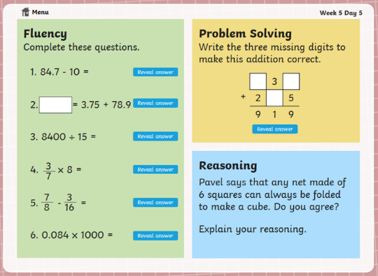  3. Main Task- 9.45am – 10:30am  Make sure you have completed the work from the rest of the week.  Complete arithmetic test 7.  Give yourself a 15 min break now until 10:45am | Reading Get Epic: 10:45am – 11.00am  Log yourself onto Get Epic using the class code and find your page. Hopefully you have either finished your book or near finishing it. Open up the book review and write a book review about the book you have just read or are reading.  Class code: dgs1868  Reading Application: 11:00am – 11.20am  Open the text (The Rush for Gold) and have a final read of it. Open in Google Classroom the Reading Application task. Read the questions carefully and then answer the questions. Think carefully where you will need to use the PEE or APE strategy in your answer. When you have finished you can check your answers by looking in the Application Answers Booklet pages 23-28.  English: 11.20am – 12.15pm  Today you are going to write the introduction for your non-chronological report about Zeus.  Use your planning sheet to remind you about what you need to include.  You can look at the Introduction WAGOLL to help you.  Give yourself an hour lunch break now until 1:15pm | Science: 1:15pm – 2:15pm  Earlier this week, you learnt all about the eye. In today’s lesson, you will learn all about how we see things.  First work through the PowerPoint called ‘I can explain how the eye works’.  Next, go through the PowerPoint called, ‘How we see’.  Task:  Hard  Complete the worksheet- How we see things. Use arrows to represent light on the different pictures. Remember that light travels in straight lines so you will need to use a ruler.  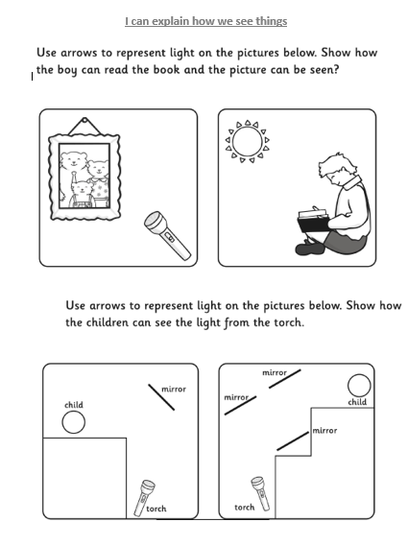  Harder  Explain in your own words how we see things. You could draw your own diagram to support your explanation. | PE: 2:15pm – 3:15pm  Complete the work posted by Miss Clayton.

