Friday 5th  February  Home Learning  Year 6 | Maths:  1. TTRS/Mathletics 9:00am – 9.30am  Before the start of each lesson get yourself onto Times Tables Rockstars or Mathletics and practise some times tables or maths skills.  We have new battles starting this term and to keep things simple the new battle is 6.1 v 6.2 v 6.3.  Let us see who are the year group champions!  2. Maths Starter 9:30am - 9:45am  Answer the maths ‘Maths Starter questions below. A large sheet is attached in Google Classroom. You can check your answers using the separate answer sheet.  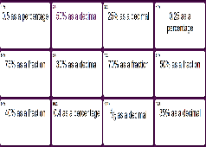  9.45am – 10:30am  3. Main Task- Work through arithmetic test 5. Don’t forget to mark your test using the mark scheme at the end of the paper. Please send your score to your teacher on Google Classroom or via the Year 6 email address.  Give yourself a 15 min break now until 10:45am | Reading:  Complete the Application Questions about California’s Unlikely Warriors.  The Reading Application sheet looks like this and is on 2 pages.  English  Plan a Letter From A Spartan Boy  LO: I can plan my letter appropriately.  BLP: Distilling 2, Planning.  Reread the WAGOLL. Remember this is a letter written by a boy (aged 7) form Sparta to his mum, just after he has arrived at training camp. You can look at Monday’s information sheet too to help you.  You are going to pretend to be a Spartan boy (aged 7) who has just arrived at camp.  Today you are going to plan your letter.  Use the Writing Planning Sheet to help you organise your ideas into paragraphs. Remember this is just a plan and you do not need to write full sentences! | Science and WSFL  Exercise and Healthy Lifestyles  Today you are going to learn about the importance of exercise and evaluate individual’s lifestyles.  1. Read the information on the Importance of Exercise PowerPoint and you can also research information too. Create a fact file about the importance of exercise. Remember to be creative by including diagrams, pictures etc!  2. Complete the Lifestyle Worksheet.  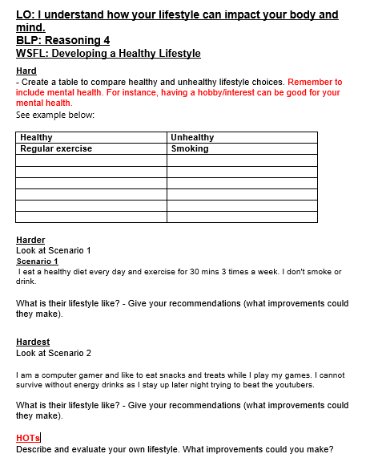 | PE  Complete the work posted by Miss Clayton.

