Monday 22nd  February Home Learning  Year 6 | Maths:  1. TTRS/Mathletics 9:00am – 9.30am  Before the start of each lesson get yourself onto times tables rockstars or matheletics and practise some timestables or maths skills.  We have new battles starting this term and to keep things simple the new battle is 6.1 v 6.2 v 6.3.  Let us see who are the year group champions!  2. Warm-up 9:30am - 9:45am  Answer the maths ‘Maths Warm-up’ questions below. A large copy of the questions is attached on Google Classroom.  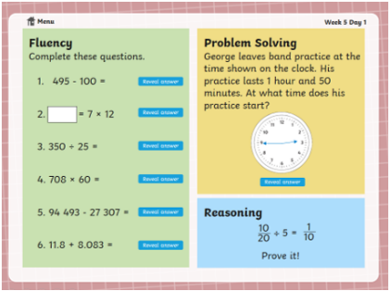  3. Main Task 9.45am – 10:30am  Open up the task sheet called ‘Maths Task Monday’ on Google Classroom and work through the questions. You will not need the videos below for today’s lesson however I would like you to watch them in time for tomorrow and if you do not get time today then do not worry.  Watch a video on perimeter:  https://www.youtube.com/watch?v=AAY1bsazcgM  Watch a video on area:  https://www.youtube.com/watch?v=xCdxURXMdFY  Give yourself a 15 min break now until 10:45am | Reading Get Epic: 10:45am – 11.00am  Log yourself onto Get Epic using the class code and find your page. Hopefully you have started a book or will need to pick a book you will start to read throughout the week. You can read whenever you get a moment through the day and need to aim to have it finished or nearly finished by Friday to write a review about it.  Class code: dgs1868  Reading Prediction: 11:00am – 11.20am  Open in Google Classroom the Prediction Sheet ‘The Rush for Gold’. Look at the illustrations on the sheet and answer the questions. Remember to give reasons for your answers.  English: 11.20am – 12.15pm  1. Complete the GPS Challenge 1 TASK. You can check your work using the answers, which are on the GPS Challenge 1 Answers sheet.  2. View the ‘Using Semi-Colons PowerPoint’. There are 2 slides to look at. Then complete the worksheet about using semi-colons. You can check your work using the Answer sheet provided. | Science: From 1:15pm - 2.15pm  In today’s lesson, you will be learning all about the eye.  First of all, watch the clip below:  https://www.bbc.co.uk/programmes/p0118jbj  After that, work through the PowerPoint called ‘Parts of the eye’.  Tasks:  Hard  Label the parts of the eye on the worksheet saved on Google Classroom.  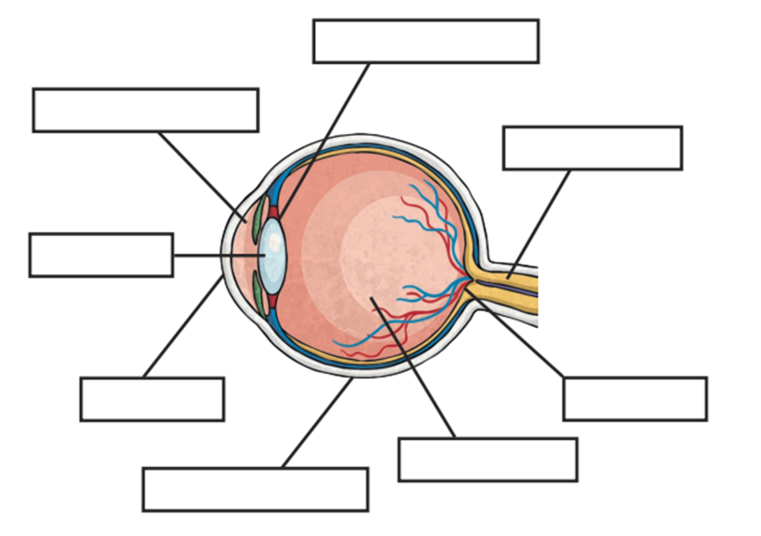  Use the answer sheet to check your work.  Harder  Describe the function of each part using the PowerPoint and information sheet saved on Goggle Classroom to help you. Don’t forget to use subheadings e.g.  The cornea, The iris etc. | Computing: From 2:15pm - 3.15pm  Blog  Last half term, you created your own Blog and completed the first post.  If you still need to do this, please watch the video called computing blog tutorial where you will see step-by-step instructions on what you are required to do.  By the end of today:  - Create your second blog on something of your choice. It could be something that you did in the holidays.  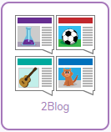  - Include a background cover

