Monday 8th  February Home Learning  Year 6 | Maths:  1. TTRS/Mathletics 9:00am – 9.30am  Before the start of each lesson get yourself onto times tables rockstars or matheletics and practise some timestables or maths skills.  We have new battles starting this term and to keep things simple the new battle is 6.1 v 6.2 v 6.3.  Let us see who are the year group champions!  2. Warm-up 9:30am - 9:45am  Answer the maths ‘Maths Warm-up’ questions below. A large copy of the questions is attached on Google Classroom.  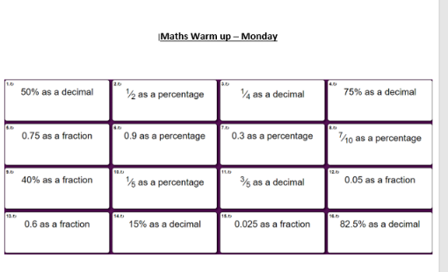  3. Main Task- % of amounts 9.45am – 10:30am  Once you have finished the warm up watch the series of these videos below and then complete the task sheet which can be found on Google Classroom. You may not need to know all the information which will be given in the videos to answer the questions but it is good to know for your knowledge. Also watch the support video posted by one of you teachers on Google Classroom. Pick a few questions to answer.  - https://www.youtube.com/watch?v=2pjaqgmZe84&feature=emb_logo  - https://www.youtube.com/watch?v=rR95Cbcjzus  - https://www.youtube.com/watch?v=9fwh0F24dew  Give yourself a 15 min break now until 10:45am | Reading Get Epic: 10:45am – 11.00am  Log yourself onto Get Epic using the class code and find your page. Hopefully you have started a book or will need to pick a book you will start to read throughout the week. You can read whenever you get a moment through the day and need to aim to have it finished or nearly finished by Friday to write a review about it.  Class code: dgs1868  Reading Prediction: 11:00am – 11.20am  Open in Google Classroom Reading prediction task 1. Read the instructions of each task carefully and answer the questions making predictions about the text.  Writing Intro sentence and P1: 11:20am - 12:15pm  Read over the WAGOLL again and ‘growing up in Sparta’ text, it is saved in Google Classroom.  You are going to write the introduction sentence and paragraph one of your own letter.  Think about the writing features you need to include.  - Punctuation = . , - : ; ‘ ? ! “  - Relative Clause  - Subjunctive  - Formal and Informal Language  - Modal verbs  - Subordinate and coordinate Clause  - Expanded noun phrases  - Parenthesis  - Apostrophes for possessions and contractions  - Passive voice and active voice  - Present perfect tense & Past perfect tense  - Year 5/6 spellings  Give yourself an hour lunch break now until 1:15pm | Science: From 1:15pm - 2.15pm  Heart Rate Investigation  In today’s lesson you will be conducting an investigation to see the effect exercise has on your heart pulse rate and seeing what happens once you rest.  Open up Science Investigation ppt.  Recap learning from last session and open ‘Science Task 1’ sheet and complete the activity thinking about the different types of exercise.  Once you have done this I want you to open up ‘Science Task 2’ sheet and conduct the investigation.  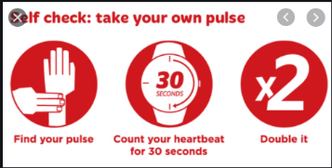  Go through the ppt and complete the table on the sheet. | Computing: From 2:15pm - 3.15pm  Creating a Blog  In today’s session you will be creating your own Blog and writing the first post.  Please watch the video called computing blog tutorial where you will see step-by-step what you are required to do.  By the end of the session you should have:  - Created and set up the Blog  - Include a background cover and icon  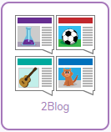  - Ad you first post on it.

