Thursday 11th  February Home Learning  Year 6 | Maths:  1. TTRS/Mathletics 9:00am – 9.30am  Before the start of each lesson get yourself onto times tables rockstars or matheletics and practise some timestables or maths skills.  We have new battles starting this term and to keep things simple the new battle is 6.1 v 6.2 v 6.3.  Let us see who are the year group champions!  2. Warm-up 9:30am - 9:45am  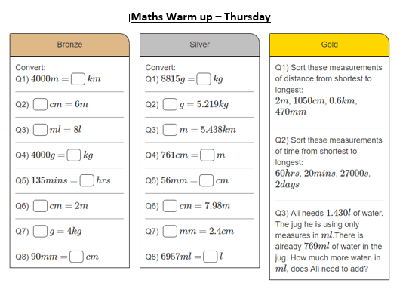  Answer the maths ‘Maths Warm-up’ questions below. A large copy of the questions is attached on Google Classroom.  Complete Maths starter 2 also.  3. Main Task- Miles and Kilometres 9.45am – 10:30am  Once you have finished the warm up open the task sheet and have a go at questions. The Tasks get harder but do progress so give each a go and see how far you get. Watch the video posted by your teacher to help you. Pick a few question to answer.  Click on the link below and watch the following videos:  https://www.youtube.com/watch?v=fCPBHPIk78M  https://www.youtube.com/watch?v=8yu-TGw3ZBU  Give yourself a 15 min break now until 10:45am | Reading Get Epic: 10:45am – 11.00am  Log yourself onto Get Epic using the class code and find your page. Continue reading your chosen book trying to get to end. You can read whenever you get a moment through the day and need to aim to have it finished or nearly finished by Friday to write a review about it.  Class code: dgs1868  Reading Inference: 11:00am – 11.20am  Re-read over the text again carefully. Open in Google Classroom Reading Step 4 task. Read the instructions of each task carefully and answer the inference questions.  Writing p4 and closing sentence: 11:20am - 12:15am  Read over the WAGOLL again and ‘growing up in Sparta’ text, it is saved in Google Classroom.  You are going to finish of writing the final paragraph and closing sentence of your letter.  Watch the video posted by Mrs Choudhery talking you through what you will need to write and doing a shared example. Open the ppt ‘Shared Write Example’ and you will have shared write example in front of you to refer too.  Think about the writing features you need to include.  - Punctuation = . , - : ; ‘ ? ! “  - Relative Clause  - Subjunctive  - Formal and Informal Language  - Modal verbs  - Subordinate and coordinate Clause  - Expanded noun phrases  - Parenthesis  - Apostrophes for possessions and contractions  - Passive voice and active voice  - Present perfect tense & Past perfect tense  - Year 5/6 spellings  Give yourself a hour lunch break now until 1:15pm | RE:  1:15pm – 2:15pm  Justice – Fair and Reasonable  Read through the PPT and understand what the difference is between being Fair and what it means to be Reasonable.  On the ppt there is the story of King Solomon and how he made a judgement. Then open the story version on Google Class of King Solomon and The Holy Cakes story and have a read of them both carefully.  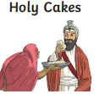  Think how what is fair and what is reasonable in both stories. Open up the RE task sheet and answer the questions for both stories comparing them both.  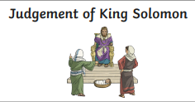 | DT:  1:15pm – 2:15pm  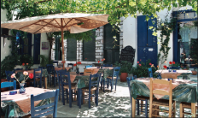  Creating a menu  You should be in the middle of designing your Greek Restaurant. This week you will be thinking a bit more into the menu you will be providing at the restaurant.  Your task is to design a 3 course menu which includes starters, main, sides, desserts and beverages. Use any tool on your device or then do it on a piece of paper and send through the year 6 email or Google Classroom.  As a fun activity for you to do with your family. Research and find a simple Greek recipe you would like to include at your restaurant. Follow the recipe and make the food. Do not forget to take and send in pictures.  Use the recipes in the folder to help and ideas.

