Thursday 25th  February Home Learning  Year 6 | Maths:  1. TTRS/Mathletics 9:00am – 9.30am  Before the start of each lesson get yourself onto times tables rockstars or matheletics and practise some timestables or maths skills.  We have new battles starting this term and to keep things simple the new battle is 6.1 v 6.2 v 6.3.  Let us see who are the year group champions!  2. Warm-up 9:30am - 9:45am  Answer the maths ‘Maths Warm-up’ questions below. A large copy of the questions is attached on Google Classroom.  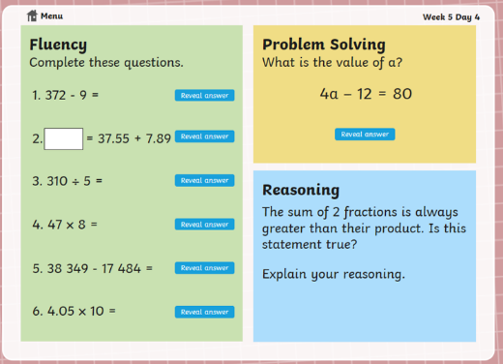  3. Main Task 9.45am – 10:30am  Open up the task sheet called ‘Maths Task Thursday’ on Google Classroom and work through the questions. Watch the both videos below on area and perimeter which help you with the work for today’s lesson.  Watch a video on perimeter:  https://www.youtube.com/watch?v=AAY1bsazcgM  Watch a video on area:  https://www.youtube.com/watch?v=xCdxURXMdFY  Give yourself a 15 min break now until 10:45am | Reading Get Epic: 10:45am – 11.00am  Log yourself onto Get Epic using the class code and find your page. Continue reading your chosen book trying to get to end. You can read whenever you get a moment through the day and need to aim to have it finished or nearly finished by Friday to write a review about it.  Class code: dgs1868  Reading Inference: 11:00am – 11.20am  Re-read the text (The Rush for Gold) again carefully. Open in Google Classroom Reading Step 4 task and answer the inference questions.  English: 11.20am – 12.15  This week and next you are going to create a non-chronological report about the Greek God Zeus.  Today you are going to plan your report.  Look at the Zeus Research Sheet, which is attached in Google Classroom. You can do your own research about Zeus too. Take information from the Research sheet and add it to the Zeus Planning Sheet to help you plan and structure your report. Remember you do not need to write full sentences – it just needs to be notes.  Give yourself an hour lunch break now until 1:15pm | RE:  1:15pm – 2:15pm  Today, you are going to learn all about human rights.  First work through the Human Rights Lesson Presentation PowerPoint and watch the ‘Everybody- we are all born free’ video clip.  After that, you need to organise the different articles from the Human Rights Poster onto the Human Rights Sorting Worksheet. Only record the article numbers on the Venn diagram.  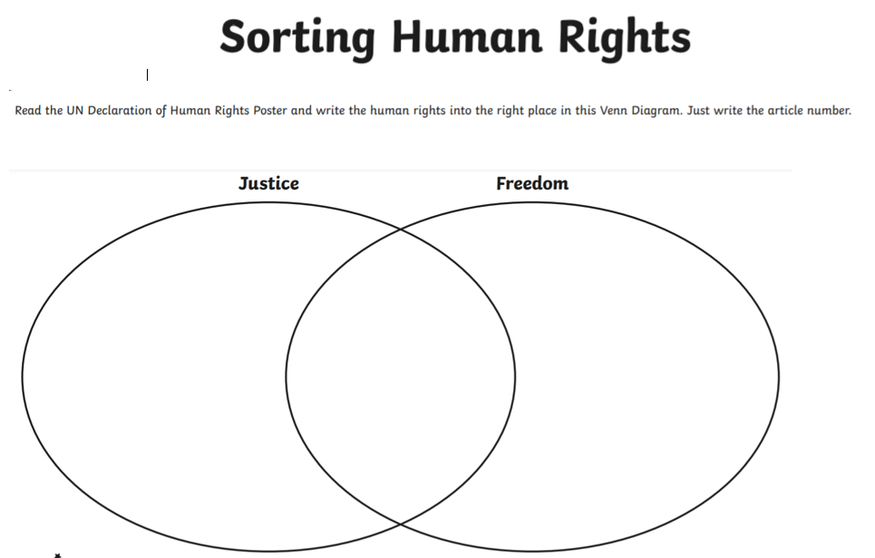  Once you have finished, use the answer sheet to mark your work. | DT:  1:15pm – 2:15pm  Today, you are going to learn all about what a sculpture is and design your own Greek Bust.  First work through the DT PowerPoint. Everything you need is on the PowerPoint.  When everyone returns to school, we will create Greek busts of a Greek God or Goddess. You need to decide which Greek God or Goddess you will make a bust of.  Once you have decided, design your Greek Bust. Draw and colour your Greek bust. Remember that it is only the Greek God’s or Goddess’ head and neck! Annotate any items you would like to stand out e.g. headdress, earrings etc.  Then create a list of the materials you will need.  If you would like to watch a sculpture in action, take a look here: https://www.youtube.com/watch?v=6dnyYu4Ff7U  Remember to take a picture of your design and send it to the Year 6 email address: year6@wibsey.bradford.sch.uk 