Thursday 4th  February  Home Learning  Year 6 | Maths:  1. TTRS/Mathletics 9:00am – 9.30am  Before the start of each lesson get yourself onto Times Tables Rockstars or Mathletics and practise some times tables or maths skills.  We have new battles starting this term and to keep things simple the new battle is 6.1 v 6.2 v 6.3.  Let us see who are the year group champions!  2. Warm-up 9:30am - 9:45am  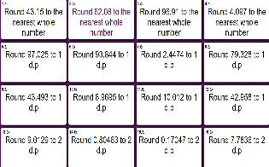  Answer the maths ‘Maths Starter’ questions below about Rounding Decimals. A large copy of the questions is attached on Google Classroom. You can check your work using the separate answer sheet.  Remember 1dp means 1 decimal place so you round to the tenth’s column. 2 dp means 2 decimal places so you round to the hundredth’s column. When you round to the nearest whole number you round to the ones column.  9.45am – 10:30am  3. Main Task- Recall Equivalences between fractions, decimals and percentages.  VIEW THE VIDEO POSTED BY MRS SCOTT  Please read the information Sheet Called Equivalences Information Sheet to help you and view the PowerPoint.  Complete the worksheet called ‘FDP Equivalences Worksheet.’  Extension: You can now complete the Extension sheet called FDP Equivalences Extension, if you wish. There aren’t very many questions. However, please do complete it if you are in Mrs Scott’s maths set.  Now give yourself a break until 10:45am. | English:  Reading: 10:45am – 11.15am  Reread the text ‘California’s Unlikely Warriors’ answer the following questions:  1. Look at the 2nd paragraph on Page 9 beginning ‘When the unlikely warriors..’. How does the writer emphasise the success of the ladybirds? Explain fully, referring to the text in your answer (at least 3 different points with explanation/quotes).  2. Do you think this author in favour of using natural methods to control pests or artificial ones? Explain your answer fully, referring to the text to support your ideas.  English: 11:15am - 12:15pm  Revise Verb Tenses by looking at the PowerPoint Verb Tenses.  Now complete the Verb Tenses Worksheet. | Geography: From 1:15pm - 2.15pm  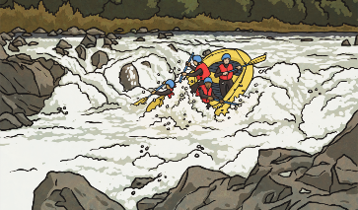  River Users  View the PowerPoint called River Users.  Then complete the River Users Worksheet, which is attached in Google Classroom.  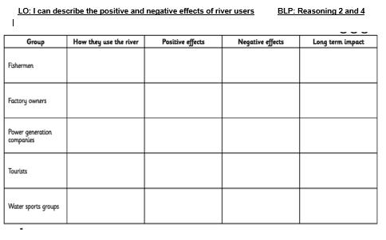 | RE: From 2:15pm - 3.15pm  Freedom  Task 1  Think about what ‘Freedom’ means to you and how it makes you feel. Record some sentences on a Google doc. You can add pictures too.  Look at the definition of freedom on the Powerpoint. Is it the same or different from what you recorded? Explain how.  Task 2  Read the story about Moses on the PowerPoint and summarise it.  Task 3  Research what Freedom for people of different religions means. Use the PowerPoint to help you.

