Tuesday 23rd  February Home Learning  Year 6 | Maths:  1. TTRS/Mathletics 9:00am – 9.30am  Before the start of each lesson get yourself onto times tables rockstars or matheletics and practise some timestables or maths skills.  We have new battles starting this term and to keep things simple the new battle is 6.1 v 6.2 v 6.3.  Let us see who are the year group champions!  2. Warm-up 9:30am - 9:45am  Answer the maths ‘Maths Warm-up’ questions below. A large copy of the questions is attached on Google Classroom.  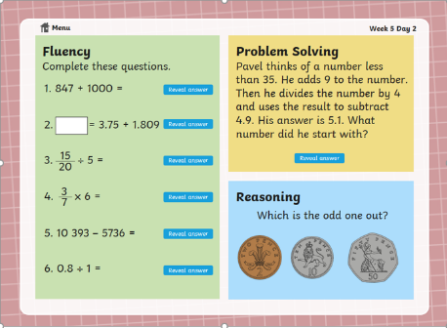  3. Main Task 9.45am – 10:30am  Open up the task sheet called ‘Maths Task Tuesday’ on Google Classroom and work through the questions. Watch the first video below on perimeter as that is the only one you will need to today’s lesson.  Watch a video on perimeter:  https://www.youtube.com/watch?v=AAY1bsazcgM  Watch a video on area:  https://www.youtube.com/watch?v=xCdxURXMdFY  Give yourself a 15 min break now until 10:45am | Reading Get Epic: 10:45am – 11.00am  Log yourself onto Get Epic using the class code and find your page. Hopefully you have started a book or will need to pick a book you will start to read throughout the week. You can read whenever you get a moment through the day and need to aim to have it finished or nearly finished by Friday to write a review about it.  Class code: dgs1868  Reading Orientation: 11:00am – 11.20am  Read the text ‘The Rush for Gold’ – which is attached in Google Classroom.  Answer the Orientation Questions, which are attached in Google Classroom.  English: 11.20am – 12.15pm  1. Complete the GPS Challenge 2 TASK. You can check your work using the answers, which are on the GPS Challenge 2 Answers sheet.  2. Look at the Worksheet called Present Perfect Worksheet. Read the information at the top of the worksheet then complete: Hard, Harder and Hardest.  You can check your answers for: Hard and Harder using the answer sheet attached.  Give yourself an hour lunch break now until 1:15pm | PPA Session: 1:15pm – 3.15pm  See the work posted by Mrs White, Mrs Walker and Mrs Clayton.

