Tuesday 9th  February Home Learning  Year 6 | Maths:  1. TTRS/Mathletics 9:00am – 9.30am  Before the start of each lesson get yourself onto times tables rockstars or matheletics and practise some timestables or maths skills.  We have new battles starting this term and to keep things simple the new battle is 6.1 v 6.2 v 6.3.  Let us see who are the year group champions!  2. Warm-up 9:30am - 9:45am  Answer the maths ‘Maths Warm-up’ questions below. A large copy of the questions is attached on Google Classroom.  Complete Maths starter 2 also.  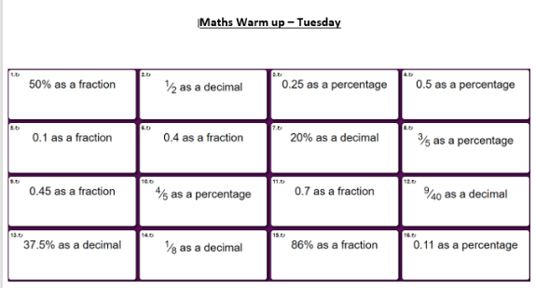  3. Main Task- ½ and % 9.45am – 10:30am  Once you have finished the warm up task open todays task sheet and have a go at the questions as many as you can. The Tasks get harder but do progress so give each a go and see how far you get. Pick a few questions to answer.  Click on the link below and watch the following videos:  https://whiterosemaths.com/homelearning/year-6/week-12-number-fractions/  - Fractions of an amount  - Fractions of an amount - find the whole  These should help you understand and answer some of the questions.  Give yourself a 15 min break now until 10:45am | Reading Get Epic: 10:45am – 11.00am  Log yourself onto Get Epic using the class code and find your page. Hopefully you have started a book or will need to pick a book you will start to read throughout the week. You can read whenever you get a moment through the day and need to aim to have it finished or nearly finished by Friday to write a review about it.  Class code: dgs1868  Reading Orientation: 11:00am – 11.20am  Attached in the assignment you will find the reading text called ‘Reading Orientation Task 2’. Then open in Google Classroom Reading task step 2 and answer the orientation questions.  Writing paragraph 2: 11:20am - 12:15pm  Read over the WAGOLL again and ‘growing up in Sparta’ text, it is saved in Google Classroom.  Today you are going to write paragraph 2 of your own letter.  Think about the writing features you need to include.  - Punctuation = . , - : ; ‘ ? ! “  - Relative Clause  - Subjunctive  - Formal and Informal Language  - Modal verbs  - Subordinate and coordinate Clause  - Expanded noun phrases  - Parenthesis  - Apostrophes for possessions and contractions  - Passive voice and active voice  - Present perfect tense & Past perfect tense  - Year 5/6 spellings  Give yourself a hour lunch break now until 1:15pm | PPA Session: 1:15pm – 3.15pm  See the work posted by Mrs White, Mrs Walker and Mrs Clayton.

