Wednesday 24th February Home Learning  Year 6 | Maths:  1. TTRS/Mathletics 9:00am – 9.30am  Before the start of each lesson get yourself onto times tables rockstars or matheletics and practise some timestables or maths skills.  We have new battles starting this term and to keep things simple the new battle is 6.1 v 6.2 v 6.3.  Let us see who are the year group champions!  2. Warm-up 9:30am - 9:45am  Answer the maths ‘Maths Warm-up’ questions below. A large copy of the questions is attached on Google Classroom.  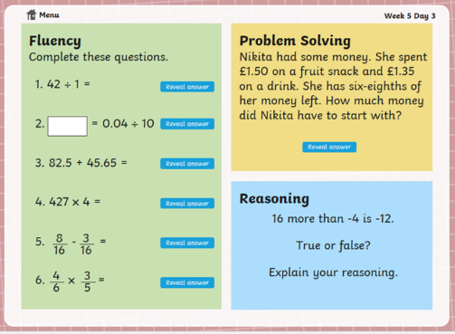  3. Main Task 9.45am – 10:30am  Open up the task sheet called ‘Maths Task Wednesday’ on Google Classroom and work through the questions. Watch the second video below on area as that is the only one you will need to today’s lesson.  Watch a video on perimeter:  https://www.youtube.com/watch?v=AAY1bsazcgM  Watch a video on area:  https://www.youtube.com/watch?v=xCdxURXMdFY  Give yourself a 15 min break now until 10:45am | Reading Get Epic: 10:45am – 11.00am  Log yourself onto Get Epic using the class code and find your page. You should be at least half way or near halfway. You can read whenever you get a moment through the day and need to aim to have it finished or nearly finished by Friday to write a review about it.  Class code: dgs1868  Reading Vocabulary: 11:00am – 11.20am  Read the text (The Rush for Gold) again and today will be focusing on looking into the meaning of some particular words and phrases. Open in Google Classroom the Reading Vocabulary task 3 and answer the questions.  English : 11.20am – 12.15pm  1. Complete the GPS Challenge 3 TASK. You can check your work using the answers, which are on the GPS Challenge 3 Answers sheet.  2. Look at the Worksheet called Past Perfect Worksheet. PLEASE BE AWARE THIS WORKSHEET LOOKS VERY SIMILAR TO YESTERDAY’S BUT IT IS DIFFERENT. Read the information at the top of the worksheet then complete: Hard, Harder and Hardest.  You can check your answers for: Hard and Harder using the answer sheet attached.  Give yourself an hour lunch break now until 1:15pm | Geography: 1:15pm – 2.15pm  Today you will be looking at the UK’s trade links with other countries.  First, watch the video and read the information about Trade on this website: https://www.bbc.co.uk/bitesize/topics/zx72pv4/articles/zk4rmfr  Next, play the Trade game to test your knowledge of trade.  After that, Complete the ‘Import and Export Geography worksheet’.  Put a tick in the correct columns to show which items you think are exported, imported or both exported and imported. Then answer the questions under the table. Once you have finished, check your answers with the answer sheet- how did you do?  Finally, open Geography worksheet 2. Use the data in the table to create 2 bar charts- one for UK imports and the other for UK exports. Your bar charts will show how much the UK earns from exporting items and importing items. Look at the example on the sheet so that you know how to set out your bar charts. Check the answer sheet if you get stuck and need extra support.  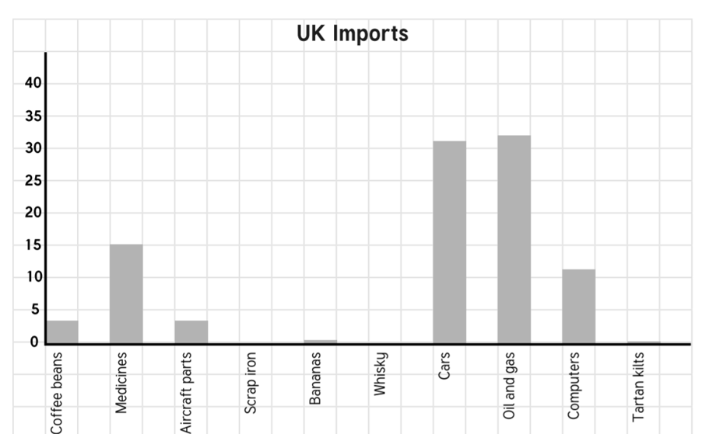 | BLP:  2:15pm – 3.15pm  This half term we are focusing on the Capitalising and Noticing muscles.  Take a look at the BLP PowerPoint and then answer the questions about the two muscles on the worksheet. Use the PowerPoint to help you identify your own targets.  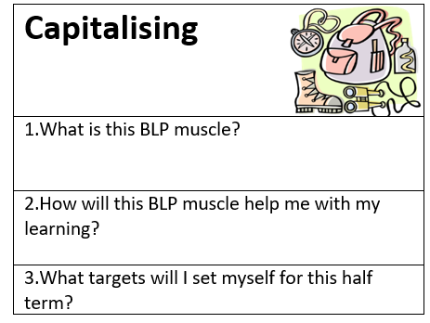  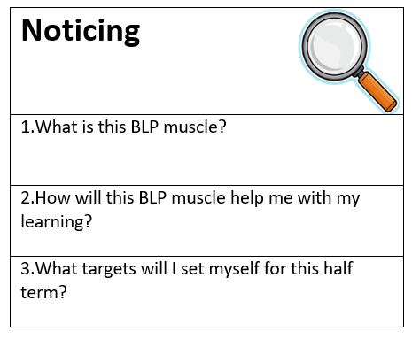  Remember that everything you need to answer the questions is on the PowerPoint.

