**Maths – 1.3.21**

**TTRS: Soundcheck**



**My Mini Maths: Complete the following questions**

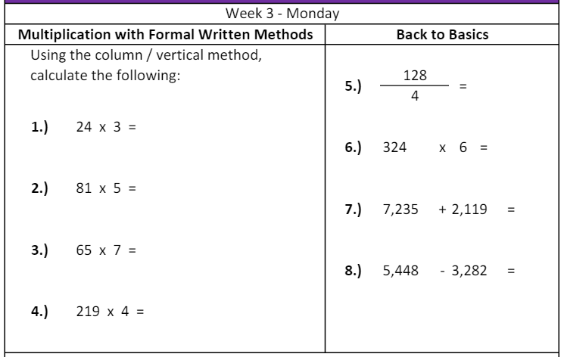

I can read analogue and digital clocks.

|  |  |  |  |  |  |  |  |  |  |
| --- | --- | --- | --- | --- | --- | --- | --- | --- | --- |
| I can read analogue and digital clocks to the nearest quarter.  Look at the following clocks and write the times underneath.   |  |  |  | | --- | --- | --- | | ____________________________ | ____________________________ | ____________________________ | | ____________________________ | ____________________________ | ____________________________ | | ____________________________ | ____________________________ | ____________________________ | |
| I can read analogue and digital clocks to the nearest 5 minutes  Look at the following clocks and write the times underneath.    _____________________ _____________________ _____________________ _____________________ e f g h    _____________________ _____________________ _____________________ _____________________ |
| I can read analogue and digital clocks to the nearest minute.   |  |  |  | | --- | --- | --- | | _____________________ | _____________________ | _____________________ | | _____________________ | _____________________ | _____________________ | | _____________________ | _____________________ | _____________________ | |

Reasoning.

**Which hand do you think is the most important hand on an analogue clock?**

|  |  |
| --- | --- |
| **minute** | **hour** |

**Explain your answer and prove it**.

English – Monday 1st March 2021

**I can use the comma to separate items in a list.**

Read the sentence about the fruit and notice that it has too many ‘and’s.

**The fruit bowl has oranges and bananas and pears and kiwis and apples in it.**

Remove the ‘and’s.

**The fruit bowl has oranges ~~and~~ bananas ~~and~~ pears ~~and~~ kiwis ~~and~~ apples in it.**

New sentence:

**The fruit bowl has oranges bananas pears kiwis apples in it.**

We need one ‘and’ in the sentence. Put it in the correct place

**The fruit bowl has oranges bananas pears kiwis and apples in it.**

We have now improved our sentence by only using one ‘and’. Now we need to separate the other items in our list to avoid confusion. This is where commas come in handy!

**The fruit bowl has oranges, bananas, pears, kiwis and apples in it.**

A comma is put between each item in the list, but the last two items always have ‘and’ between them and no comma.

THINGS TO AVOID:

* **Don’t** put a comma before the first item in your list:

**The party was, fun, loud and exciting.**

* **Don’t** put a comma in a list of just two items:

**For tea we are having tea, and toast.**

**Task:** Rewrite the sentences using commas to separate the items and one ‘and’ between the two final items.

|  |
| --- |
| Mrs Bilevych thought the beef and the stir fry and the vegetables looked delicious. |
|  |
| Mr Hudson and Mrs Knowles and Mr Cooper went swimming. |
|  |
| His bag was full of clothes and food and books. |
|  |
| We will watch the javelin and the hockey and the horse riding tomorrow. |
|  |
| On safari we saw lions and tigers and giraffes and a snake. |
|  |
| I made the card using brown paper and glitter and glue. |
|  |

**CHALLENGE:** Create your own sentences where you need to use commas to separate items in a list and an ‘and’.

**The Magic Box**

I will put in the box

the swish of a silk sari on a summer night,  
fire from the nostrils of a Chinese dragon,  
the tip of a tongue touching a tooth.

I will put in the box

a snowman with a rumbling belly  
a sip of the bluest water from Lake Lucerene,  
a leaping spark from an electric fish.

I will put into the box

three violet wishes spoken in Gujarati,  
the last joke of an ancient uncle,  
and the first smile of a baby.

I will put into the box

a fifth season and a black sun,  
a cowboy on a broomstick  
and a witch on a white horse.

My box is fashioned from ice and gold and steel,   
with stars on the lid and secrets in the corners.  
Its hinges are the toe joints of dinosaurs.

I shall surf in my box   
on the great high-rolling breakers of the wild Atlantic,  
then wash ashore on a yellow beach   
the colour of the sun. **by Kit Wright**

**Reading Orientation**

Read the text and answer the questions.

**Orientation questions.**

1. What type of text is this?
2. What is the repeated phrase used in the text?
3. Make a list of 3 alliterative phrases used in the text.

**Reasoning questions – use because to explain your reasons.**

Watch the video link below:

<https://www.bbc.co.uk/bitesize/clips/zkpmhyc>

1. Do you enjoy the text?

Provided is the link to remind yourselves about the text that we read last week:

<https://www.bbc.co.uk/bitesize/clips/zp9b4wx>

Compare ‘The Magic box’ by Kit Wright to ‘Chocolate Cake’ by Michael Rosen.

1. How are the texts similar?
2. How are the texts different?
3. Which do you prefer?

**Challenge**: Be inspired by Kit Wright! Use different actions and facial expressions to perform ‘The Magic Box’. Send videos of your performances to the year 4 email address.

RE – Monday 1st March 2021

LO: To know about special places, days, objects and rituals of different faith communities.

Watch the following videos:

<https://www.bbc.co.uk/bitesize/topics/znk647h/articles/zmqpkmn>

<https://www.bbc.co.uk/bitesize/topics/ztkxpv4/articles/zvfnkmn>

<https://www.bbc.co.uk/bitesize/topics/zpdtsbk/articles/zrxxgwx>

<https://www.bbc.co.uk/bitesize/topics/zsjpyrd/articles/zkjpkmn>

<https://www.bbc.co.uk/bitesize/topics/zh86n39/articles/zmpp92p>

Hard

Complete the table below looking at the religions you have just looked at.

|  |  |  |  |  |
| --- | --- | --- | --- | --- |
| Religion | Special places | Special days | Special objects | Special rituals |
| Humanism |  |  |  |  |
| Christianity |  |  |  |  |
| Islam |  |  |  |  |
| Sikhism |  |  |  |  |
| Hinduism |  |  |  |  |

Harder: Are there any similarities between the religions?

WAGOLL: Islam and Hinduism are similar because they both……

Hardest: What have you learnt today that you would like to learn more about? Why?

**Maths – 2.3.21**

**TTRS: Soundcheck**



**My Mini Maths: Complete the following questions**

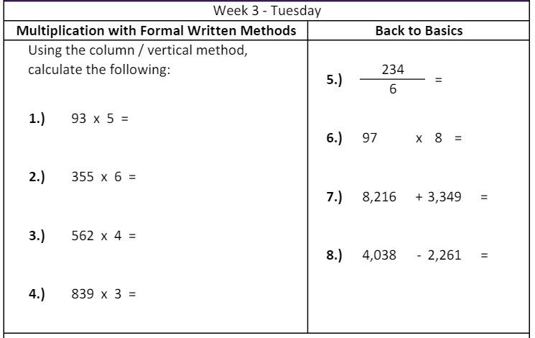

I can convert analogue and digital clocks.

|  |  |  |  |  |  |  |  |  |  |  |
| --- | --- | --- | --- | --- | --- | --- | --- | --- | --- | --- |
| I can convert analogue and digital clocks to the nearest quarter.  Match the correct analogue clock to the correct digital clock.  Answers:  1 is a match with _______.  2 matches with ________.  3 matches with ________.  4 matches with ________.  5 matches with ________.   |  |  | | --- | --- | | 1 | A | | 2 | B | | 3 | C | | 4 | D | | 5 | E | |
| I can convert analogue and digital clocks to the nearest 5 minutes  Match the correct analogue clock to the correct digital clock.  Answers:  1 is a match with _______.  2 matches with ________.  3 matches with ________.  4 matches with ________.  5 matches with ________.   |  |  | | --- | --- | | 1 | A | | 2 | B | | 3 | C | | 4 | D | | 5 | E | |
| I can convert analogue and digital clocks to the nearest minute.  Match the correct analogue clock to the correct digital clock.  Answers:  1 is a match with _______.  2 matches with ________.  3 matches with ________.  4 matches with ________.  5 matches with ________.   |  |  | | --- | --- | | 1 | A | | 2 | B | | 3 | C | | 4 | D | | 5 | E | |

Reasoning.

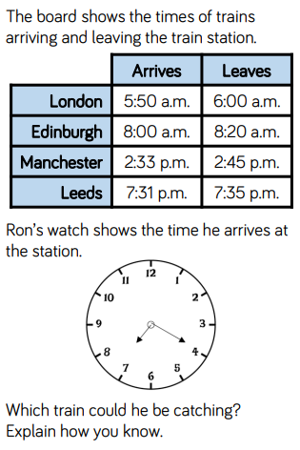

English – Tuesday 2nd March 2021

**I can use the comma to separate actions.**

Tick the correct sentence.

|  |  |
| --- | --- |
| Mrs Bilevych ate some cake and watched a movie and did the tidying up. |  |
| Mrs Bilevych ate some cake and watched a movie, did the tidying up. |  |
| Mrs Bilevych ate some cake, watched a movie and did the tidying up. |  |

|  |  |
| --- | --- |
| Miss Knowles did some decorating, planted some vegetables and went to the shops. |  |
| Miss Knowles did some decorating and planted some vegetables and went to the shops. |  |
| Miss Knowles, did some decorating planted some vegetables and went to the shops. |  |

|  |  |
| --- | --- |
| Mr Hudson played bingo and went to the park and painted a picture. |  |
| Mr Hudson played, bingo and went, to the park and painted, a picture. |  |
| Mr Hudson played bingo, went to the park and painted a picture. |  |

Look at bank of actions. Choose 3 to write a sentence and show that you can use a comma and an ‘and’ to separate the actions. You can write about anyone you like! **A minimum of 5 sentences please.**

|  |  |  |  |
| --- | --- | --- | --- |
| watched | cooked | danced | cut |
| made | went | sang | washed |
| tidied | played | jumped | bought |

My sentences:

**Reading Vocabulary**

Re-read the Magic Box by Kit Wright and highlight/underline the words listed below.

|  |  |  |
| --- | --- | --- |
| Gujarati | ancient | fashioned |
| hinges | surf | breakers |

Use word hippo to explore the definitions of the words.

<https://www.wordhippo.com/>



For each word, write the meaning and put it into a sentence. Either complete on Google docs or on paper. Please submit any photo evidence to: [Year4@wibsey.bradford.sch.uk](mailto:Year4@wibsey.bradford.sch.uk)

Use word hippo to explore any other words that you are unfamiliar with.

**Maths – 3.3.21**

**TTRS: Soundcheck**



**My Mini Maths: Complete the following questions**

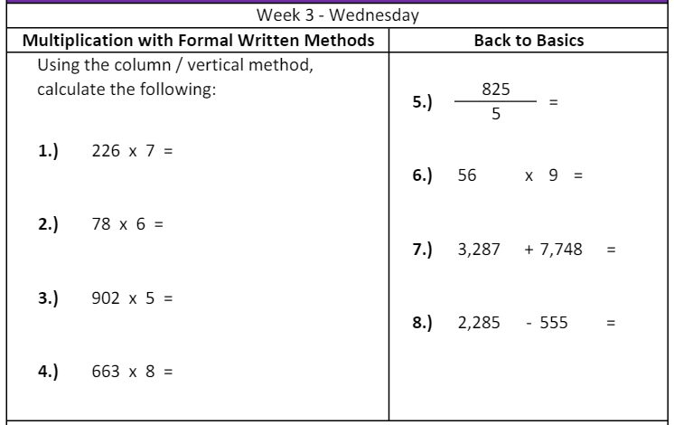

I can convert times from the 12-hour clock to the 24-hour clock.

|  |  |  |  |  |  |  |  |  |  |  |  |  |  |  |  |  |  |  |
| --- | --- | --- | --- | --- | --- | --- | --- | --- | --- | --- | --- | --- | --- | --- | --- | --- | --- | --- |
| I can convert times to the 24-hour clock to the nearest quarter  Convert the following times into the 24-hour clock.   |  |  | | --- | --- | | **12 hour** | **24 hour** | | 3:15am | 03:15 | | 9:15am |  | | 8:40am |  | | 12:30am |  | | 1.15pm |  | | 4.45pm |  | | 10.30pm |  | | 12:15pm |  |   Convert the time on these clocks into 24-hour clock times  am pm am   1. b) c)   pm am pm  d) e) f) |
| I can convert times to the 24-hour clock to the nearest 5 minutes  Convert the following times into the 24-hour clock.   |  |  | | --- | --- | | **12 hour** | **24 hour** | | 3:25am | 03:25 | | 7:15am |  | | 8:05am |  | | 12:20am |  | | 1.10pm |  | | 4.50pm |  | | 10.45pm |  | | 12:55pm |  |   Convert the time on these clocks into 24 hour clock times     1. b) c)     d) e) f) |
| I can convert times to the 24-hour clock to the nearest minute.  Convert these am and pm times into the 24- hour clock.   |  |  |  | | --- | --- | --- | | 1. 1:24pm = | 1. 2:56am = | 1. 7:45pm = | | 1. 5:16am = | 1. 3:56pm = | 1. 12:25pm = | | 1. 11:27pm = | 1. 8:13pm = | 1. 12:42am = |   Convert the time on these clocks into 24-hour clock times     1. b) c)     d) e) f) |

Reasoning.

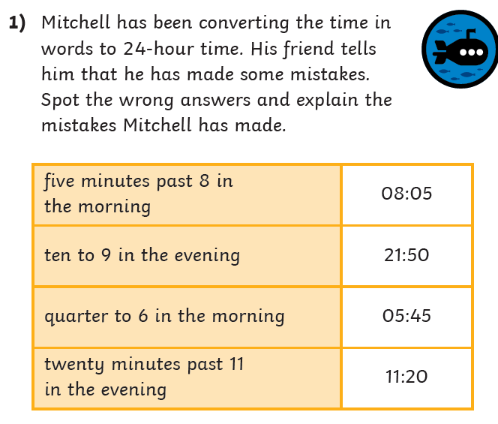

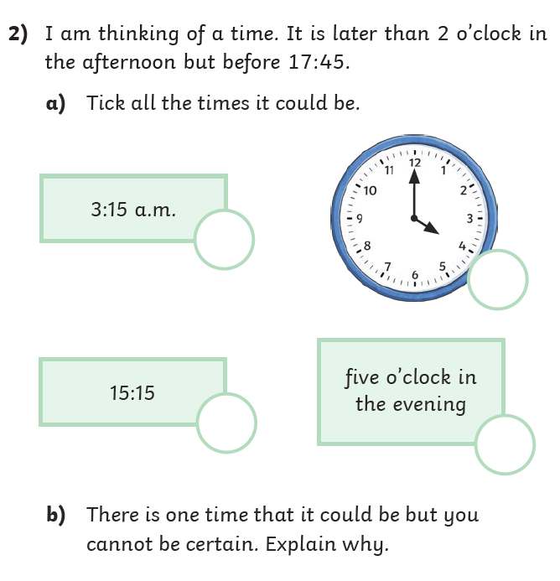

Science – Wednesday 3rd March 2021

I know why different animals have different teeth.

BLP – Reasoning

Read the following slides:

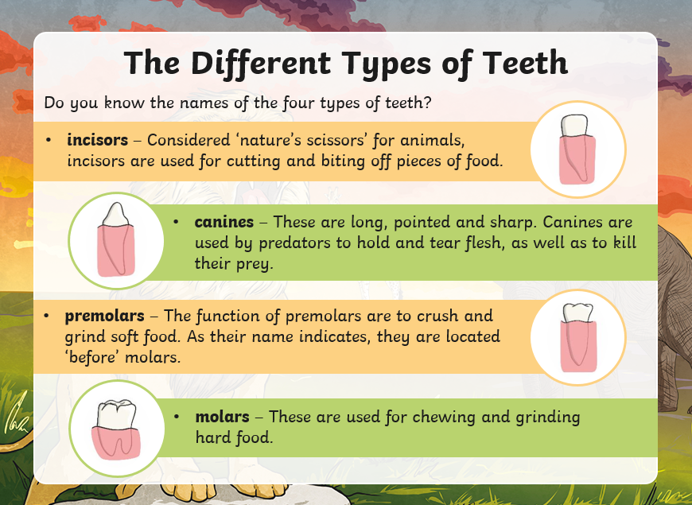

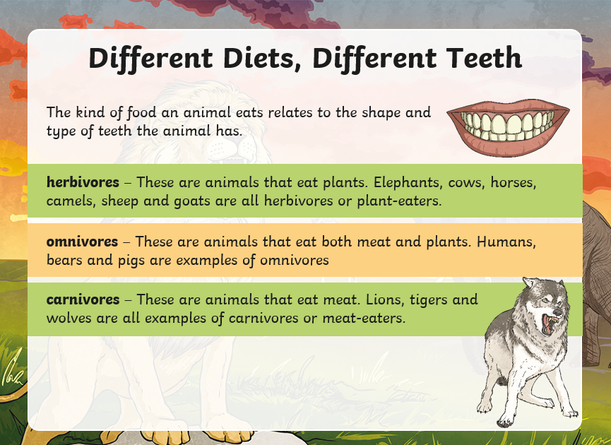

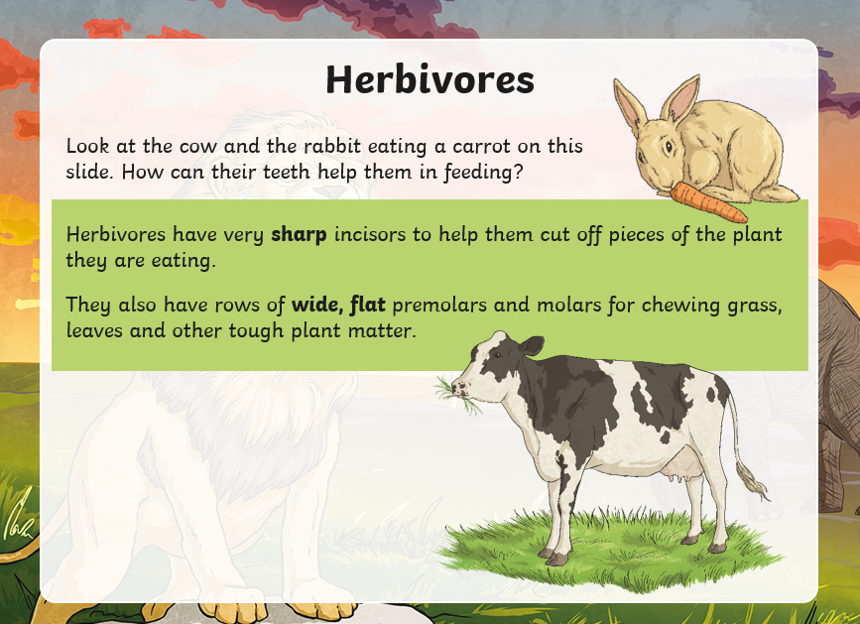

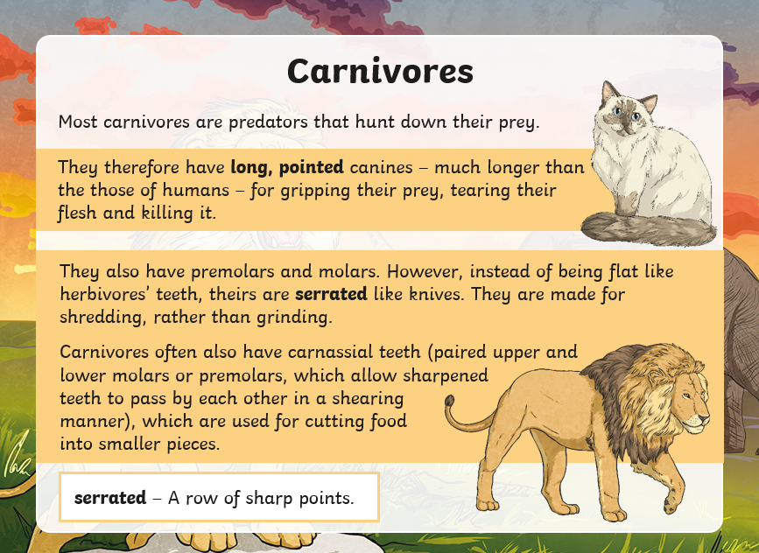

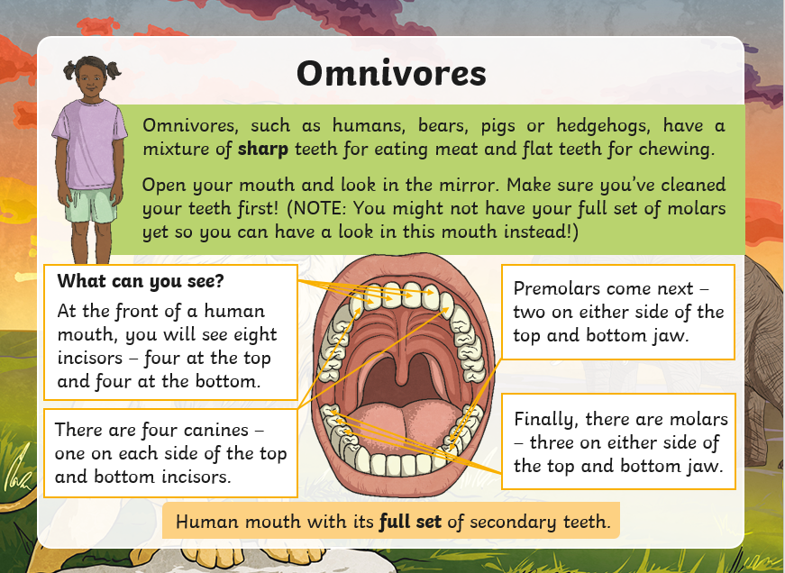

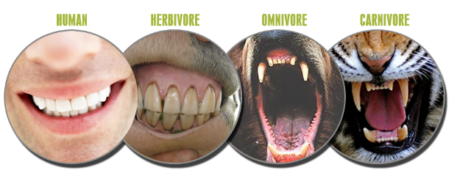Hard: Complete the table below using the

information you have just read about. Think about different animals, what teeth they have and what classification group they belong to.

|  |  |  |
| --- | --- | --- |
| Animal | What different teeth does it have? | Is it an omnivore, carnivore or a herbivore? |
|  |  |  |
|  |  |  |
|  |  |  |
|  |  |  |
|  |  |  |
|  |  |  |
|  |  |  |

Harder – Using what you know about different teeth, answer the questions.



Why does an omnivore need flat pre-molars and molars?

Why does a carnivore need their long, pointed canines?

Why do herbivores need sharp teeth if they don’t eat meat?

Hardest – Use what you know to compare the teeth of a herbivore and a carnivore.

1a. What is the difference between a herbivore and a carnivore’s teeth?

1b. Why do they need to be different?

2. Which type of animal do human teeth match best? Why?

HOTS

Look at the two animal skulls and pay close attention to their teeth.

Answer the following questions

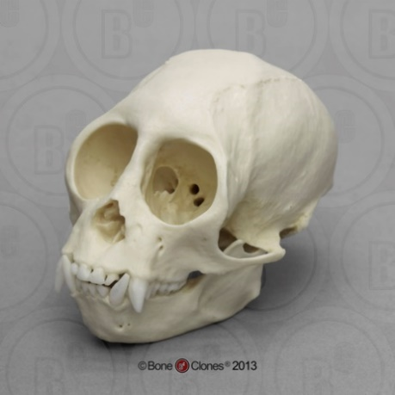Skull 1

1. Is it a herbivore, omnivore or carnivore?
2. How can you tell?
3. What animal do you think it is?

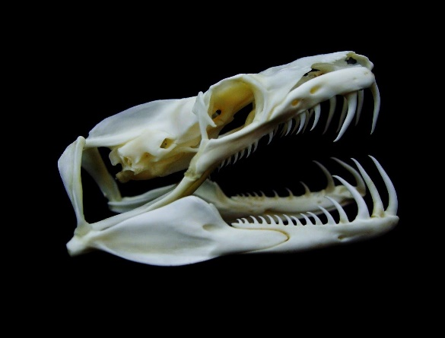

Skull 2

1. Is it a herbivore, omnivore or carnivore?
2. How can you tell?
3. What animal do you think it is?

**Maths – 4.3.21**

**TTRS: Soundcheck**



**My Mini Maths: Complete the following questions**

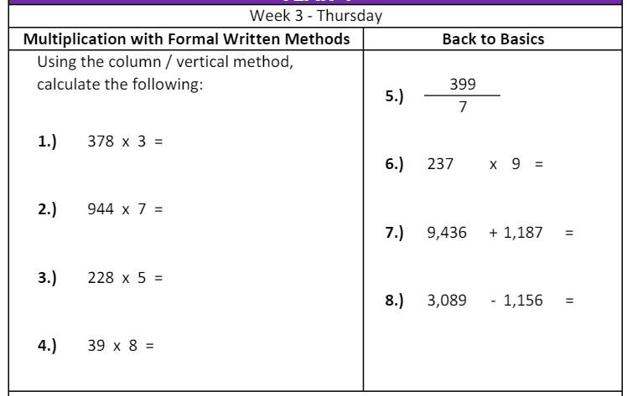

I can compare times from the 12 and 24-hour clock.

|  |
| --- |
| I can compare times from the 12 and 24-hour clock. to the nearest quarter  Order these clocks from earliest to latest      am  am  am    Order these clocks from earliest to latest    pm  pm  pm    Order these clocks from earliest to latest    am    pm  am |
| I can compare times from the 12 and 24-hour clock. to the nearest 5 minutes.  Order these clocks from earliest to latest      am  am  am      Order these clocks from earliest to latest    pm  pm    pm      Order these clocks from earliest to latest    am  pm  am |
| I can compare times from the 12 and 24-hour clock. to the nearest minute.  Order these clocks from earliest to latest      am  am    Order these clocks from earliest to latest    pm  pm  pm        Order these clocks from earliest to latest    am  am  pm |

Reasoning.

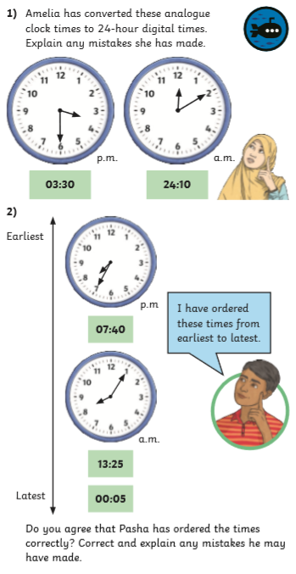

**English – Thursday 4th March**

**I can use was/were correctly.**

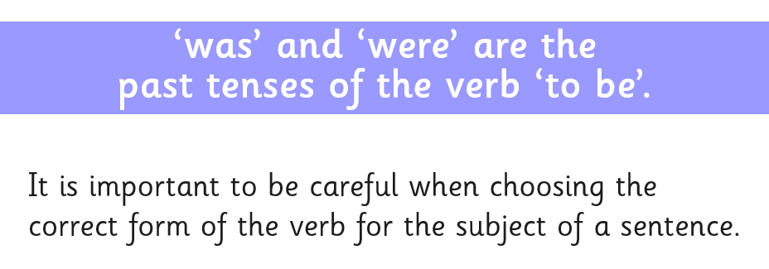

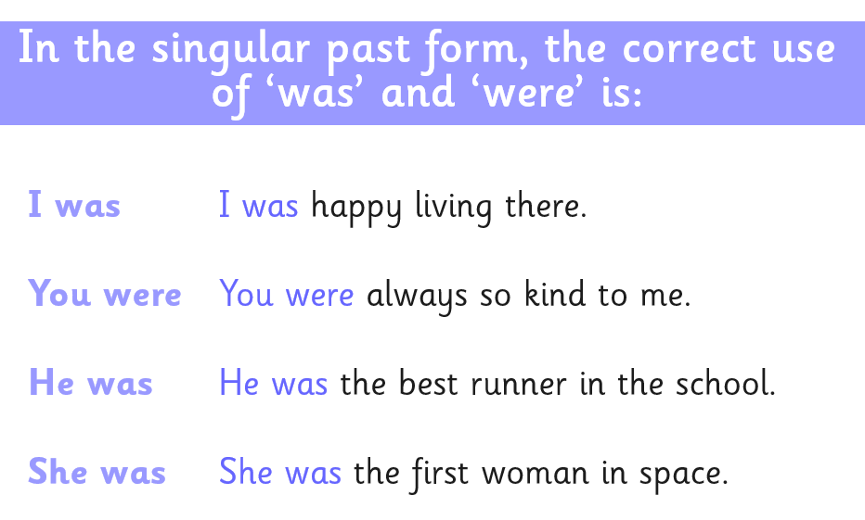

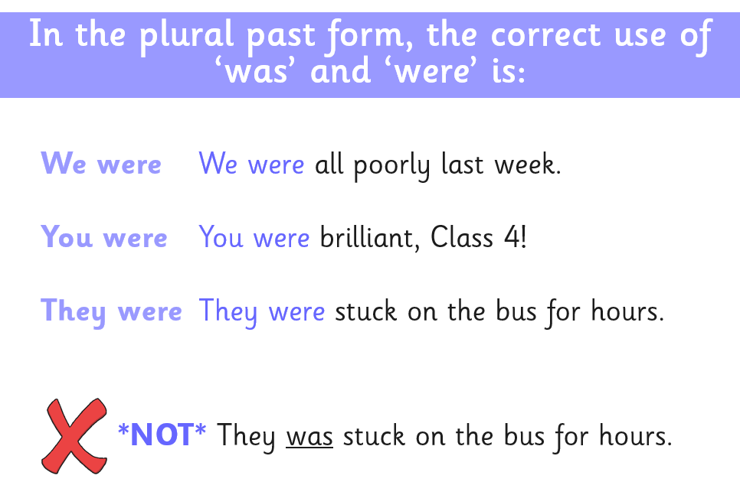

**Hard: Know which are singular and plural nouns.**

|  |  |  |  |  |  |
| --- | --- | --- | --- | --- | --- |
| singular (s) or Ppural (p)?  The first one has been done for you. | | | | | |
| I | s | it |  | dog |  |
| we |  | child |  | shops |  |
| dogs |  | shop |  | he |  |
| she |  | they |  | children |  |

**Harder: Use the above nouns to write was/were sentences correctly. Minimum 6 sentences please.**

My sentences:

* Hardest: Evaluate the sentences - Decide whether the subject is singular or plural and underline the correct verb. The first one has been done for you.

He (**was**/were) a very sensible member of the class.

He (was/were) prepared for school.

We (was/were) scared of thunder.

I (was/were) excited about my new book.

We (was/were) playing together as a team.

She (was/were) my best friend.

**Reading: Higher Order Reading Skills.**

Re-read ‘The Magic Box’ by Kit Wright and complete the chart sorting the different things that are placed in the box depending on which sense they relate to.

The first one has been done for you.

|  |  |  |  |  |  |
| --- | --- | --- | --- | --- | --- |
| Item placed in the box | Sense.  Is it something that we can… | | | | |
| see? | smell? | taste? | hear? | feel? |
| swish of a silk sari |  |  |  | swish of a silk sari |  |
| fire |  |  |  |  |  |
| snowman with a rumbling belly |  |  |  |  |  |
| sip of water |  |  |  |  |  |
| leaping spark |  |  |  |  |  |
| wishes spoken in Gujarati |  |  |  |  |  |
| joke from an ancient uncle |  |  |  |  |  |
| smile of a baby |  |  |  |  |  |
| black sun |  |  |  |  |  |

**Maths – 5.3.21**

**TTRS: Soundcheck**



**My Mini Maths: Complete the following questions**

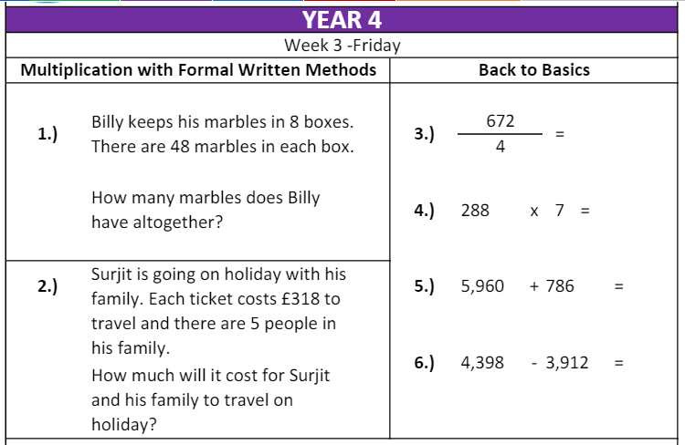

**I can complete an arithmetic test**

Select the Google Form and complete.

English – Friday 5th March 2021

I can use punctuation in various sentence types correctly.

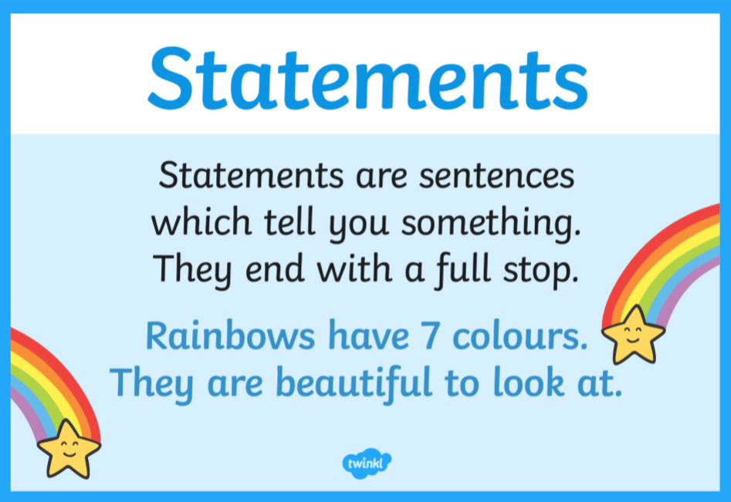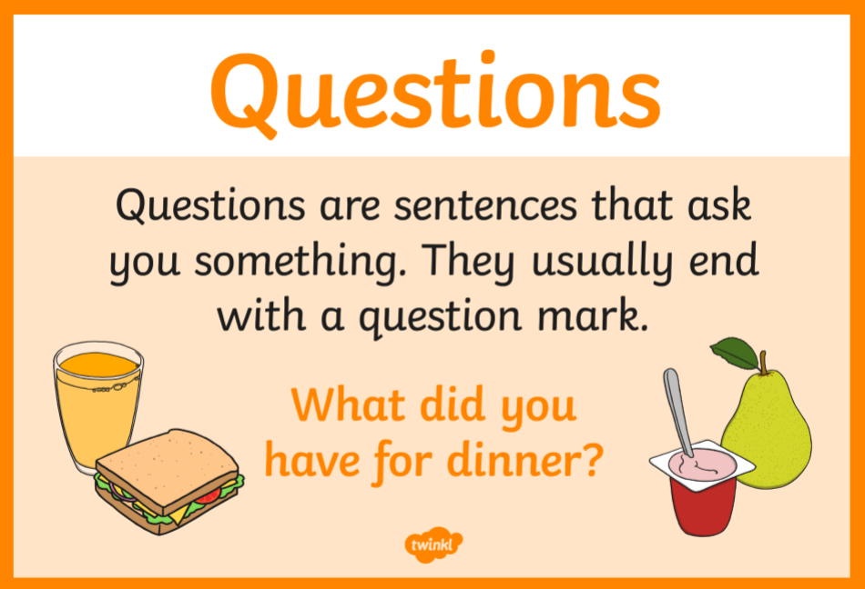

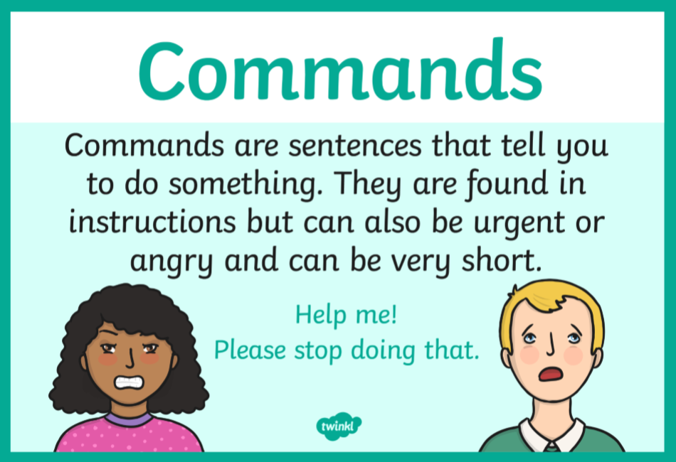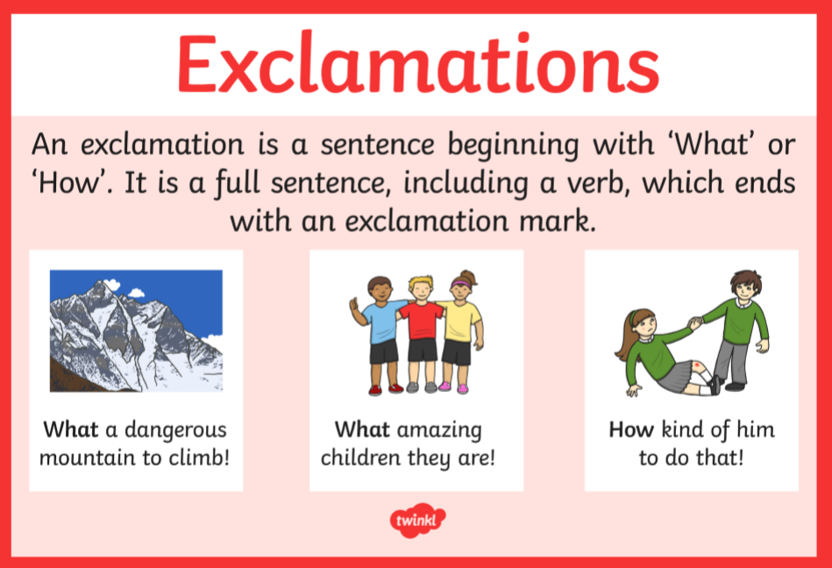

Hard: Know the different various sentence types.

|  |  |  |  |
| --- | --- | --- | --- |
| Statement (S), Command (C), Question (Q) or Exclamations (E)?  The first one has been done for you. | | | |
| What day is it today | Q | Mrs Bilevych teaches class 4.3 |  |
| Today is Friday |  | Is it nearly the weekend |  |
| What good work that is |  | I am off to the shop to buy some milk |  |
| When you are going to Bradford |  | What a fast ride that was |  |
| Tidy your room |  | Stop |  |

Harder: Using the correct punctuation, write your own different sentence types. 8 sentences minimum; 2 statements, 2 commands, 2 questions and 2 exclamations.

Hardest: Evaluate the different sentences types below. Fix the punctuation errors. The first one has been done for you.

**W**hat an amazing goal**!**

is it going to be august soon

help help me i’m drowning

Go back and walk sensibly

who was the first person to land on the moon

our head teacher is called mr cooper

I go to wibsey primary school in Bradford

Don’t sit there

**Reading: Application.**

Re-read ‘The Magic Box’ by Kit Wright and answer the questions.

|  |
| --- |
| **Hard: I can retrieve information from a text.** |
| 1. How many Gujarati wishes are placed in the box? 2. What colour is the horse? 3. What materials have been used to make the box? 4. What has been used to decorate the lid of the box? 5. What colour is the beach? 6. Sequence the order in which the items were place in the box. The first one has been done for you.  |  |  | | --- | --- | | the last joke of an ancient uncle |  | | a black sun |  | | the swish of a silk sari | 1 | | a snowman with a rumbling belly |  | | a witch on a white horse |  | | the first smile of a baby |  | |
| **Harder: I can comment on language used by the writer.** |
| 1. Find and write an example of alliteration. 2. What is the loudest thing that goes in the box? Find and write the word which proves this. 3. Is the box colourful? Use three pieces of evidence from the text to explain. 4. What is interesting about the poet’s use of:   a cowboy on a broomstick and a witch on a white horse. |
| **Hardest: I can express a personal response to the text and show some awareness of the writer’s viewpoint.**   1. How do you think the poet feels about the box? Why? 2. Where do you think the box might be kept? Why? |