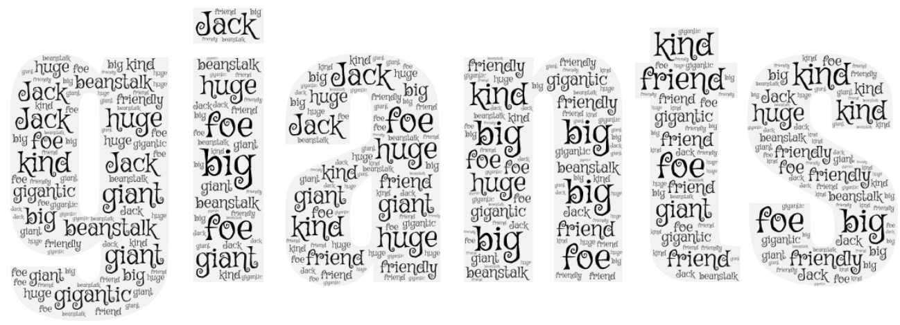
Next half term our topic is ‘Are giants friend or foe?’
Do you notice any key words below? Can you tell me what they mean? Can you think of any other words that link to giants?

