Next half term’s Nursery learning challenge question is:
What do tigers like to eat?
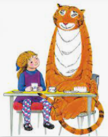

We’re going to be using our ‘questioning’ learning muscle a lot to help us learn about different types of animals. One animal that we always like to find out about in Nursery is the tiger. Why don’t you see if you can find a picture of one and have a go at copying it. Remember to make your tiger stripy.

