Drop off/ Collection September 2021
Year 1 to Year 6
Start of the school day
Parents and children can enter through any gate leading to the playground as restrictions are eased and the one-way system is no longer needed. Gates will open at 8.35am. Please note that until 8.50am all children are the responsibility of the parents/carer At 8.45am, children will go to their class blue cone in the coned off area and line up. Teachers will bring the children in at 8.50am. Gates will then close at 8.55am. Any children arriving after this time will need to enter via the school office and will be registered as being late.
End of the school day.
The children will be led into the coned off areas by staff. The school gates will then be opened allowing parents to enter the playground from 3.20pm. Parents will go to the edge of the coned off area and signal to the staff/pupil that they are there. The teacher will dismiss the pupils to the parents/carers one at a time. Please be patient as staff need to make sure that each child is going with the correct adult. Gates will be closed at 3.40pm. After this time your child will be taken to t-time club and charges may apply.
Please note that the coned off area is for children and staff only. This is to ensure that staff have a clear view of all the children and can ensure they are kept together until they are dismissed to parents/carers.
Please view the map below to show you where your child will be collected from.

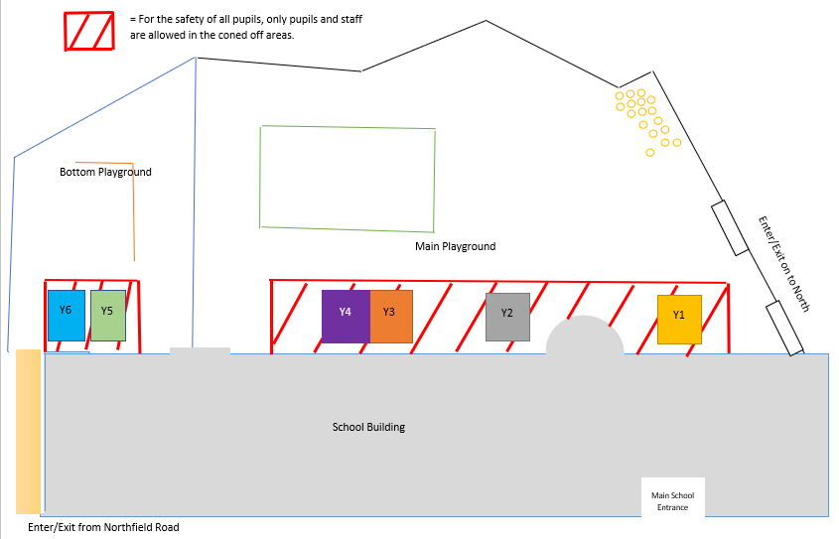

Nursery and Reception
Start of the school day
There is only 1 gate that will be used for Reception and Nursery. At 8.35am the gates will be opened allowing parents and pupils to enter. Please note that until 8.50 am all children are the responsibility of the parents/carer. At 8.45 staff will come out and greet the children, allowing the children into the building. The gate will close at 9am. Any children arriving after this time will need to enter via the school office and will be registered as being late.
End of the school day
At the end of the day, gates will be opened at 3.20pm allowing parents to enter to collect their child/ren. Teachers will dismiss the children one at a time so please be patient while they ensure each child is collected by the approved adult. Gates will be closed at 3.45pm. After this time your child will be taken to t-time club and charges may apply.
Please note parents are not permitted to enter the coned off area. This is to ensure the safety of children and make sure they are in the eye sight of the staff.
Please view the map below to show you where your child will be collected from.

