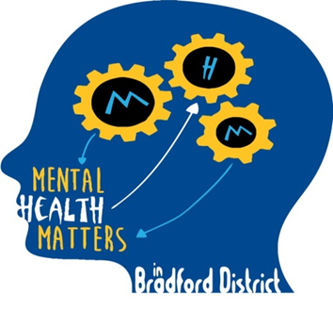
Mental Health Champions
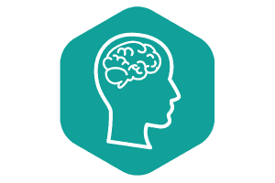Bradford Educational
Psychology Team

Parent/Carer workshops for Mental Health and Emotional Wellbeing
From the Mental Health Champions Project / Bradford Educational Psychology Team
- Are you a parent/carer* of a child or young person who lives in Bradford?
- Are you worried about the mental health or emotional wellbeing of your child?
- Would you like to hear from the Educational Psychology Team what you can do to support your child, and where else you can access support?
Bradford Educational Psychology Team are FREE workshops for parents and carers, via the Mental Health Champions project, which is commissioned and funded by the Clinical Commissioning Groups in Bradford.
Parents and carers are eligible if a child/young person (up to age 18) in their care lives in the Bradford area.
The dates of the next round of sessions are:
- Monday 22 November, 1-2:30pm
- Monday 29 November, 1-2:30pm
- Tuesday 30 November, 9:30-11am
- Tuesday 7 December, 9:30-11am
The topic for the sessions this term is ‘Understanding and Managing Anxiety’
Due to the ongoing coronavirus situation, we are holding our events this term online, via Microsoft Teams.
Sessions may be cancelled if minimum numbers are not met, and any parents/carers booked on to sessions that are cancelled will be offered an alternative.
Please note that these events are group sessions, intended to offer information and training for parents/carers, but we are not able to offer any individual advice via this forum.
Booking details: To register interest or book a session, please contact Charlotte McLaughlan on 07816 089217 (before 12 noon please) or email charlotte.mclaughlan@bradford.gov.uk. Once interest has been registered, log in details and passwords will be sent.
*Please note: All sessions are for parents and carers only, not school staff or professionals unless they are attending in their capacity as parent of a young person living in Bradford

