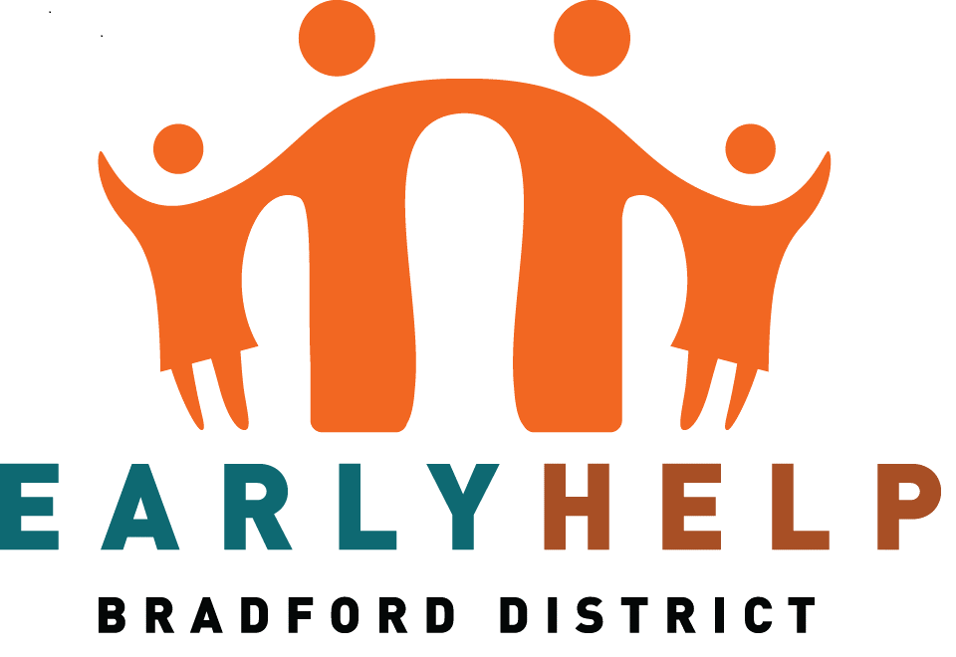
Bradford First Response Crisis Service offers support 24 hours a day, 7 days a week to people of all ages living in Bradford experiencing a mental health crisis https://www.bdct.nhs.uk/services/first-response/
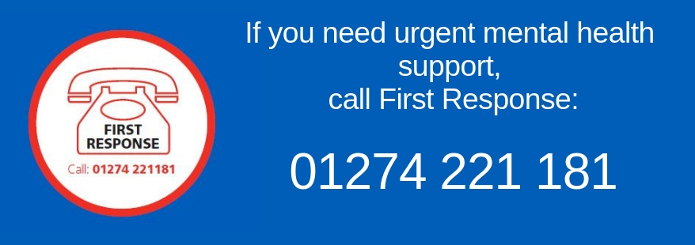

Supporting Our Community this Summer
This leaflet will help to advise and support our families this summer,and keep our Community happy, safe and well.

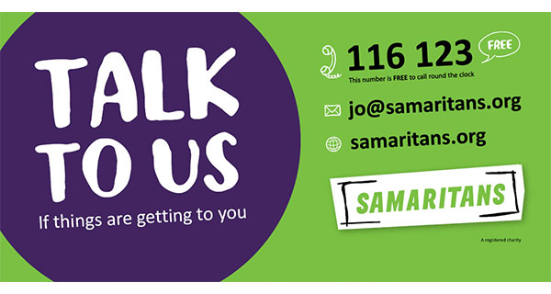
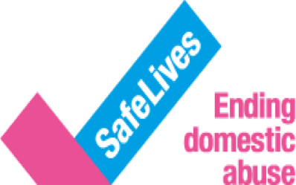
http://directory.mindinbradford.org.uk/
In their ‘Factsheets’ section; they display a range of information sheets covering subjects such as Housing, Debt, Anger and Anti-Depressants.
If you are not in crisis but would like to talk to a friendly, mental health professional, call Mind in Bradford’s free on 08001 884 884.

Lines are open midday-midnight every day. The Mind Wellbeing Service offers a range of recovery-focused groups, social spaces and wellbeing activities for people who are struggling with their mental health. Our open wellbeing timetable is varied, from walking to peer support, arts & crafts to qi gong. They also run closed groups to help you manage things like self-esteem.

To book a 1:1 Welcome Session call 01274 730815 (Mon-Fri 9am-5pm)
or email admin@mindinbradford.org.uk

Mind in Bradford offer a live chat service here

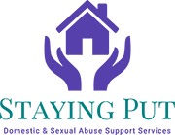Staying Put is a domestic abuse and sexual violence charity which provides support services to victims and survivors across Bradford.For support call the free and confidential helpline on: 0808 2800 999
MyWellbeing College has a number of tools and resources to help you through life’s ups and downs. They offer guidance on things such as low mood, anxiety, sleep problems or stress. This is done through a wide range of learning opportunities including online courses from the comfort of your own home, group courses, phone advice and one-to-one ‘talking therapies’.

For further information, phone: 0300 555 5551 or visit www.bmywellbeingcollege.nhs.uk
Bradford Citizens advice
Argus Chambers
BRADFORD
BD1 1HZ

Email: debtadvice@bradfordcab.com
03442 451282

PARENTS Online provides text based emotional support from trained volunteers through an online platfororm. You can chat confidentially about your feelings with someone who is trained to listen to you and support you.
For more information visit:
PARENTSONLINE.CO.UK

An independent charity, which offers online chat and phone advice for people affected by crime or traumatic events. https://www.victimsupport.org.uk

The Mix offer judgement-free information and support to young people aged 13-25 on a range of issues including mental health problems. Young people can access the The Mix's support via phone, email, web chat, peer to peer counselling service.

Text 'THEMIX' to 85258.
Phone: 0808 808 4994 (11am-11pm, free to call)
Website: www.themix.org.uk/get-support
Resources, guidance and support for people living with domestic abuse through the coronavirus pandemic. https://safelives.org.uk/news-views/domestic-abuse-and-covid-19
Local Food Banks
Bradford Foodbanks
Enter your postcode to find your nearest foodbank
https://bradfordfoodbanks.org.uk

Bradford Central Foodbank
https://bradfordcentral.foodbank.org.uk
Jubilee Centre, Jermyn St,
Bradford
BD1 4EJ
01274 734 314
07838 830438
info@bradfordcentral.foodbank.org.uk

Wyke foodbank
68 Blackstone Ave, Wyke
BD12 8SJ
07941326723 or 07941380420
Email: info@wyke.foodbank.org.uk

Sandale Trust
https://sandaletrust.org
42-46 Reevy Road West,
Buttershaw,
BD6 3LX
01274 270170

Salvation Army Bradford Holmewood
Church
https://www.facebook.com/holmewoodsalvationarmy.
Food Parcels available on drop in’s on Tuesday’s or Friday’s 11.30 to 13.00

Jobseekers Allowance
Information on eligibility and how to claim plus an online claim form:
www.gov.uk/jobseekers-allowance/how-to-claim

Income support
Information on eligibility and how to claim:
www.gov.uk/income-support/how-to-claim

Family Action - Bradford Advice Service provide advice across the Bradford East Constituency on welfare benefits, housing, debt, immigration, employment and consumer issues.
Contact :
Canterbury Advice Centre,
1-3 Ringwood Road,
Bradford, BD5 9LB
01274 577571 (Mon - Fri 9am to 1pm)
canterburyadministrator@family-action.org.uk
www.family-action.org.uk/what-we-do/children-families/bradford/advice-service/

Kooth provides free, safe and anonymous online support for young people. https://www.kooth.com
Bright Sky is a free to download mobile app providing support and information for anyone who
may be in an abusive
relationship or those
concerned about someone
they know.
Benefits Calculator - Work out your entitlement to benefits: https://benefits-calculator.turn2us.org.uk/AboutYou

Warm Homes Healthy People offer advice on energy suppliers, reducing bills, help with fuel debt, draught proofing, water saving devices and will help towards winter warmth packs and emergency heating.
TEL: 0808 1683547
Every family is different. And no matter who's in your family, things can be tough sometimes.
You might worry about:
- arguments, being shouted at, or having different opinions or beliefs
- divorce and separation
- money problems or having to move
- alcohol problems
- being hurt or abused
Whatever’s happening at home, Childline can help you through it.
https://www.childline.org.uk/

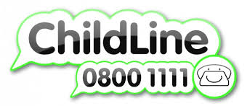

Shout is the UK’s first 24/7 text service, free on all major mobile networks, for anyone in crisis anytime, anywhere. It’s a place to go if you’re struggling to cope and you need immediate help.

TEXT shout to 85258 or visit www.giveusashout.org/
HALE is an established healthy living charity based in Bradford since 2003. They work with people of all ages; providing a wide range of innovative services to tackle the causes of health issues experienced by the local community. HALE focus on the most vulnerable members of society that feel isolated and lonely; those that struggle with mental health or self-confidence issues or are exposed to dangerous or exploitative situations. They offer advice in a language and format that people understand using home visits, door knocking and letting people know about services that they can access.

Tel: 08082 800999
National 24hr: 08082 000247
Provide support for families who have experiences domestic abuse & sexual violence.

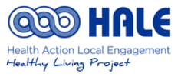

Events & Activities

Event | Venue | Date | Time |  | Event | Venue | Date | Time
Cycling skills & bike check - Bradford Bikery Cycling | Wibsey Park | July 24th | 1.30pm |  | Bradford Libraries Teddy Bear Picnics 2021  Our Teddy Bear Picnics will take place outside to adhere to library guidelines on Covid-19 safety.  Please book your place by calling in to the relevant library.  www.bradford.gov.uk/libraries | Wibsey Library Teddy Bear Picnic  Wyke Library Teddy Bear Picnic | 9th August  31st Aug | 2.15pm – Fairfield on North Street  11am – outside the library
Nature Play – Run by Bradford Urban Discovery Project | Wibsey Park | August 8th, 22, 29th |  |  | Summer Reading Challenge Young Ambassadors  We offer young people between the ages of 13 and 21 the chance to volunteer as a Young Ambassador, to support the Summer Reading Challenge and summer activities.  For further information, contact the Development Officer for Young People:  Christinea Donnelly  01274 433915  christinea.donnelly@bradford.gov.uk | Libraries across the district
Pop up Cricket – Yorkshire Cricket Foundation | Wibsey Park | Every Wednesday from 31st July to 21st August | 2pm – 3pm |  | Multi Sports Camp at  £15.00 per child, per day  Covid Restrictions in place  Single day bookings welcome  Early drop off / late collection if required  Qualified Staff  DBS, Safeguard & First Aid certified  Ages 5-10 years  Fun for all  - Get in touch to book in now | Clayton Rugby Club | Week Commencing 16th Aug Mon - Fri
Warriors for 2 to 5 year olds – Wibsey Warriors | Wibsey Park | Every Tuesday & Thursday | Evenings |  | Play Day – lots of fun activities for you to join in. | Wyke Community & Children’s Centre | 1st August | From 10am
Model boating | Wibsey Park – on the lake | Every Sunday | 10.30am |  | Summer Holiday football camps  £15per day or £40 for 3 days  For more information or to book contact: 07814 757 379  Provisionsportscoaching@gmail.com | Queensbury Celtic AFC, Pit Lane  Queensbury | various dates | 9am – 3pm
Health Walk | Wibsey Park – Meet at Beacon Road Entrance | Every Monday | 11am |  | The Peace Artistes  The Peace Artistes are a riotous and raucous explosion of brass, woodwind and percussion, playing tunes from around the world and entertaining audiences with their toe-tapping music, eccentric costumes and haphazard choreography.  Free Entry | Harold Park, Park Road, Low Moor, Bradford, BD12  tel: 01274 433828  www.peaceartistes.com | Saturday 14th August | 1pm – 4pm
Wake Up To Woodside | Woodside Drive Park & Village Centre | Wednesday - 28th July | 2pm – 4pm |  | Lombard Rally Festival  Some forty to fifty historic rally cars will strut their stuff around the narrow, winding tarmac route inside the park. The historic rally cars will have around eight to ten runs around the park during the day. Rally stars will be interviewed and shown on a big screen, as will further live footage of what is taking place.  tim@lombardrallybath.co.uk | Bowling Park –Spectator Entry from Bowling Hall Road | Saturday 24th July | 10am – 5pm
For more information on activities visit https://www.bradford.gov.uk/summer

