

**Supporting Our Wibsey Primary Community this Christmas**

Many of us look forward to Christmas, but this time of year be overwhelming, particularly if you’re struggling financially. Christmas can create feelings of loneliness and isolation; while difficult relationships with loved ones can cause added stresses and pressures. Hopefully this leaflet will help to advise and support our families this Christmas, and help keep our Wibsey Primary Community happy, safe and well.

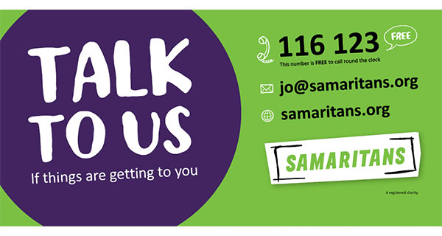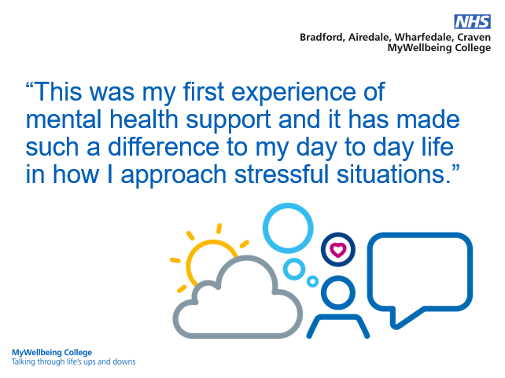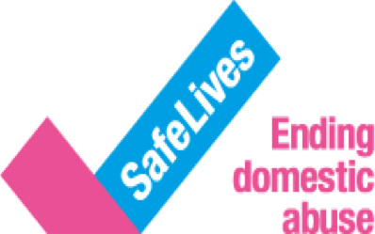

Bradford First Response Crisis Service offers support 24 hours a day, 7 days a week to people of all ages living in Bradford experiencing a mental health crisis [**https://www.bdct.nhs.uk/services/first-response/**](https://www.bdct.nhs.uk/services/first-response/)

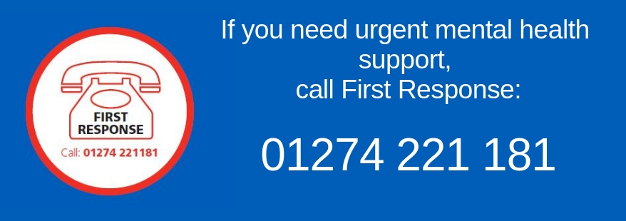

Bradford Citizens advice

Argus Chambers

BRADFORD

BD1 1HZ

Email: debtadvice@bradfordcab.com

03442 451282

The Mix offer judgement-free information and support to young people aged 13-25 on a range of issues including mental health problems. Young people can access the The Mix's support via phone, email, web chat, peer to peer counselling service.

[**Text** 'THEMIX' to 85258](https://www.themix.org.uk/get-support/speak-to-our-team/crisis-messenger).

**Phone:** 0808 808 4994 (11am-11pm, free to call)  
**Website:** [www.themix.org.uk/get-support](http://www.themix.org.uk/get-support)

If you are not in crisis but would like to talk to a friendly, mental health professional, call Mind free on 08001 884 884.

Lines are open midday-midnight every day.

Mind also runs a text information line on 86463.



**http://directory.mindinbradford.org.uk**/ - Mind Bradford have links for a wide range of local and national organisations catering for a variety of mental health needs.

In their ‘Factsheets’ section; they display a range of information sheets covering subjects such as Housing, Debt, Anger and Anti-Depressants.

An independent charity, which offers online chat and phone advice for people affected by **crime or traumatic events**. **https://**[**www.victimsupport.org.uk**](http://www.victimsupport.org.uk/)

The Mind Wellbeing Service offers a range of recovery-focused groups, social spaces and wellbeing activities for people who are struggling with their mental health. Our open wellbeing timetable is varied, from walking to peer support, arts & crafts to qi gong. They also run closed groups to help you manage things like self-esteem.

To book a 1:1 Welcome Session call 01274 730815 (Mon-Fri 9am-5pm)

or email admin@mindinbradford.org.uk

MyWellbeing College has a number of tools and resources to help you through life’s ups and downs. They offer guidance on things such as low mood, anxiety, sleep problems or stress. This is done through a wide range of learning opportunities including online courses from the comfort of your own home, group courses, phone advice and one-to-one ‘talking therapies’.

For further information, phone: 0300 555 5551 or visit **www.bmywellbeingcollege.nhs.uk**

Resources, guidance and support for people living with **domestic abuse** through the coronavirus pandemic. <https://safelives.org.uk/news-views/domestic-abuse-and-covid-19>

Family Action - Bradford Advice Service provide advice across the Bradford East Constituency on welfare benefits, housing, debt, immigration, employment and consumer issues.

Contact :

Canterbury Advice Centre,

1-3 Ringwood Road,

Bradford, BD5 9LB

01274 577571 (Mon - Fri 9am to 1pm)

canterburyadministrator@family-action.org.uk

[**www.family-action.org.uk/what-we-do/children-families/bradford/advice-service/**](http://www.family-action.org.uk/what-we-do/children-families/bradford/advice-service/)

Jobseekers Allowance

Information on eligibility and how to claim plus an online claim form:

[www.gov.uk/jobseekers-allowance/how-to-claim](http://www.gov.uk/jobseekers-allowance/how-to-claim)

Income support

Information on eligibility and how to claim:

[www.gov.uk/income-support/how-to-claim](http://www.gov.uk/income-support/how-to-claim)

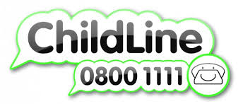

Every family is different. And no matter who's in your family, things can be tough sometimes.

You might worry about:

* arguments, being shouted at, or having different opinions or beliefs
* divorce and separation
* money problems or having to move
* alcohol problems
* being hurt or abused

Whatever’s happening at home, Childline can help you through it.

[**https://www.childline.org.uk/info-advice/home-families/seasonal-events/christmas/**](https://www.childline.org.uk/info-advice/home-families/seasonal-events/christmas/)

Tel: 08082 800999

National 24hr: 08082 000247

Provide support for families who have experiences domestic abuse & sexual violence.

HALE is an established healthy living charity based in Bradford since 2003. They work with people of all ages; providing a wide range of innovative services to tackle the causes of health issues experienced by the local community. HALE focus on the most vulnerable members of society that feel isolated and lonely; those that struggle with mental health or self-confidence issues or are exposed to dangerous or exploitative situations. They offer advice in a language and format that people understand using home visits, door knocking and letting people know about services that they can access.

**Shout** is the UK’s first 24/7 text service, free on all major mobile networks, for anyone in crisis anytime, anywhere. It’s a place to go if you’re struggling to cope and you need immediate help.

TEXT shout to 85258 or visit **www*.*giveusashout*.org/***

Benefits Calculator - Work out your entitlement to benefits: <https://benefits-calculator.turn2us.org.uk/AboutYou>

Kooth provides free, safe and anonymous online **support for young people. https://**[**www.kooth.com**](http://www.kooth.com/)



Bright Sky is a free to download mobile app providing support and information for anyone who

may be in an abusive

relationship or those

concerned about someone

they know.

**Local Food Banks**

Wyke foodbank

68 Blackstone Ave, Wyke

BD12 8SJ

07941326723 or 07941380420

Email: [info@wyke.foodbank.org.uk](mailto:info@wyke.foodbank.org.uk)

Bradford Central Foodbank

<https://bradfordcentral.foodbank.org.uk>

Jubilee Centre, Jermyn St,

Bradford

BD1 4EJ

01274 734 314  
07838 830438  
info@bradfordcentral.foodbank.org.uk

Sandale Trust

https://sandaletrust.org

42-46 Reevy Road West,

Buttershaw,

BD6 3LX

01274 270170