WIBSEY PRIMARY SCHOOL

Bereavement Policy and Suggested Guidance

Agreed by Governors  Date: | Full Governors | x
 | Finance and General Purposes
 | Teaching and Learning
Signed on behalf of Governing Body by Chair of Committee:
Approved
Review

Content | Page
Bereavement Policy Guidelines and Aims | 3
Guidelines for Staff and Governors | 4
Guidelines for Informing Students | 6
In the Days After the Death | 7
Bereavement Flowchart | 8
Guidelines for Supporting a Bereaved Student Return to School | 9
Guidelines for Providing Ongoing Support For a Bereaved Student | 12
Guidelines for Supporting Students with Special Educational Needs | 13
Appendix 1 – Guidelines on HOW to Inform Children | 14
Appendix 2 – Information Sharing Pathways | 15
Appendix 3 – Templates | 19
Appendix 4 – External Support Agencies | 21

Every year 20,000 children under the age of 16 years will be bereaved of a parent and many more will experience the death of someone else special in their life.
In addition to these individual pupils, schools may also experience the death of a child at the school or a staff member.
It is almost inevitable therefore, that at some time all schools will have to deal with a death that affects the school community.
As children spend the vast majority of their time at school, teachers and staff members will be the primary source of care and support. Bereaved children will see school as a safe haven away from the turmoil of emotions at home and will look to trusted staff members for help.
Death is something that most people choose not to think about so when faced with it we often find ourselves ill prepared.
The purpose of the Bereavement Policy is to help everyone involved at a time when there may be shock, upset and confusion, ensuring that there is as little disruption as possible, effective communication takes place and each member of the school community is supported to help them through a very difficult time.

Aims of a Bereavement Policy
  - To identify key staff within the school and LA, resources and further support services to help the whole school community work together.
  - To provide a framework for all staff, teaching and non-teaching, to give guidance in how to deal sensitively and compassionately with difficult and upsetting circumstances.
  - To have clear expectations about the way school will respond to the death, and provide a nurturing, safe and supportive environment for all.
  - To support pupils and/or staff before (where applicable), during, and after bereavement.
  - To meet the needs of all its children and staff and to be a place that both child and family can rely on, and gain much needed support.
  - For children to have the opportunity to tell their story, express their feelings, share their memories and develop coping strategies through support by sensitive staff.

Guideline for Staff and Governors

A death can affect the school community in different ways and often depends on:
The role the deceased person had within school
How well known they were in the local community
Circumstances surrounding the death, particularly suicide or violent deaths

The experience of working with many schools affected by death has taught Simon Says that adults and children benefit from being kept informed. Rumour and gossip can be very damaging and can even lead to both young and old developing the attitude that the death is not a topic to talk about. Children and young people have a healthy curiosity, and if they are not informed of the circumstances or feel they are unable to ask questions, their normal grief process can be obstructed.

The following guidelines may help when informing staff and governors:
- Where possible, discussion should take place with the bereaved family and their wishes considered before any decisions are made in relation to how and what to tell the staff and wider school community.
- It is important to consider any cultural or religious implications and seek advice if necessary.
- ALL staff (including support staff such as lunch time supervisors, PE coaches…) should be informed as soon as possible using your normal method of communication, e.g. a whole school staff meeting or team meeting, ensure this includes part time staff and measures are taken to inform absent staff over the telephone.
- Give a factual explanation of how the death occurred and if applicable the circumstances of what happened leading up to the death.
- Ensure Senior Leadership team are prepared for reactions to this news including visible upset and feelings of anger/guilt. People may connect the incident to their own personal experience of bereavement, so feelings about past bereavements may need to be discussed. This is perfectly natural.
- Ensure a member of Senior Leadership is available to members of staff, parents or children if they are finding the situation particularly hard. Seek the advice of external support services as appropriate (see Appendix 4).
- Be prepared to arrange supply cover if necessary.
- Establish one person as a point of contact for the family to ensure free flow of accurate information to and from the school.
- Bereavement support or counselling should be available to all as necessary (requesting external bereavement support if needed – Simon Says, Winston’s Wish, Cruse, Compassionate Friends and the Educational Psychology Service, if psychological de-briefing is thought necessary).
- Arrange staff/pupil condolences with collaborative agreement if felt appropriate.
- Agree a set time for teachers to inform their class what has happened, how this is to be done and EXACTLY what is going to be said. Identify any absent pupils.
- Be prepared to follow this up with a special assembly, memorial service or memorial tree/garden...
- Arrange for the Wellbeing Team or Senior Leadership Team to be on hand at the end of the working day for staff to de-brief and reflect upon the day’s events and to agree upon any further action or support that may need to be put in place. Staff who will be alone that night could be identified and arrangements made for colleagues to contact them by phone if necessary.
- Speed and chaos may be a major factor on a day when a critical incident has happened – the speed and chaos meaning that constant referring to plans and lists is not possible. DON’T WORRY! Be confident enough to go with your gut instinct. Remember that keeping people as informed as possible is always helpful.
- Trained and experience practitioners are available on the Simon Says helpline (02380 647550) should you want to check out ideas during the following days, weeks and months ahead.
- Where possible staff who have requested to attend the funeral or memorial should be released.

Guidelines for informing staff

People often think that children do not grieve, but even very young children will want to know what happened, how it happened, why it happened and perhaps most importantly of all, what happens next?
The following guidelines will help you to inform children of the death:
- Identify children who are most likely to be impacted by the news because they had a close relationship with the deceased or are already bereaved to be told together as a separate group. Where possible inform pupils in the smallest group, preferably class or tutor groups. This should be done by adults they know.
- It is always a shock when a death occurs in a school even if it may have been anticipated. Children expect to live forever, and so a fellow student dying can feel quite shocking. Experience has shown that it is more beneficial if all pupils are informed.
- Provide staff with guidelines on how to inform children; be honest, it is ok to say if you don’t have the answers but remember to revisit the question at a later date when you do have the answer (See Appendix 1).
- Be prepared for children to say or do the unexpected, experience has shown some responses or apparent lack of response may be upsetting for adults. No apparent response does not mean that a child does not care.
- Try to identify any key answers that you may need to prepare, e.g. the facts about an illness, or dates which may be relevant to the death such as end of school year and changing class or schools.
- End up discussion on a positive note - not all people who are ill or have accidents die - many get better. Consider a prayer to remember the deceased and their family. Perhaps co-ordinate an assembly to end discussion.
- Do pupils want to do an activity to express their thoughts and feelings? (See Bereavement Lessons Pack) Do they want to arrange for representatives to attend the funeral? How will this be managed?
Grief will last a life time and can surface throughout with new questions and many reflections

In the days after the death

- It is important to consider any cultural or religious implications and seek advice if necessary.
- Ensure nominated staff with responsibilities for supporting staff and children, are available to do so.
- It may be necessary temporarily to provide staff cover for their normal activities.
- Identify an allocated quiet place where children, young people and staff can go if necessary.
- It is preferable for there to be minimum disruption to the timetable but some flexibility may be required.
- Try to engender an awareness of when people need help and support, particularly those who worked closely with the person who has died and secretaries /administrative staff who are taking telephone calls, dealing with parents etc.
- Through the nominated staff member who has responsibilities for liaising with the individual’s family, ascertain their wishes about the school’s involvement in the funeral, if any.

In line with the families’ wishes consider practical issues such as:
- Sending flowers to the home or to the funeral, making a collection etc...
- Who will attend the funeral?
- Cover for any staff who may be going to the funeral.
- Informing the parents of those pupils who will be involved.
- Possible closure of the school. If this is the case remember to tell lunchtime supervisors, caretaker etc. in advance.

Bereavement Flow Chart

Guidelines for supporting a bereaved pupil returning to school

When the child or young person returns to the setting they may want to get straight back into friends, work and routine. They will have been surrounded by grieving family members and often a chaotic household of visitors. School maybe their break from that.
Have some action plans in place to help the child and young people return by:
- Identifying a member of the team who will be the main contact point for them and their family.
- Ensure regular contact, this may be daily or weekly depending on needs and wishes of the family. This helps you understand how they are coping, what support they may need now and in the future, to discuss concerns and worries and plan strategies to cope.
- If they stay at home, remember them. Have cards and messages sent to them from appropriate people (peer group and staff they have good relationships with) Activities such as these will give the other children the opportunity to discuss their own concerns or experiences with the family and help them to feel they are doing something positive to support them, you may want to collate them into a book. This death may remind others of their own experiences and so be prepared to support them. You may find out information about a child in your class that you didn’t know before. Be ready to listen to them all.
- Before they return ensure all staff are aware of the bereavement and the possible effects on them, their behaviour and their learning, so that appropriate care and support can be given throughout the setting. Remember bereaved children and young people have ‘physical’ illness, such as headaches, tummy aches and feeling sick, as well as mental sadness including lack of concentration, feeling tired, disorganised anger and frustration. These will have an impact on work load and learning. Monitor how things are going on their return and maintain communication with all staff involved.
- Maintain normal rules and expectations of behaviour. This is important for the children and young people within the setting and the child or young person who have been bereaved. The rules and expectations are all part of the ‘normal’ routine and will help to make them feel secure. Remember the impact of bereavement on the whole family when giving sanctions and the impact the sanctions may have on the whole family
- Consider ‘time out’ strategies that suit the child or young person and the setting. Time out cards, signals or signs can help them to exit the room quickly if they are feeling vulnerable or emotional. Make sure they have a safe place to exit to.
- Remember, there is no set pattern or time limit to grief – It is a unique experience and the process is a lifelong one. At different ages and during new or transitional times they will have new questions requiring answers and questions requiring a re-visit of what happened; to develop a better understanding and acceptance.
- It is not unusual for bereaved pupils to take time off school during the early stages of their bereavement. For some, the need to be with their families will be strong, and indeed they may suffer from separation anxiety when the time comes for a return to school. For others the familiarity, stability and routines of school life may prompt an early return. The time away from school will vary from pupil to pupil but when they do return, they may have a number of concerns – you will only know what these are and how they might be resolved if you ask. Some of the more common concerns might be:
- How will staff and peers react– who has been told, what do they know, what will be said, how much will I have to say to people?
You can help by – trained pastoral team meeting with them to welcome them back, acknowledge the death and talk through their concerns. Saying something simple like “I am sorry to hear that your dad died – sometimes it helps to talk about it and if so, who would you like to be there for you?” is usually much appreciated by them. If possible offer them choices about how things should be handled and what support would be helpful. Let staff and classmates know how they want to be received and supported.
- Fear of sudden emotional outbursts – anger, distress, panic…
You can help by - normalising grief reactions and giving them choices about what strategies will help them to cope in the classroom e.g. able to leave lessons without fuss – “exit card” system, where they can go, who they can talk to.
- Fear when they realise they may not remember what the deceased person looks like
A laminated photo of the deceased person may give enormous comfort when the visual image begins to disappear. A special teddy or other memento will often give great comfort in times of distress and upset. They may also want to show this when talking about the person who died. It should be stressed that whatever helps the child within reason should be encouraged.
- Fear of being behind with work and unable to catch up
You can help by - clarifying with other staff what is essential to accomplish and what can be left, and offering appropriate help to achieve what needs to be done.
- Inability to concentrate and feel motivated or sit still
You can help by - Reassuring them that this lack of motivation and concentration is normal and will pass. Offer shorter more manageable tasks, write down the task, give encouragement for achievements, and minimising difficulties can often help.
- Family grief impacting on normal family functioning
Disrupted routines, sporadic meals, chaotic bedtimes are possible reasons why they may be inadequately prepared for school, does not have the necessary equipment, and may be tired or hungry.
You can help by - Talking with them to ascertain where areas of difficulty lie and try and work out strategies with them and their family to help keep things on an even keel in school. Identify their strengths and help them build on them.
- Unable to meet homework/project deadlines because of altered responsibilities within the family and home
You can help by - helping them work out and meet priorities. Be flexible where possible and offer additional support where needed.
- Forthcoming examinations
You can help by - Explaining the process of notifying examination boards and the possible outcomes.

Guidelines for providing on-going support for a bereaved student

- If the child/young person thinks it would be helpful and friends agree, establish a peer support network – ensuring that those helping are given appropriate support themselves or seek help outside, for example, by making a referral to Simon Says.
- Make a note of significant dates which might affect the pupil, e.g. date of death, birthdays, Christmas, anniversaries. Make sure other members of staff are aware of these and the possible impact these may have. Don’t be afraid to acknowledge these potentially difficult times with them e.g. “I know Christmas is coming up and it might feel a very different and difficult time for you all this year without your Dad – so don’t forget, if it helps to talk you can always come and see me”.
- Consider possible reactions to class/assembly topics. Discuss how these difficulties might best be managed with them e.g. if making Mother’s day cards do ask them if they wish to be included in the activity too, very often the answer is ‘yes’ as they still have a parent, they just can no longer see them, but still want to remember them.
- Look out for signs of isolation, bullying or difficulties in the playground – bereaved children/young people are often seen as vulnerable and may become a target.
- Consider using books/activities to help explore feelings and ideas about death as part of the normal school curriculum (call Simon Says for further advice)
- Be alert to changes in behaviour – these may be an indication that they are more affected by their bereavement than they are able or willing to say. Reactions may present themselves months or years after the event, and it may be difficult for staff and others to relate behaviour(s) to the bereavement.
- Follow up absences – absence could indicate bereavement – associated problems at home or school.
- At transition time make sure the new class teacher and/or school are aware of the bereavement and support in situ.
- At the end of the day, be yourself, listen and care.

Guidelines for supporting a student with Special Educational Needs.

All children benefit from being given simple, honest “bite size” pieces of information about difficult issues - often repeated many times over. For further support visit www.autism.org.uk/about/family-life/bereavement.aspx or contact Simon Says.
When talking about death and bereavement with a child with learning difficulties it might be helpful to consider: -
- WHO should be key worker working with the child and family - inform parents who this person will be and keep in contact, this should be someone they ALREADY have a good relationship with.
- WHERE is the student most receptive to new ideas? – quiet room, pool, outside. Use this space for talking with them.
- WHAT should be talked about? (as agreed with parents). Ensure that you use the same language and ideas as the family to avoid confusion.
- HOW is new information normally given? - signs, verbally, pictures. Use their normal communication methods to talk about illness and death.
- HOW is new information normally backed up? – you will probably need to repeat information a number of times over a long period. Do you need to make a social story? (www.speakingspace.co.uk will assist with this)
- PROCEED at a level, speed and language appropriate to them.
- BUILD on information given – small bites of the whole, given gradually will be easier to absorb.
- REPEAT information as often as needed.
- WATCH for reactions to show the child understands – modify and repeat as needed.
- FOLLOW the student’s lead – if indicating a need to talk or have feelings acknowledged, encourage as appropriate.
- WATCH for changes in behaviour to indicate the child is struggling more than they can say and offer support as needed.
- MAINTAIN normal daily routine as much as possible.
- LIAISE with other agencies involved with the student to ensure accuracy and continuity of information.

Appendix 1

Guidelines on how to inform children

Remember it is ok to show your emotions in moderation. It is important we model to children and young people healthy responses to sad news and a natural response to hearing about a death is to shed a tear.
- Be honest and factual.
- Use clear language – use the person’s name, do not use euphemisms like ‘passed away’ or ‘lost’ use the words dead, died and death to avoid confusion.
- Allow the children/young people to ask questions and answer them honestly and factually in terms they will understand.
- Allow the children/young people to ask questions and answer them honestly and factually in terms that they will understand.
- Allow the children/young people to verbalise their feelings.
- Allow the children/young people to discuss the situation and share their experiences of death (even if that is the death of a pet).
- Ensure the children/young people understand that the death is nothing to do with anything they have said or done. It is in no way their fault.
- Reassure them that not all people who are ill or have had an accident will die and that many people get better.
- Acknowledge some days will be harder than others
- Do not expect to go straight into maths, allow for a time of restoration preferably with a physical outlet.
- Put an appropriate time limit on the discussion. It is preferable to resume normal school activities as soon as possible thus ensuring minimal disruption within the school day which also offers a sense of security and familiarity.

Suggested scripts to use when someone dies:

“I’ve got some really sad news to tell you today that might upset you. I know most of you will have heard of cancer, and know that sometimes people with cancer get better, but other times people die from it. __________, the _______teacher, has been ill with cancer for a long time. I have to tell you that __________ died yesterday in hospital”.

“Sometimes people have accidents at work, at home, at school or on the road. People may be hurt or injured in the accident and they may have to go to hospital for treatment. Sadly, there are some accidents that cause people to die. I have some really sad news to tell you that might upset you. Yesterday _________, who is in Year 4, was in an accident and he was so badly injured that he died”.
Appendix 2

Information sharing pathway following death of Headteacher

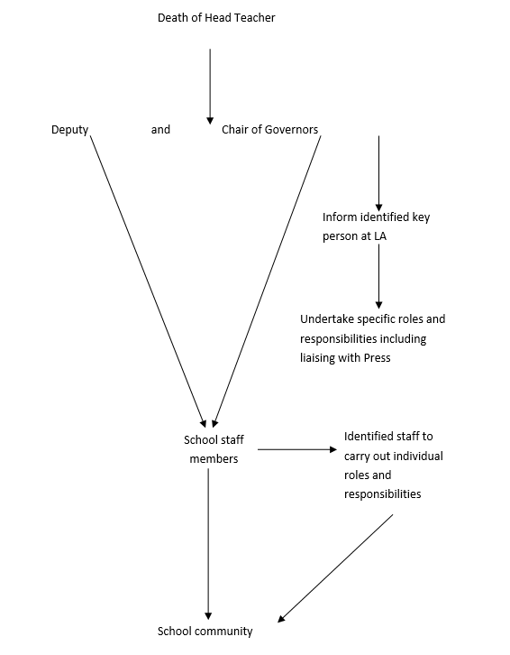

Information sharing pathway following death of a staff member

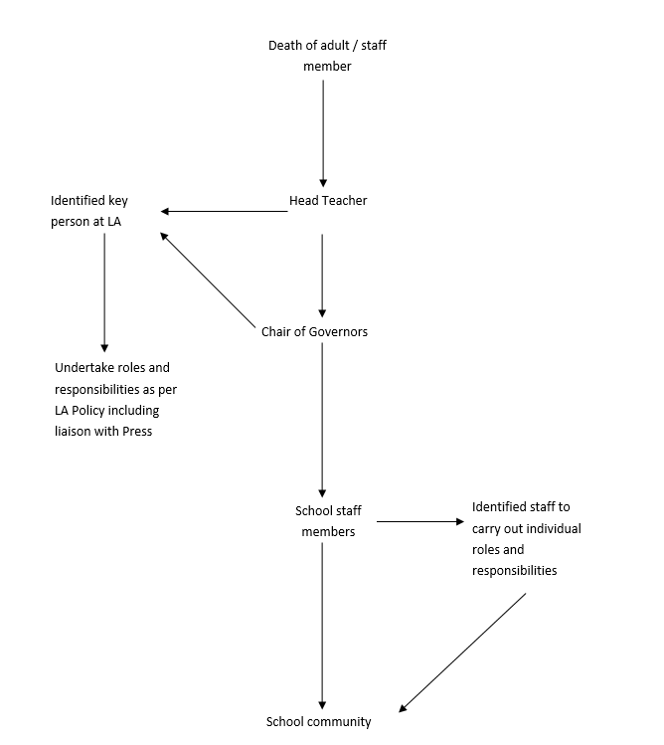

Information sharing pathway following death of a pupil

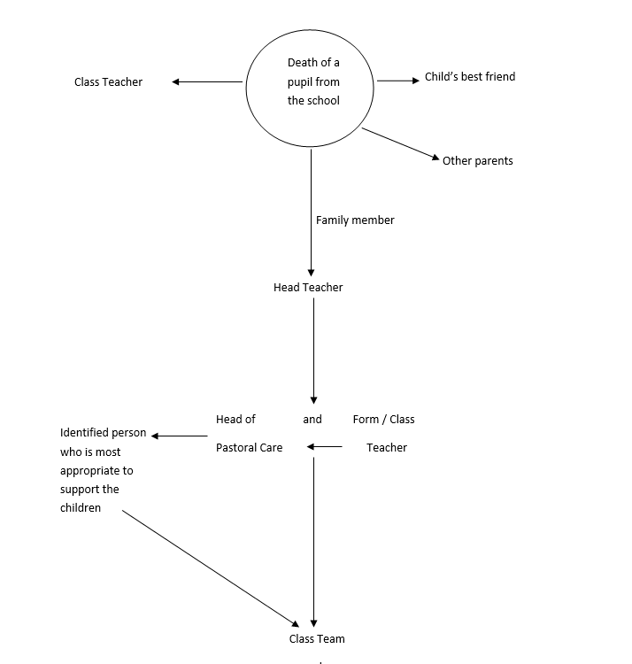

Information sharing pathway following death of a close family member of pupil

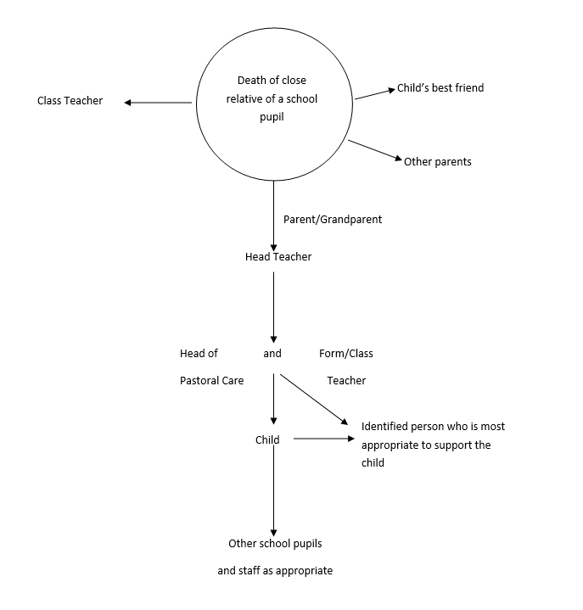

Appendix 3

Templates

Template of a letter informing parents of the death of a member of staff

<Date>

Dear Parents

Your child’s class teacher/form tutor/head of year had the sad task of informing the children of the tragic death of <Name> who has been a teacher at this school for a number of years.

Our thoughts are with <Name …….’s> family at this time and in an effort to try to respond to his/her death in a positive way, all the children have been informed.

When someone dies it is normal for family and friends to experience many different feelings like sadness, anger and confusion, and children are likely to ask questions about the death that need to be answered honestly and factually in terms that they will understand.

The children have been told that their teachers are willing to try and answer their questions at school but if there is anything else you or your child needs to know, please do not hesitate to ring the school office and we will be more than happy to help you.

Yours sincerely

<Name> Head Teacher

Template of a letter informing parents of the death of a pupil

Before sending a letter home to parents about the death of a pupil, permission must be gained from the child’s parents.
The contents of the letter and the distribution list must be agreed by the parents and school.

<Address>
<Date>

Dear Parents

Your child’s class teacher/form tutor/had the sad task of informing the children of the death of <Name>, a pupil in <Year>.

<Name> died from an illness called cancer. As you may be aware, many children who have cancer get better but sadly <Name> had been ill for a long time and died peacefully at home yesterday.

He/She was a very popular member of the class and will be missed by everyone who knew him/her.

When someone dies it is normal for their friends and family to experience lots of different feelings like sadness, anger and confusion. The children have been told that their teachers are willing to try to answer their questions at school but if there is anything more that you or your child needs to know, please do not hesitate to ring the school office and we would be more than happy to help you.

We will be arranging a memorial service in the school in the next few months as a means of celebrating <Name..’s> life.

Yours sincerely

<Name> Head Teacher

Appendix 4

External Support Agencies

simonsays.org.uk - Child/Adolescent Bereavement Support.
autism.org.uk/about/family-life/bereavement.aspx – Advice when supporting someone with autism cope with a death.
childbereavement.org.uk – Supports families and professionals when a child is bereaved or facing bereavement.
childhoodbereavementnetwork.org.uk - Childhood bereavement.
childline.org.uk - Free national telephone helpline for children and young people.
crusebereavementcare.org.uk - All aspects of bereavement.
griefencounter.org.uk - Helps bereaved children & young people rebuild their lives.
hopeagain.org.uk - Specifically for young people aged 12-18. supportline.org.uk - Confidential emotional support for children, young people & adults.
papyrus-uk.org - Provides resources & support for those dealing with suicide, depression or distress – particularly teenagers & young adults.
seesaw.org.uk - Grief support service for children and young people.
sands.org.uk - Providing support for parents & families whose baby is stillborn or dies soon after birth.
teenissues.co.uk – Discussing the issues teenagers face.
theredlipstickfoundation.org – Support for families bereaved by suicide.
uk-sobs.org.uk - Those who are left behind after a suicide can be helped by talking to others who have experienced a similar loss.
Widowedandyoung.org.uk – peer-peer network for those widowed before their 51st birthday
winstonswish.org.uk - Help for grieving children and their families.

