Pupil premium strategy statement

This statement details Wibsey Primary School’s use of pupil premium (and recovery for the 2021-2024 academic years) funding to help improve the attainment of our disadvantaged pupils. It outlines our pupil premium strategy, how we intend to spend the funding in this academic year and the effect that last year’s spending of pupil premium had within our school.

School overview
Detail | Data
School name | Wibsey Primary School
Number of pupils in school | 668
Proportion (%) of pupil premium eligible pupils | 32% PP 30% FSM
Academic year/years that our current pupil premium strategy plan covers (3 year plans are recommended) | 2021-2024
Date this statement was published | 20.10.21
Date on which it will be reviewed | 21.4.22  20.10.22  20.4.23  20.10.23  19.4.24  18.10.24
Statement authorised by | Karen Yates
Pupil premium lead | Hannah Smith
Governor / Trustee lead | Michelle Clarkson
Funding overview
Detail | Amount
Pupil premium funding allocation this academic year | £ 276345
Recovery premium funding allocation this academic year | £29165
Pupil premium funding carried forward from previous years (enter £0 if not applicable) | £0
Total budget for this academic year  If your school is an academy in a trust that pools this funding, state the amount available to your school this academic year | £305510

Part A: Pupil premium strategy plan

Statement of intent
When making decisions about using Pupil Premium funding it is important to consider the context of the school and the subsequent challenges faced. This alongside research conducted by the EEF. Common barriers to learning for disadvantaged children can be: less support at home, weak language and communication skills, lack of confidence, more frequent behaviour difficulties and attendance and punctuality issues. There may also be complex family situations that prevent children from flourishing. The challenges are varied and there is no “one size fits all”.
We will ensure that all teaching staff are involved in the analysis of data and identification of pupils, so that they are fully aware of strengths and weaknesses across the school.
Principles
- We ensure that teaching and learning opportunities meet the needs of all the pupils
- We ensure that appropriate provision is made for pupils who belong to vulnerable groups, this includes ensuring that the needs of socially disadvantaged pupils are adequately assessed and addressed
- In making provision for socially disadvantaged pupils, we recognise that not all pupils who receive free school meals will be socially disadvantaged
- We also recognise that not all pupils who are socially disadvantaged are registered or qualify for free school meals. We reserve the right to allocate the Pupil Premium funding to support any pupil or groups of pupils the school has legitimately identified as being socially disadvantaged.
- Pupil premium funding will be allocated following a needs analysis which will identify priority classes, groups or individuals. Limited funding and resources means that not all children receiving free school meals will be in receipt of pupil premium interventions at one time.

Demography and School Context
Wibsey Primary is a community school located in South Bradford. We are larger than normal primary school with 3-forms in each year group.
The maps below display the “Lower Super Output Areas” (LSOAs) which surround the school and they are colour coded according to which national decile they belong to: decile 1 being the most deprived and decile 10 being the least deprived (IMD rankings). Th yellow markers are where pupils live.
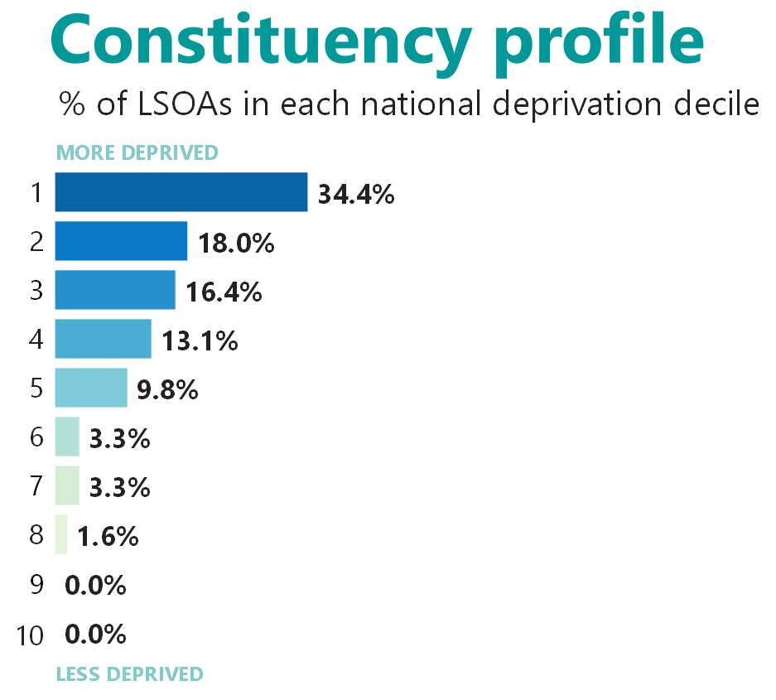
Ministry of Housing Communities & Local Government IoD- Local Authority Focus accessed: 30.09.21

In October 2021, 64% of the children attending Wibsey Primary live in one of the top two most deprived categories nationally.
Overarching Objectives
- To diminish the attainment gap between disadvantaged and non-disadvantaged pupils
- To build the cultural capital of children from disadvantaged backgrounds through a broad and balanced curriculum and extra visits and experience to build on their skills and knowledge.
- To build on the attendance of disadvantaged children

Challenges

This details the key challenges to achievement that we have identified among our disadvantaged pupils.
Challenge number | Detail of challenge
1 | Lower attainment on entry to EYFS and KS1: Gaps in early reading and phonics acting as a barrier to pupils accessing the full curriculum and achieving the highest levels of attainment
2 | More frequent SEMH difficulties: A number of children have social and emotional difficulties which directly impact on attainment and progress
3 | Attendance and Punctuality issues: The ongoing challenge of securing high levels of attendance and reducing the number of children who are persistently absent
4 | Family/Home living issues with social services/Early help involve
5 | Weak Language and Communication Skills: Many pupils have limited communication skills, including barriers linked to speech and language issues
6 | Parental engagement with reading and learning at home
7 | Limited life experiences: Many of our pupils have limited life experiences and do not engage in diverse cultural activities outside of school life

Intended outcomes
This explains the outcomes we are aiming for by the end of our current strategy plan, and how we will measure whether they have been achieved.
Intended outcome | Success criteria
Strong progress in reading resulting in strong levels of attainment | - Achieve in line with national Age Related progress scores in KS2 Reading  - Achieving national expectations by the end of KS1 and KS2 in Reading  Greater proportion of pupils pass Y1 Phonic check
Strong progress in writing resulting in strong levels of attainment | - Achieve in line with national Age Related progress scores in KS2 Writing  Achieving national expectations by the end of KS1 and KS2 in Writing
Strong progress in Maths resulting in strong levels of attainment | - Achieve in line with national Age Related progress scores in KS2 Maths  Achieving national expectations by the end of KS1 and KS2 in Maths
Pupils engage in a range of diverse cultural activities | Strong programme of enrichment activities take place
Improved attendance and reduced persistent absence | Ensure attendance of disadvantaged pupils is above 95%

Activity in this academic year
This details how we intend to spend our pupil premium (and recovery premium funding) this academic year to address the challenges listed above.

Teaching (for example, CPD, recruitment and retention)
Budgeted cost: £ 135941
Activity | Evidence that supports this approach | Challenge number(s) addressed
Activities to increase the proportion of high-quality Wave 1 teaching:  - Ensure all staff, including associate staff receive ongoing phonics and reading training.  - Strong ECT support through mentor support, training and observing good practice.  - Whole staff CPD led by Maths and English teams  - Purchase of National College membership to access CPD for staff at all levels across school  Deploy support staff to provide targeted phonics, reading and maths across school | NFER research: ‘High quality teaching for all’ is 1 of the 7 key building blocks for successful support of DA children.  EEF Toolkit Predicted Impact:  Teaching Assistants +1 month  EEF  Impact of school closures on the attainment gap: Rapid Assessment  June 2020  - Recommends high-quality materials are available for ECTs linked to the ECF | 1,5
Enhance provision to embed the reading culture and accelerate language acquisition across school:  - Reading Hub in EYFS resourced and used by Associate Staff during interventions and focused activities to promote early language development  - Reading areas enhanced within classrooms across school  - Accelerated reader used across school Y2 - Y6 | Improving Literacy in KS1 / 2 EEF 2017  Developing pupils speaking and listening skills and wider understanding of language including the active and repeated exposure to new vocabulary has convincing evidence for improving attainment in Literacy  The importance of motivation and engagement and a wide range of literacy experiences in improving literacy has compelling evidence  EEF Toolkit Predicted Impact:  - Oral Language interventions +4 months  - Early Years interventions +5 months  - Teaching Assistants +1 month  Parental Involvement +3 month | 1,5,7
Increased parental engagement is  encouraged by:  - Increased support with homework completion, home reading  - Recovery videos for parents addressing gaps in Maths  Purchase of RWI phonic video links for parents. | EEF Toolkit Predicted Impact:  Parental Involvement +3 months  Primary Homework +2 months | 6
Activities to increase the proportion of high-quality Wave 1 teaching:  - Ensure all staff, including associate staff receive ongoing phonics and reading training.  - Strong ECT support through mentor support, training and observing good practice.  - Whole staff CPD led by Maths and English teams  - Purchase of National College membership to access CPD for staff at all levels across school  Deploy support staff to provide targeted phonics, reading and maths across school | NFER research: ‘High quality teaching for all’ is 1 of the 7 key building blocks for successful support of DA children.  EEF Toolkit Predicted Impact:  Teaching Assistants +1 month  EEF  Impact of school closures on the attainment gap: Rapid Assessment  June 2020  - Recommends high-quality materials are available for ECTs linked to the ECF | 1,5
Enhance provision to embed the reading culture and accelerate language acquisition across school:  - Reading Hub in EYFS resourced and used by Associate Staff during interventions and focused activities to promote early language development  - Reading areas enhanced within classrooms across school  - Accelerated reader used across school Y2 - Y6 | Improving Literacy in KS1 / 2 EEF 2017  Developing pupils speaking and listening skills and wider understanding of language including the active and repeated exposure to new vocabulary has convincing evidence for improving attainment in Literacy  The importance of motivation and engagement and a wide range of literacy experiences in improving literacy has compelling evidence  EEF Toolkit Predicted Impact:  - Oral Language interventions +4 months  - Early Years interventions +5 months  - Teaching Assistants +1 month  Parental Involvement +3 month | 1,5,7
Increased parental engagement is  encouraged by:  - Increased support with homework completion, home reading  - Recovery videos for parents addressing gaps in Maths  Purchase of RWI phonic video links for parents. | EEF Toolkit Predicted Impact:  Parental Involvement +3 months  Primary Homework +2 months | 6
Activities to increase the proportion of high-quality Wave 1 teaching:  - Ensure all staff, including associate staff receive ongoing phonics and reading training.  - Strong ECT support through mentor support, training and observing good practice.  - Whole staff CPD led by Maths and English teams  - Purchase of National College membership to access CPD for staff at all levels across school  Deploy support staff to provide targeted phonics, reading and maths across school | NFER research: ‘High quality teaching for all’ is 1 of the 7 key building blocks for successful support of DA children.  EEF Toolkit Predicted Impact:  Teaching Assistants +1 month  EEF  Impact of school closures on the attainment gap: Rapid Assessment  June 2020  - Recommends high-quality materials are available for ECTs linked to the ECF | 1,5
Enhance provision to embed the reading culture and accelerate language acquisition across school:  - Reading Hub in EYFS resourced and used by Associate Staff during interventions and focused activities to promote early language development  - Reading areas enhanced within classrooms across school  - Accelerated reader used across school Y2 - Y6 | Improving Literacy in KS1 / 2 EEF 2017  Developing pupils speaking and listening skills and wider understanding of language including the active and repeated exposure to new vocabulary has convincing evidence for improving attainment in Literacy  The importance of motivation and engagement and a wide range of literacy experiences in improving literacy has compelling evidence  EEF Toolkit Predicted Impact:  - Oral Language interventions +4 months  - Early Years interventions +5 months  - Teaching Assistants +1 month  Parental Involvement +3 month | 1,5,7

Budgeted Cost
Activity | Amount
Cost of staff deployment | £131141
Cost of National College CPD | £1300
Cost of reading provision | £3500
Total budget for this academic year | £135941

Targeted academic support (for example, tutoring, one-to-one support structured interventions)
Budgeted cost: £143753
Activity | Evidence that supports this approach | Challenge number(s) addressed
Gaps in learning, including those in early reading and Phonics are addressed:  - Deploy Associate Staff to provide effective support to targeted individuals/key groups (34% from PP)  - KS1 and KS2 – same-day interventions Maths continuum – AS. (33% from PP) £ 68073  - Subject leads and teachers identify gaps in Foundation subjects and changes made to LTP to gap fill key concepts in subsequent years (informed by exceptions grids)  - Cover for recovery intervention – additional teacher for release of class teachers and delivery of small group interventions for pupils who are falling behind age related expectations. High skew to PP pupils.  - In school tuition through National Tutoring Programme (Phonics, Reading and Maths) funded by Catch Up funding) work with predominantly PP pupils across school.  - English specialist bought in to work across years 4-6 with PP pupils (Catch-Up funding)  £204219 | There are many pupils who are currently in receipt of PP funding and are also on the SEND register – these pupils are particularly vulnerable in terms attainment and progress and are below ARE.  Many PP pupils rely on additional TA support to access tasks. They may have limited access to language, extra-curricular experiences and / or emotional / behaviour needs.  The Education Endowment Fund tool kit highlights high cost/low impact of TA’s in general. However, there is clear case study/data evidence that investment in precision teaching training and training on learning continuum for TA’s for identified groups/individuals is impacting positively on pupil progress.  The EEF toolkit highlights how a focus on small group tuition has a ‘moderate impact for low cost based on moderate evidence’. It details how small group tuition has a positive impact overall (+ 4 months). Research suggest that small group tuition is effective and that the smaller the group the better. | 1,5
Associate staff trained, and delivering, nationally available/recognised intervention strategies  a.Precision Teaching  b.Talking Partners  c. Wellcom  d. Wave 3  e. NELI - continuation to 20 weeks within Y1. Trained TA allocated 100% of timetable to NELI – backfill post in Reception.  £204219 | The Education Endowment Fund tool kit highlights moderate cost/medium impact of small group tuition. There is evidence that intervention grouping is impacting positively on pupil progress.  EEF Toolkit Predicted Impact:  Feedback +8 months  One to one tuition +4 months  Learning Styles +2 months | 1,5
Gaps in early reading and Phonics are addressed:  - RWI Phonics taught into Year 3 and additional sessions in Year 1 and 2. Taught by Associate Staff (33% from PP) £68073  - TAs unfamiliar with RWI Phonics delivering within year group receive RWI training and have access to training videos  - RWI development days purchased  - Training for ECT staff in Accelerated Reader  - English specialist bought in to work across years 4-6 with PP pupils (Catch-Up funding) | Reading interventions rated highly on EEF Toolkit.  Reading Interventions +  Internal data shows RWI highly effective eg Phonics data 2017 for Y1 test PP - 91%  Feedback + 8 months (EEF Toolkit)  The Education Endowment Fund tool kit highlights moderate cost/medium impact of small group tuition. There is clear evidence that providing intervention grouping is impacting positively on pupil progress and ensures catch up. See also EEF toolkit for feedback (+8 months) and individualised learning (+3 months).  Feedback + 8 months  One to one tuition +5 months  (EEF Toolkit)  EEF Toolkit Predicted Impact:  Reading +3 months (other pupils)  Reading +5 months (PP) | 1,5
Gaps in communication and early language addressed by:  • Welcomm Programme continued to improve receptive and expressive language in Nursery – 12 sessions  - NELI programme in Reception delivered by Associate Staff  - Specific speech and language support from therapist – 1 day alternate weeks across school  £6195 | PP pupils enter Foundation with significantly lower starting points (2020/21):  Nursery - 25% PP pupils entered with expected communication and language development (Baseline Target Tracker)  Reception – 33% of PP pupils entered Reception with language below average (NELI screening)  EEF Toolkit Predicted Impact:  Oral Language interventions +4 months  Early Years interventions +5 months  Teaching Assistants +1 month  Improving Literacy in KS1 / 2 EEF 2017  Developing pupils speaking and listening skills and wider understanding of language including the active and repeated exposure to new vocabulary has strong evidence for improving attainment in Literacy  EEF Toolkit Predicted Impact:  Oral Language interventions +4 months  Early Years interventions +5 months  Teaching Assistants +1 month | 1,5
Address social and emotional difficulties:  •Small group intervention and targeted nurture support provided by the Pastoral team | EEF Toolkit Predicted Impact:  Behaviour interventions +3 months | 2,4
Address gaps in early reading and phonics:  - RWI Phonics taught into Year 3 and additional sessions in Year 1 and 2  - TAs unfamiliar with RWI Phonics delivering within year group receive RWI training and have access to training videos  - RWI development days purchased  - Accelerated reader to be used from Y2 upwards.  - Training for ECT staff in RWI and / or Accelerated Reader  - In school tuition through National Tutoring Programme (Phonics, Reading and Maths) funded by Catch Up funding) work with predominantly PP pupils across school. | The EEF toolkit highlights how a focus on small group tuition has a ‘moderate impact for low cost based on moderate evidence’. It details how small group tuition has a positive impact overall (+ 4 months). Research suggest that small group tuition is effective and that the smaller the group the better. | 1,5

Budgeted Cost
Activity | Amount
Cost of Associate Staff | £68073
Cost of RWI | £2200
Speech and Language | £7000
Tuition costs including English specialist / additional teacher | £66480
Total budget for this academic year | £143753

Wider strategies (for example, related to attendance, behaviour, wellbeing)
Budgeted cost: £24000
Activity | Evidence that supports this approach | Challenge number(s) addressed
Embed a system for challenging and supporting families with attendance issues and those at risk of persistent absence:  - External services used to support attendance procedures  - Regular attendance meetings complemented by weekly attendance reports | NfER / DfE recommendations November 2015 include attendance.  The severe negative effect of absence poses a particularly high risk for disadvantaged pupils, who typically have lower rates of attendance and whose families have indicated that they would be substantially less likely to send their child back to school if given the choice (IFS 2020)  The EEF Toolkit highlights a focus on parental engagement has ‘moderate impact for very low cost based on extensive evidence.’ It details how it has a positive impact overall (+4 months) | 3,4
Disadvantaged pupils are funded for all curriculum events, music tuition, trips and activities that enhance their educational provision:  - Year group budgets used to subsidise class visits so all pupils can access out of school opportunities  - Enrichment for PP pupils: music therapy, music tuition  - School residential – cost covered for PP pupils  - Brathay weekly sessions and visits for Y5 / Y6  - Identified children receive music therapy  - Extra curricular activities  - Cultural capital opportunities: fishing, after school clubs, residentials, pre-learning visits, pantomime  Disadvantaged pupils receive financial support with school uniform - £30 per family £6000 Full uniform vouchers – 3 children | Many PP Pupils do not have access to music lessons or club membership. Physical activity is key for good mental health and many pupils find a new hobby having been given opportunity to try clubs at school.  Many PP Pupils do not have access to residentials and day trips due to lack of funding. These visits are integral to pupils’ learning experiences in order for learning to be ‘brought to life’. Residentials give pupils an opportunity to be more independent and build relationships with their peers. Physical activity is key for good mental health and many pupils find a new hobby having been given opportunity to try clubs at school.  EF Toolkit Predicted Impact:  Outdoor Adventure Learning +4 months  Learning Styles +2 months  Arts Participation +2 months | 2,7
Staff are equipped to support pupils with more frequent SEMH difficulties:  - CPD for staff – from Mental Health Lead and Education Psychologist  - Family and home related issues are mitigated in-school by sign-posted support and do not contribute to reduced learning. Pupils come to school ready to learn | EEF Toolkit Predicted Impact:  Behaviour Interventions +3 months | 2, 4
Build on the positive learning behaviour and increased participation in lessons and readiness to learn by:  - Purchase of BLP resources £195  - Introduction of play mentors and enhanced lunch and playtime provision  - Breakfast Club attendance paid for vulnerable PP pupils | Many PP pupils have poor attendance. Breakfast Club attendance enables them to have a calm start to the day and supports attendance.  EEF Toolkit Predicted Impact:  Meta Cognition and self regulation +8 months  Collaborative learning (BLP link) +5 months | 2

Budgeted Cost
Activity | Amount
Cost of enhanced provision | £17000
Cost of uniform | £6000
BLP / playground resources | £1000
Total budget for this academic year | £24000

Total budgeted cost: £303694

Review of the outcomes in previous academic year

Pupil premium strategy outcomes
This details the impact that our pupil premium activity had in the 2020-2021 academic year
Aim | Outcome
Progress in core subjects | Due to the challenges of COVID-19, gaps have widened for all pupils including those who are disadvantaged
Phonics | Year 2 Autumn 2020 86% attained the required standard with 92% entering KS2 having met the required standard.
Attendance | Attendance across the 2020-2021 academic year was 94.2% which is above the national for 20/21 of 92.6%  Persistent absence continues to be a problem
Other | Clubs and trips offer was limited due to the barriers presented by COVID-19. This will be addressed in the 2021-2022 academic year.

