YEAR 6 HOME LEARNING OCTOBER HALF TERM
DUE IN 1st NOVEMBER 2021
Spellings to learn:  mischievous  muscle  necessary  neighbour  nuisance  occupy  occur  opportunity  parliament  persuade | English/Science  Choose a type of bear e.g. polar bear or sloth bear and research it. Present your findings.  Remember to think about:  Appearance  Behaviour  Habitat  Adaptations Interesting facts  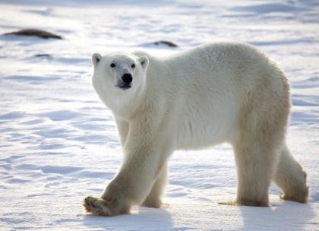  Reading Challenge:  See how many reading challenges you can complete!  The challenges are listed on the sheet on Google Classroom. | Maths  1. Mathletics  2. Times Table Rock Stars.  EARN SOME POINTS FOR YOUR CLASS!  3. Complete Reasoning Quiz 5, which is on Google Classroom

